**Core Java Index**

**Day-1 (05-08-2024)**

1. Language and Applications
2. Java Features
3. Why Java is Platform Independent
4. Oops
5. Exception Handling
6. Multi-Threading
7. Web applications
8. Open source
9. Security
10. Supports Networking
11. Memory Management
12. JDK, JRE, JVM
13. Conditional Statements ,Operators
14. Basic Java Programming
15. Largest of Two numbers
16. Largest of Three numbers
17. Swapping of two numbers with and without temp variable
18. Packages
19. Practice program: Largest of 5 numbers

**Day -2 (06-08-2024)**

1. Nested loops- Pattern Programs
2. Arrays - 1D example programs
3. 2D Arrays - example programs
4. Logical Programmings
5. Switch cases
6. Java.Lang package & object class methods
7. Scanner
8. Enumeration
9. Event management Applications

**Day -3 (07-08-2024)**

1. Oops
2. Encapsulation
3. Calculations
4. PersonClass
5. MethodFlow
6. System.Out.Println()
7. Inheritance
8. Polymorphism
9. MethodOverloading
10. MethodOverriding
11. Abstract
12. IS-A Relation (inheritance )
13. HAS-A Relation(Object creation)

**Day -4 (08-08-2024)**

**Constructors**

-> Class name and Constructor name should be Same

-> They are 2 types of Classes

1. Default constructors
2. Parameterized constructors

-> We can Access constructors while creation of objects

-> Constructors are mainly for initializing.

-> Constructors doesn’t have any returntype not even void also.if we declare as a void the compiler will consider it as a method not as a constructors.

-> Every class needs atleast one Constructors.

->Always constructors are overloaded.

->this and super keyword.

this---- keyword is always pointing to instance variable.

this can be use to call one constructor to another constructor (within a class)

Super----- Keyword always it will call super class constructor

-> Copy Constructor ----- Object reference is copied & calls the constructor

**Program 1: Program 2:**

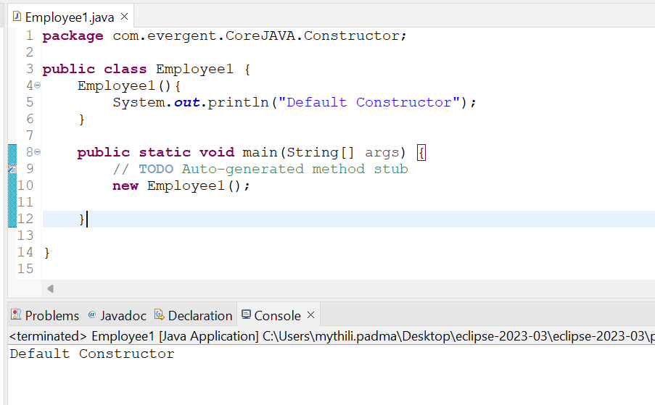 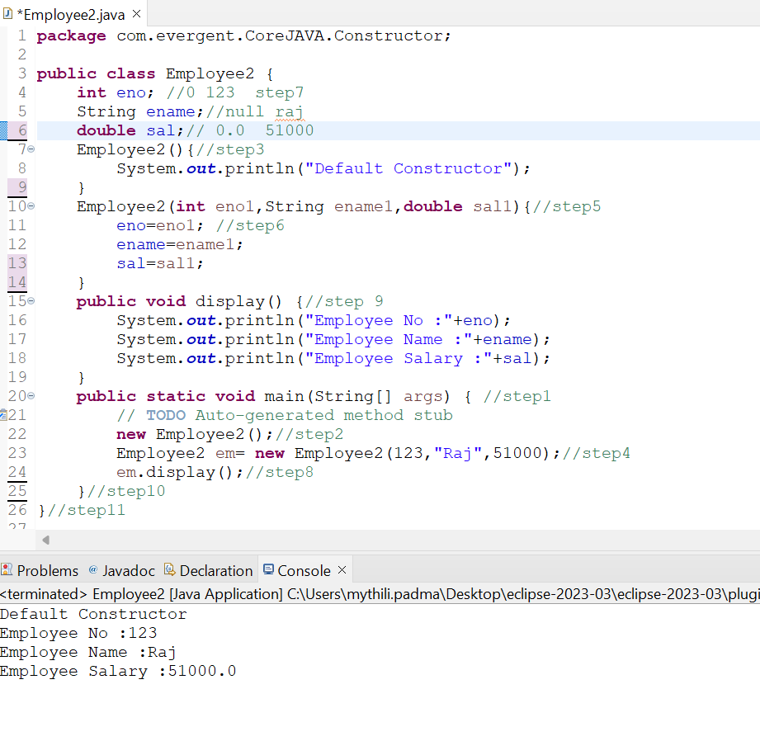

**Program 3: Program 4:**

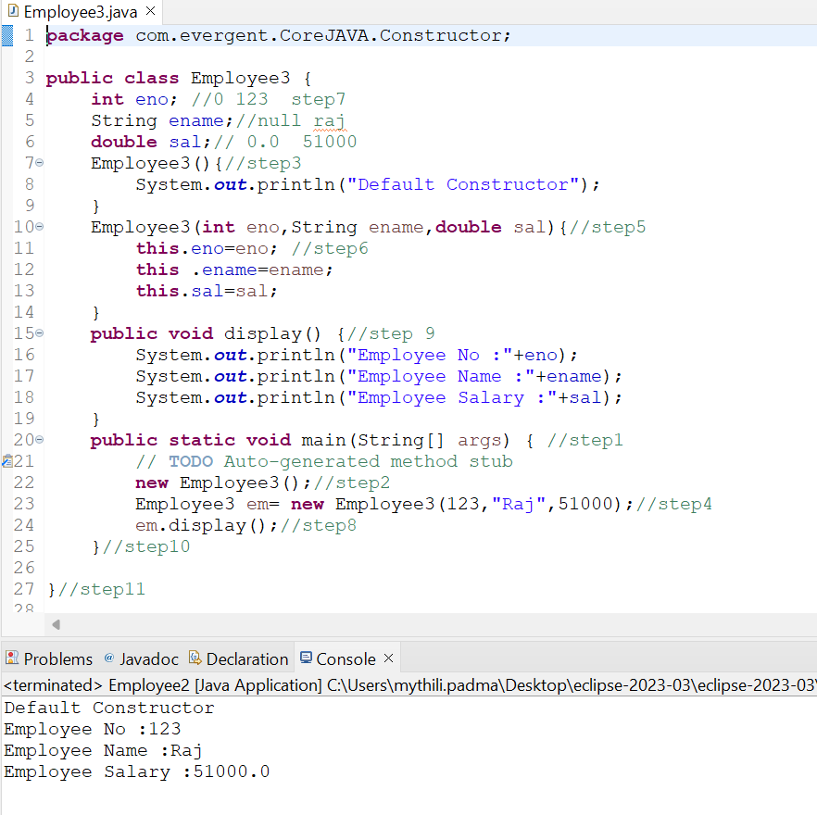 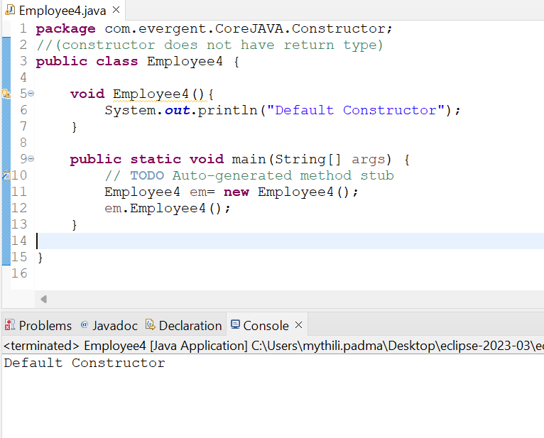

**Program 5:** **Program 6:**

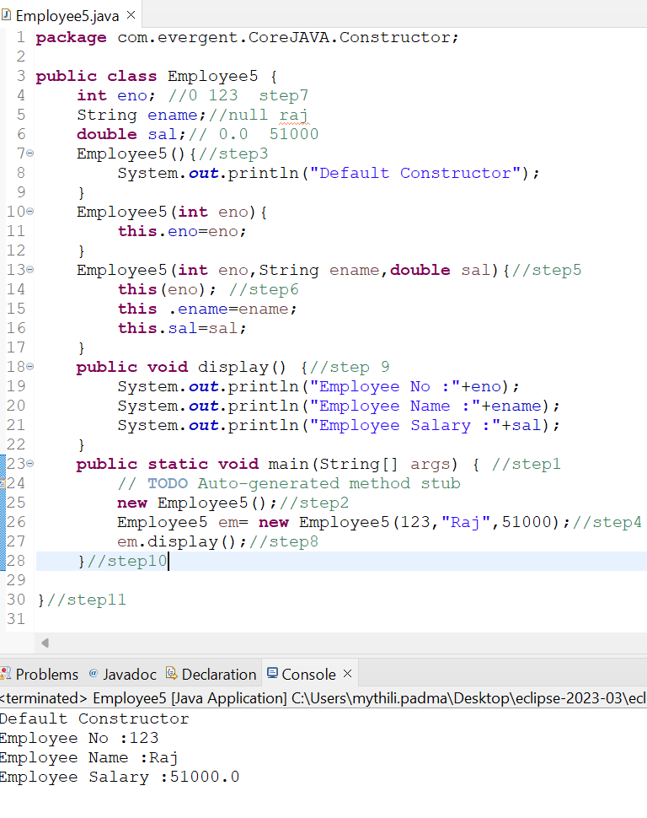 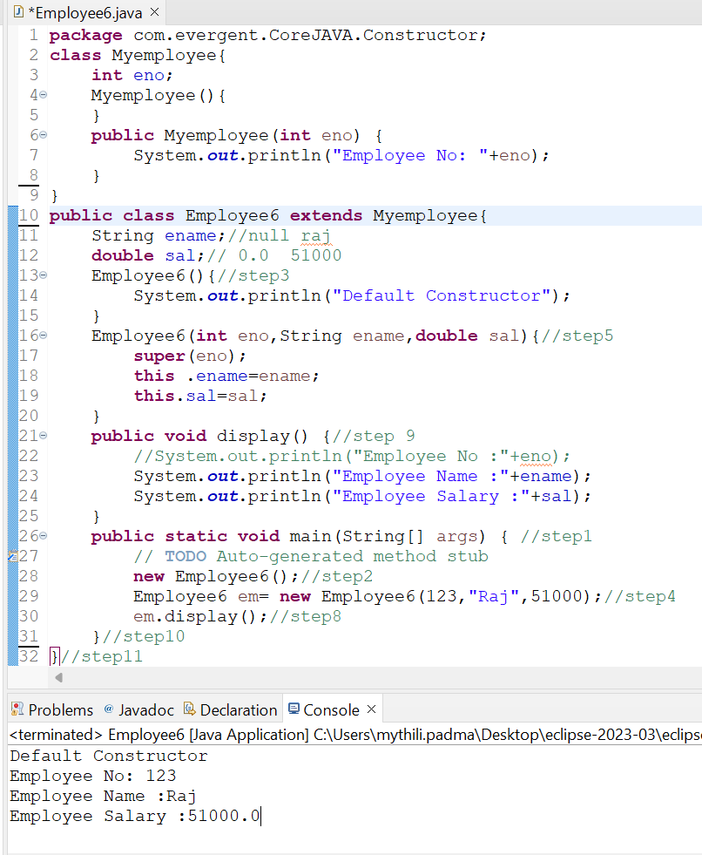

**Program 7:** **Program 8:**

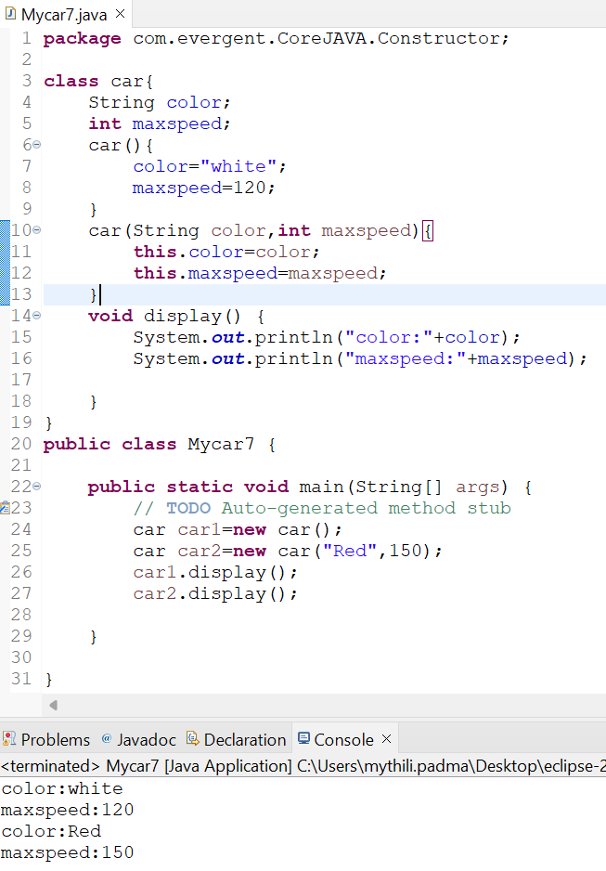 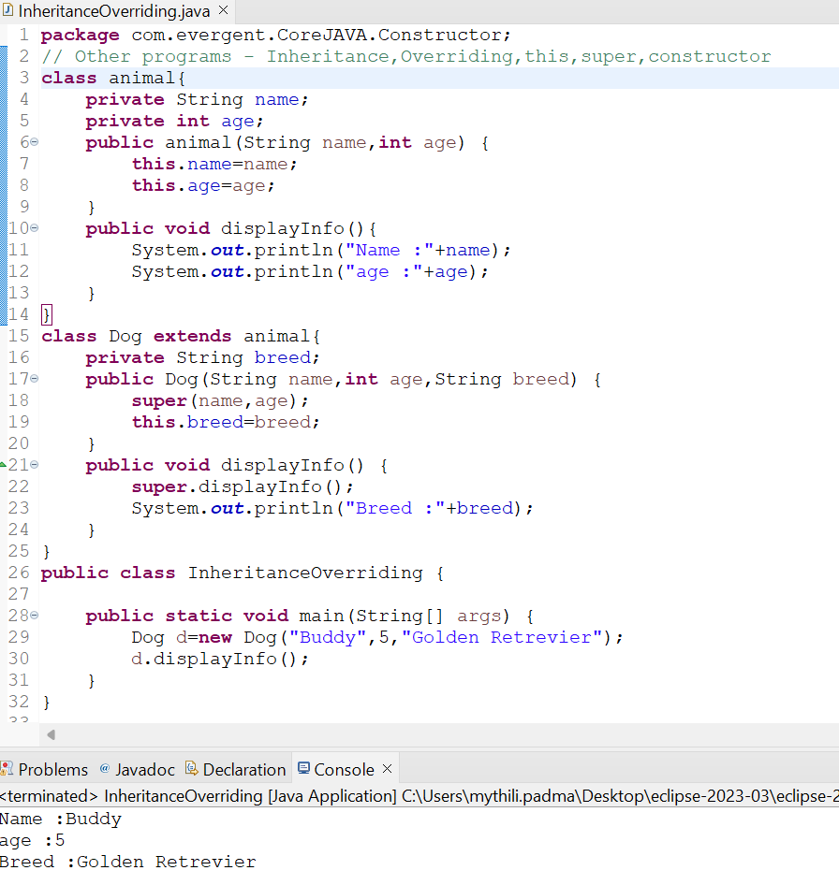

**Program 9:**

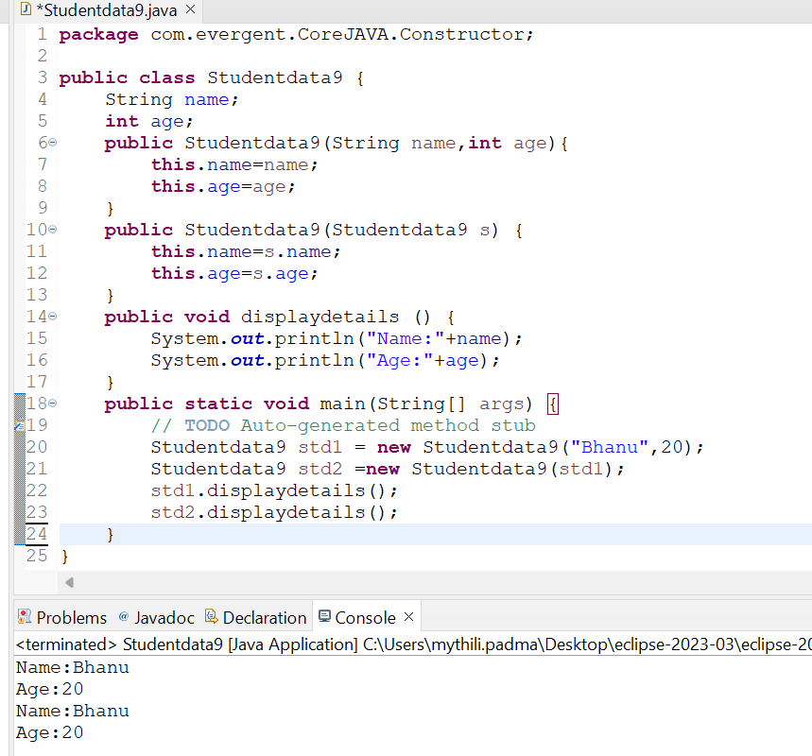

**Day -5 (09-08-2024)**

**Static :**

1. static is a Keyword.
2. We can declare static as Methods & Variables.
3. We can access static variables & static methods directly through Classname. Method name and Classname.Variablename.
4. Static methods can access static methods and static variables.
5. Static methods can not access non-static methods and non-static variables.
6. Non-Static methods can access static methods and static variables.
7. Static block ---> whenever class is loaded into JVM at that time static block is initialzed.
8. If Static variable is modified it will reflect globally

**Final :**

1. final is a Keyword.
2. We can declare final as Variables, Methods & Class.
3. Final variables can not be modify.
4. Final methods can not be Override.
5. Final Class can not be extends (Inherited).

**Program 1:**

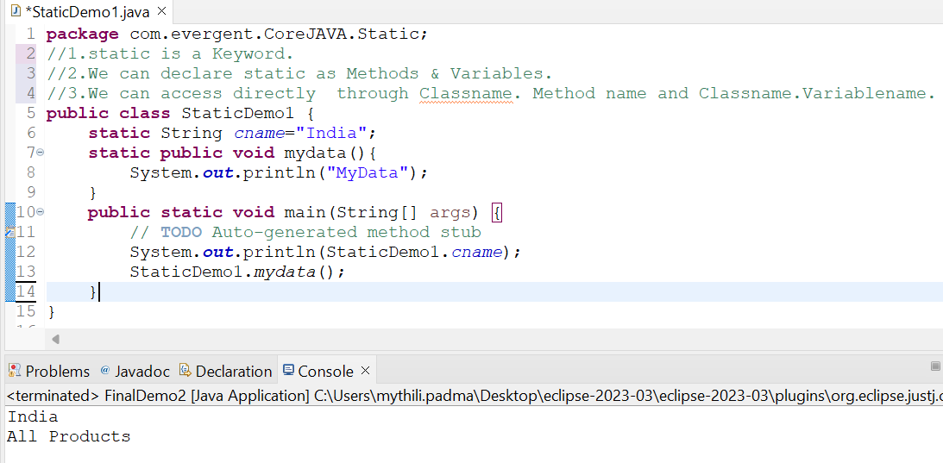

**Program 2:**

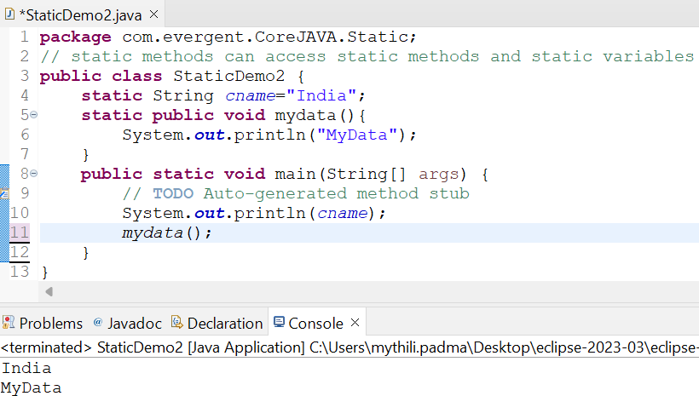

**Program 3:**

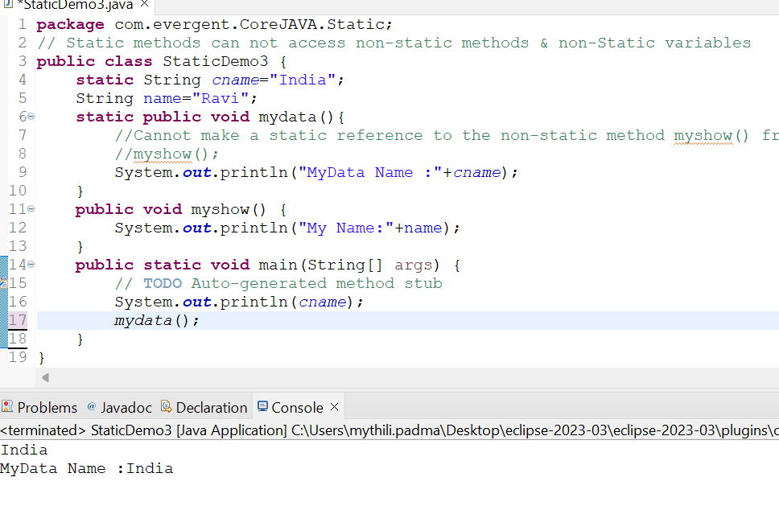

**Program 4:**

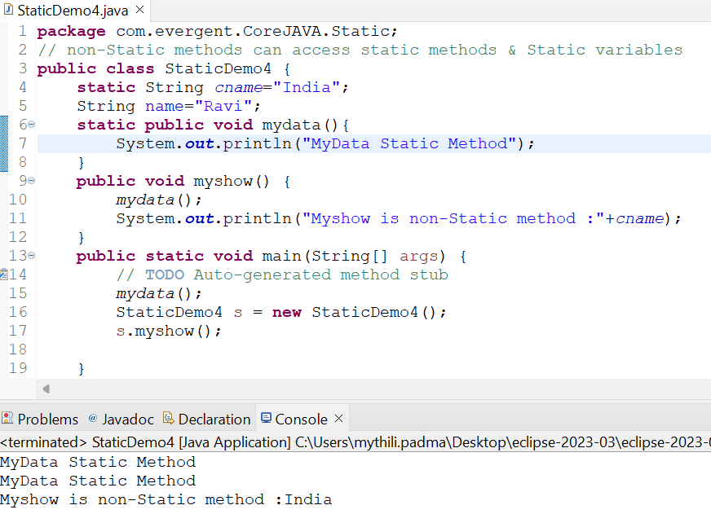

**Program 5:**

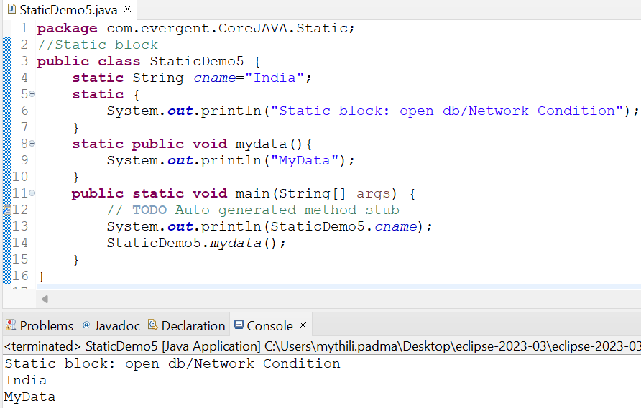

**Program6:**

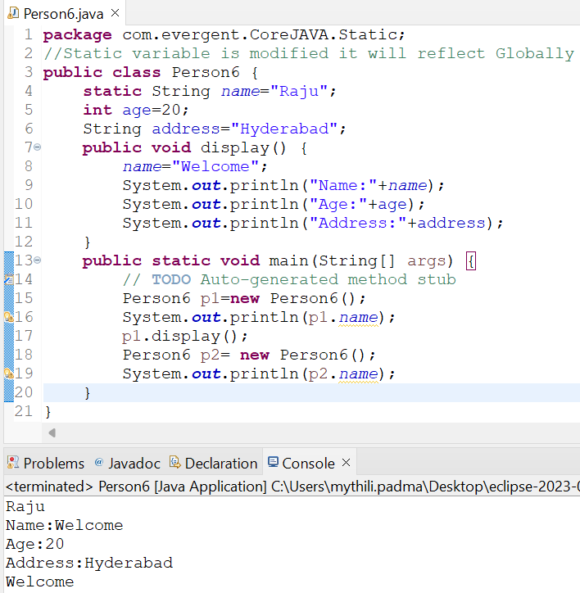

**Program 7:**

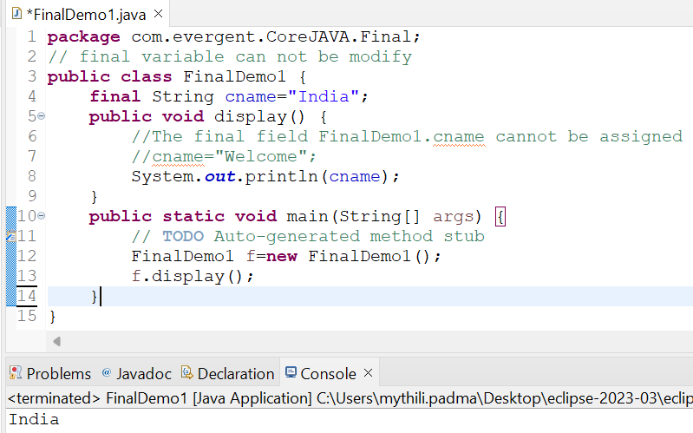

**Program 8:**

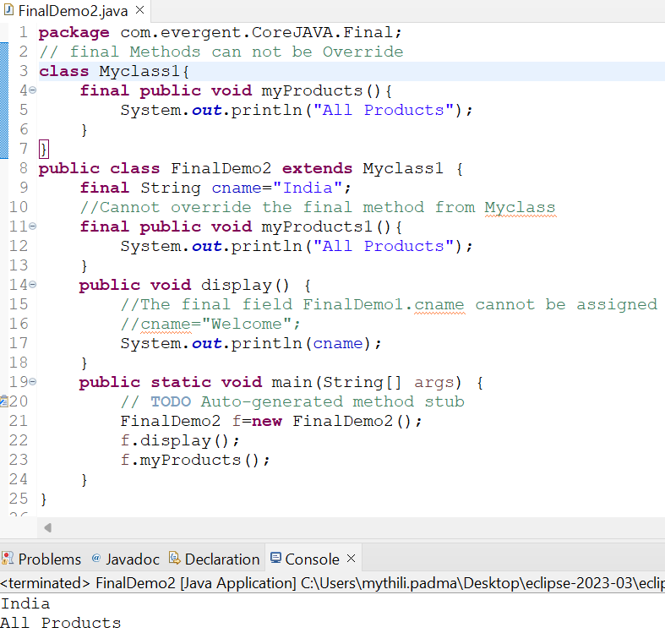

**Program9:**

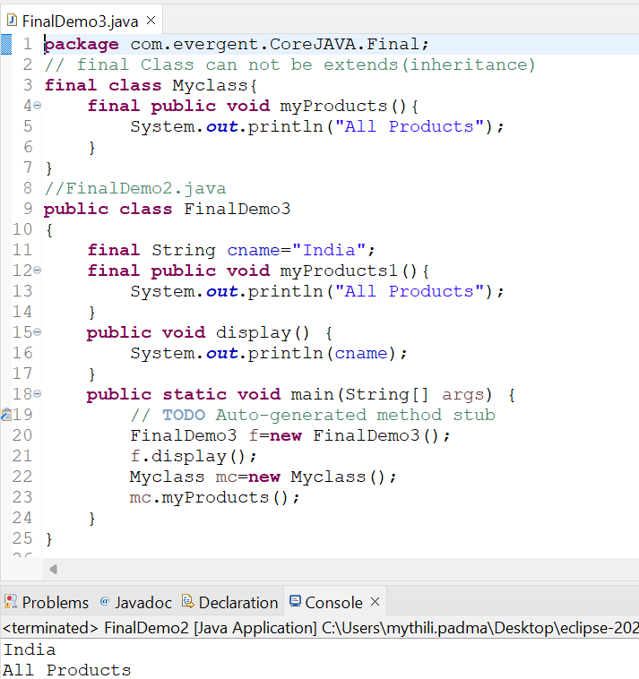

**Day -6 (12-08-2024)**

**String :**

* 1. **String class**  
      -String is Final Class  
      -Strings are immutable  
      -Why strings are immutable?  
      Once we declare any string object, it is constant. If we are trying to modify an existing string it will create another memory location, the existing object is eligible for Garbage Collection.  
      -String class having methods  
      -All string class methods are non-synchronized  
     **1.2 String Buffer**  
      -String is Final Class  
      -Strings are mutable  
      -String class having methods  
      -All string class methods are synchronized

-It is not recommended to use in development but still in API.

-Methods --> append(),insert(),delete(),replace(),reversed(),capacity(),length()  
**1.3 String Builder** -String is Final Class  
 -Strings are mutable  
 -String class having methods  
 -All string class methods are non-synchronized

-Methods --> append(),insert(),delete(),replace(),reversed()

**Program 1: program 2:**

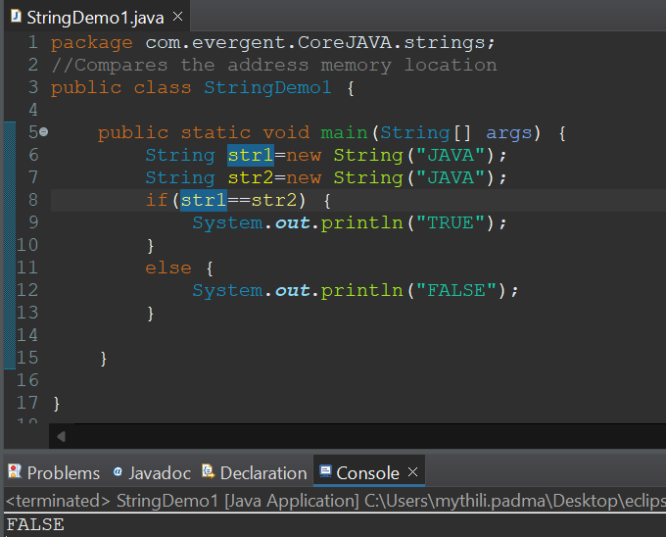 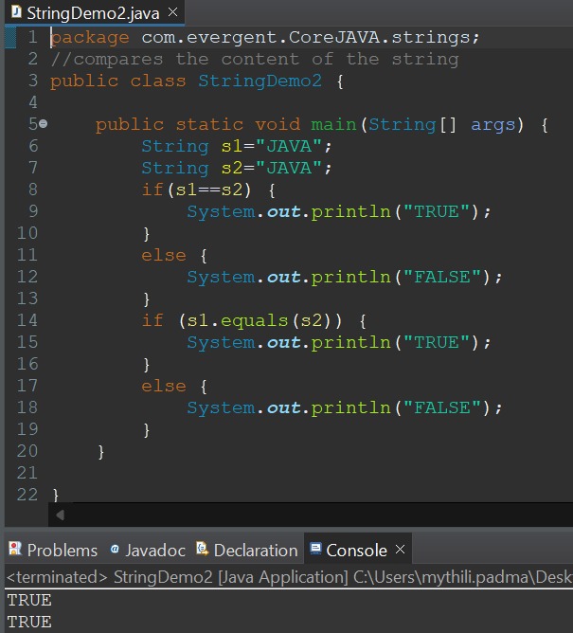

**Program 3: Program 4:**

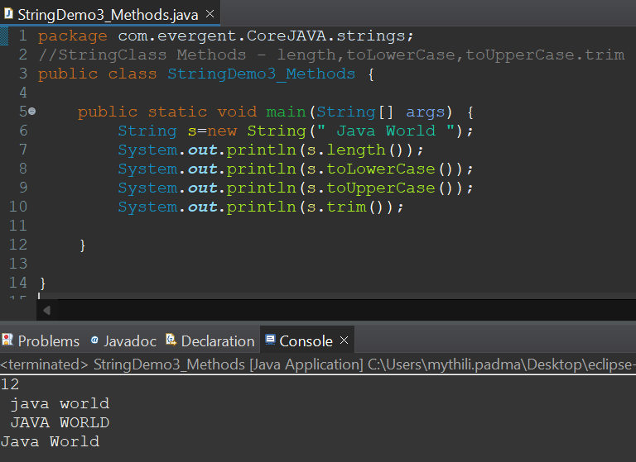 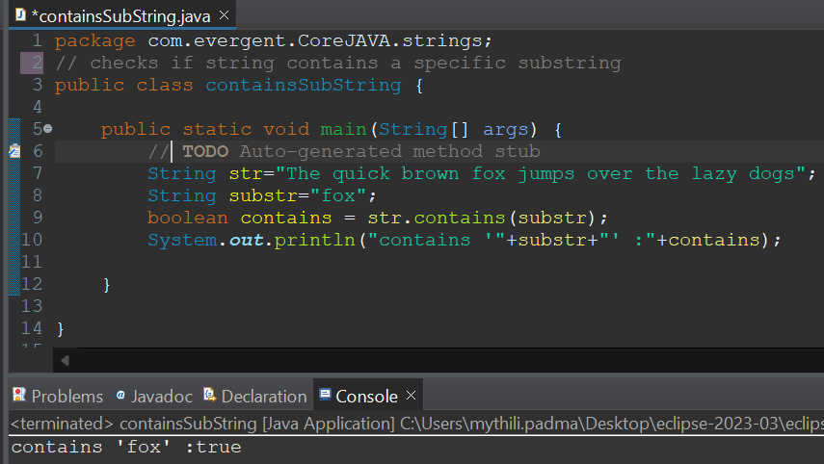

**Program 5: Program 6:**

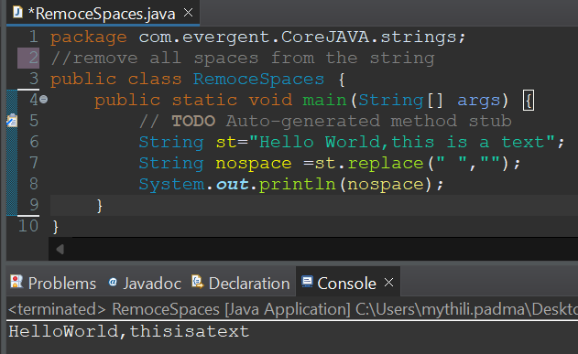 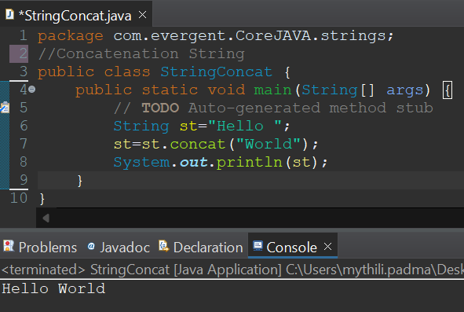

**Program 7: Program 8:**

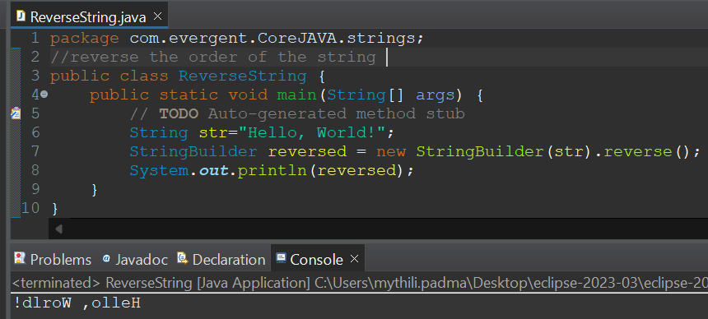 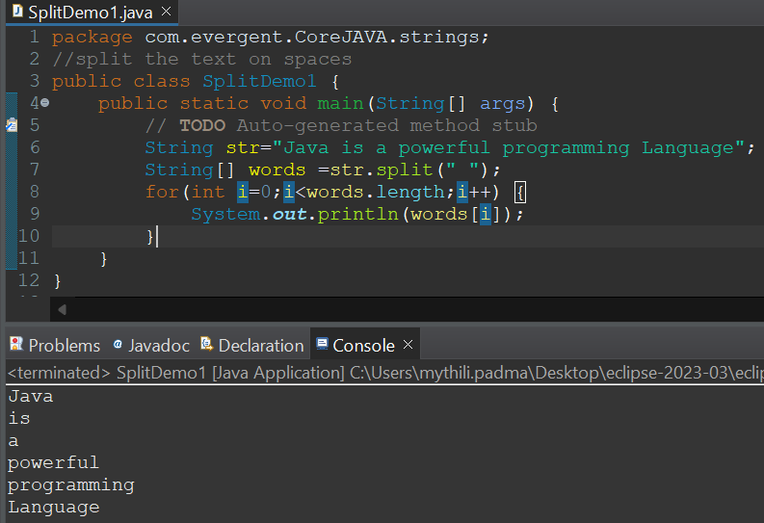

**Program 9: Program10:**

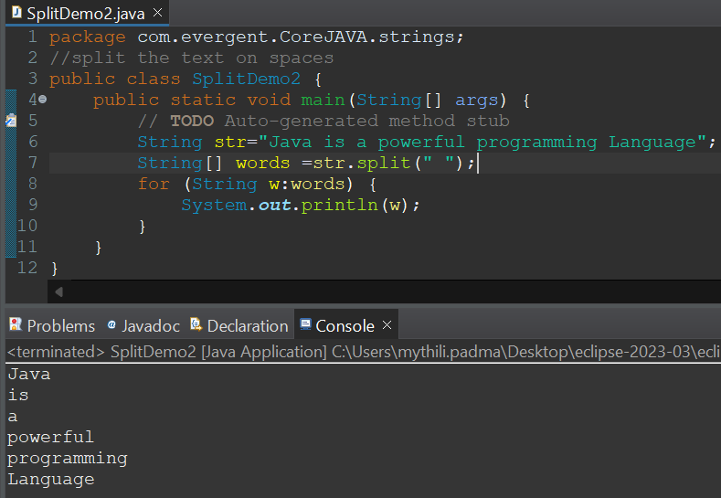 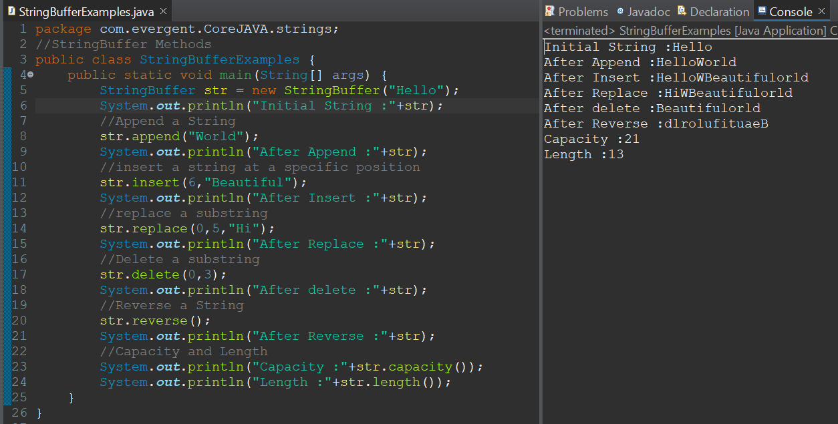

**Program 11: Program 12:**

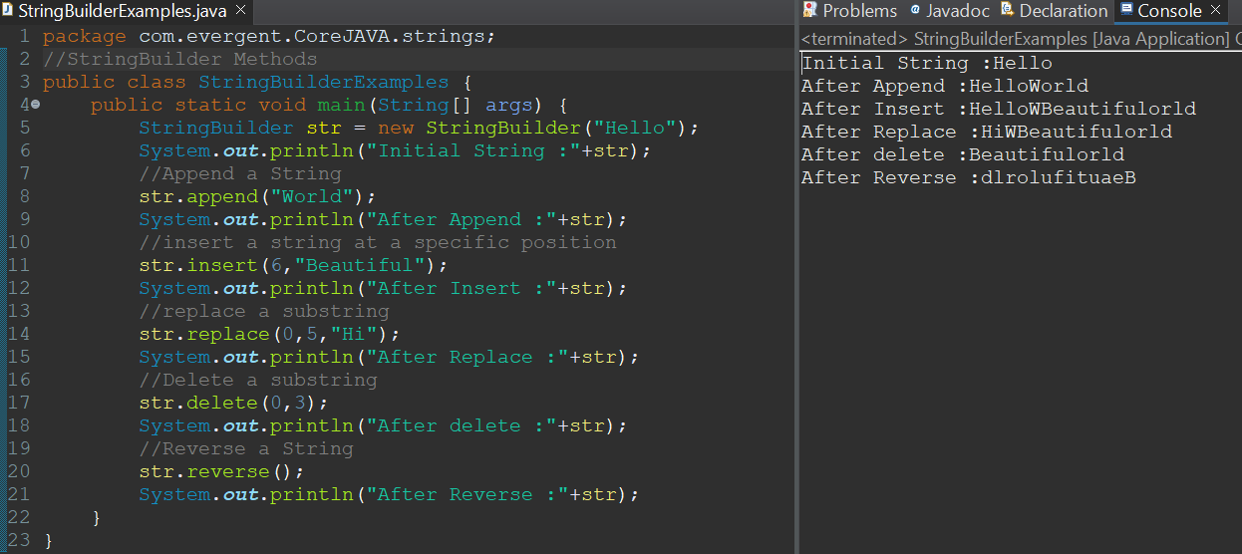 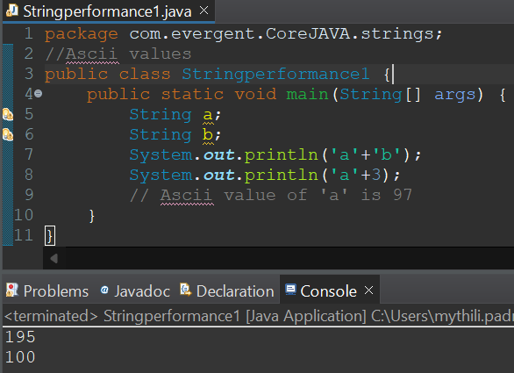

**Program 13: Program 14:**

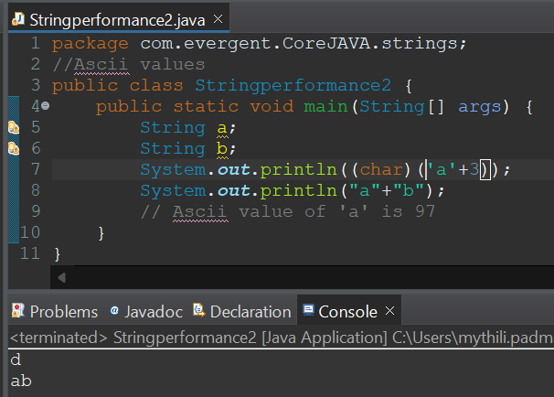 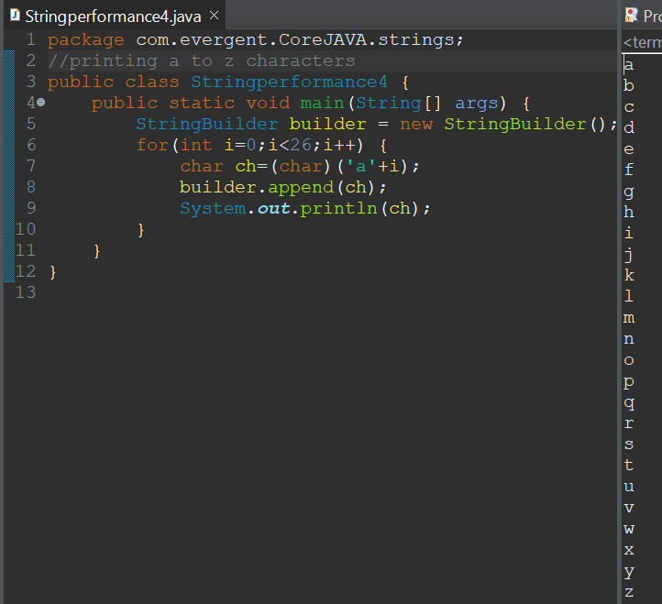

**Program 15: Program 16:**

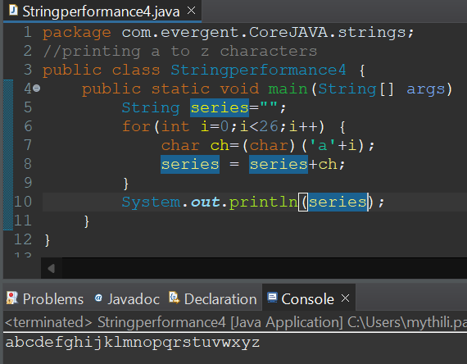 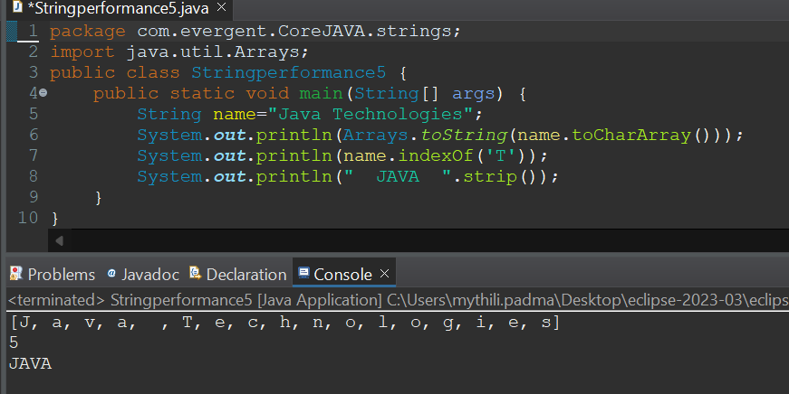

**Day-7 (13-08-2024)**

* **Immutable**

1.We can create our own immutable class?

a.We can declare class as final.

b.The class is declared as final so that it cannot be sub classed..

c.Private final fields:

i.The fields name and age are private and final constructor.

d.Constructor:

ii.The constructor initializes the final fields when the person object is created.

* **Object Class Methods :**

1. toString()
2. hashCode()

* I**nterfaces:**

1. Interface is a keyword.
2. We can declare methods signatures only but not implementations.
3. By default all interface methods are abstract.
4. If any class implements interface that class should override all interface methods otherwise the class will be showing compile time error.
5. We cannot create objects to interface, but we can create references to interface.
6. We can declare variables inside the interface all are public static final.
7. Java will support Multiple inheritance through interface.
8. One class can implements more than one interface.
9. One interface can extend other interface.

**Program 1:**

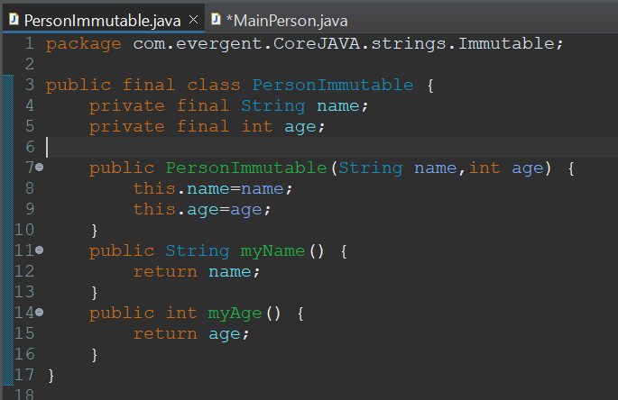 **--->** 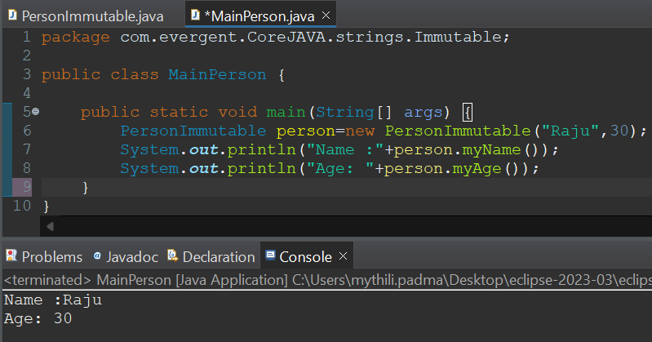

**Program 2:**

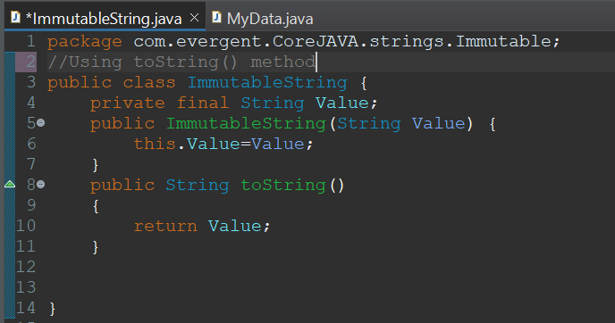 **--->** 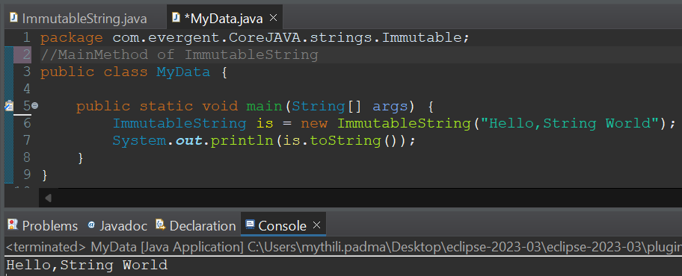

**Program 3:**

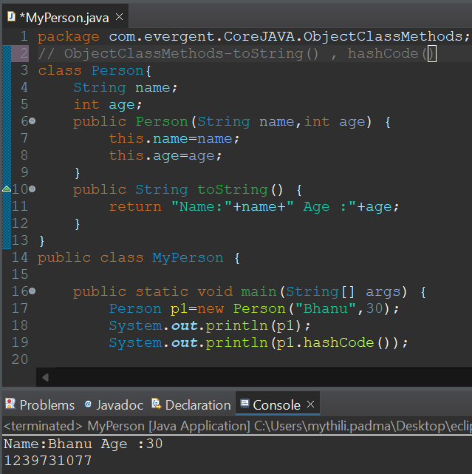

**Program 4:**

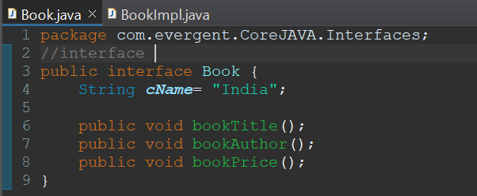

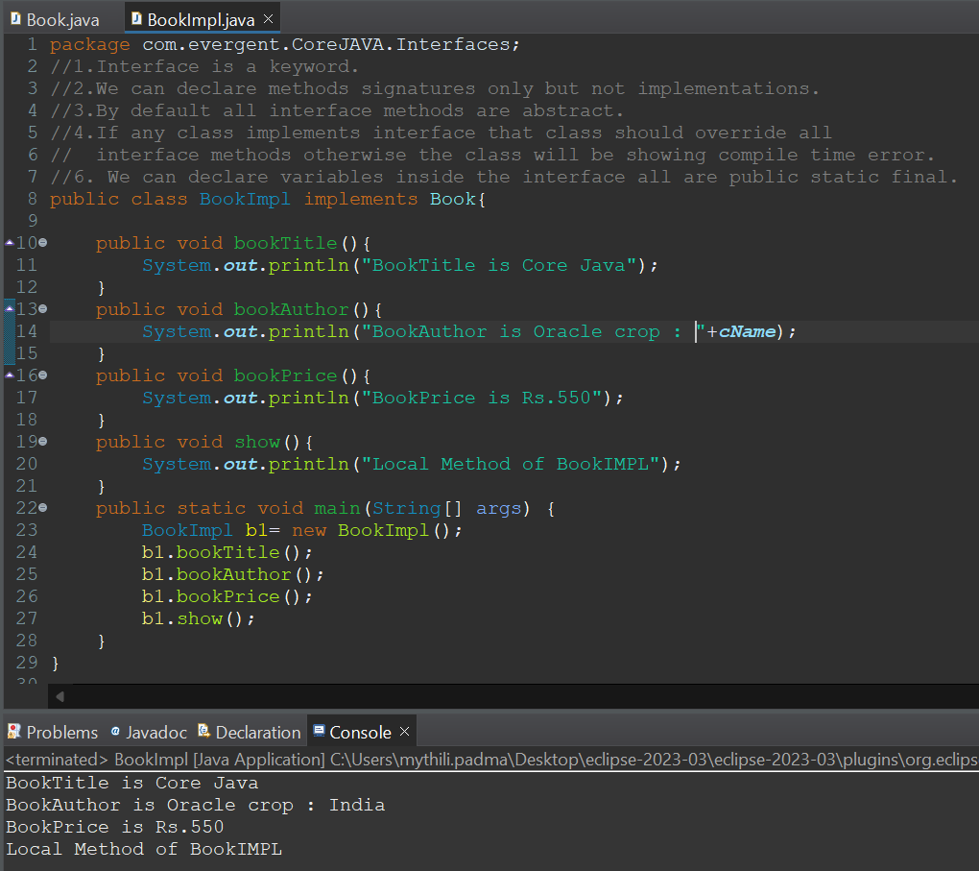

**Program 5:**



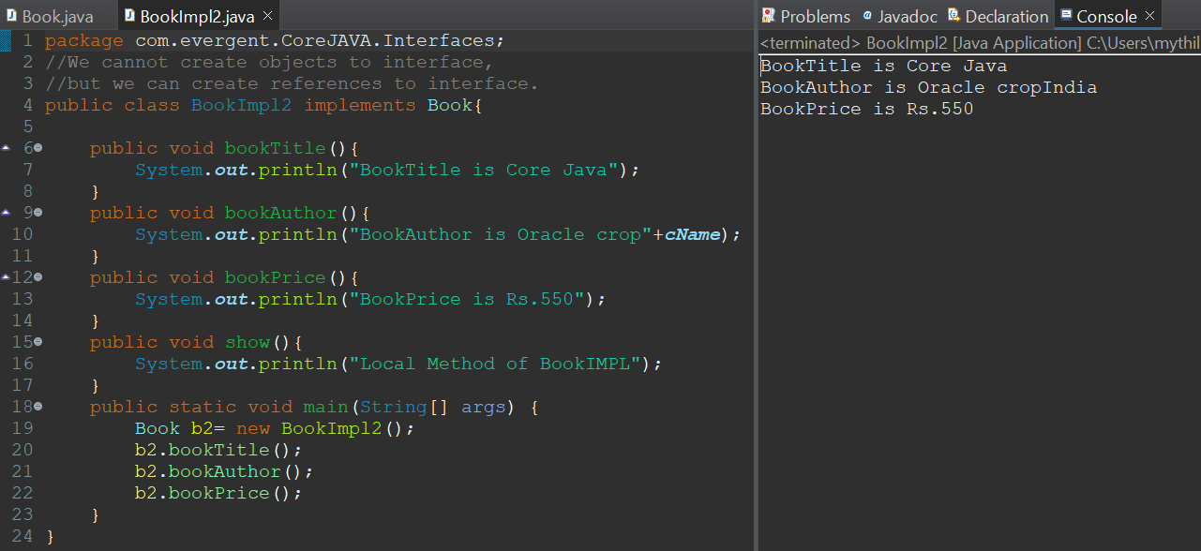

**Program 6:**

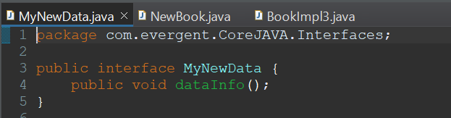

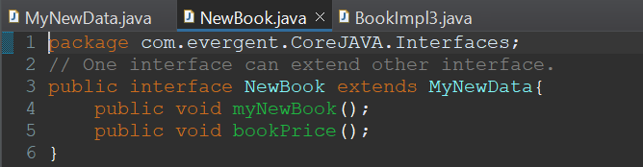

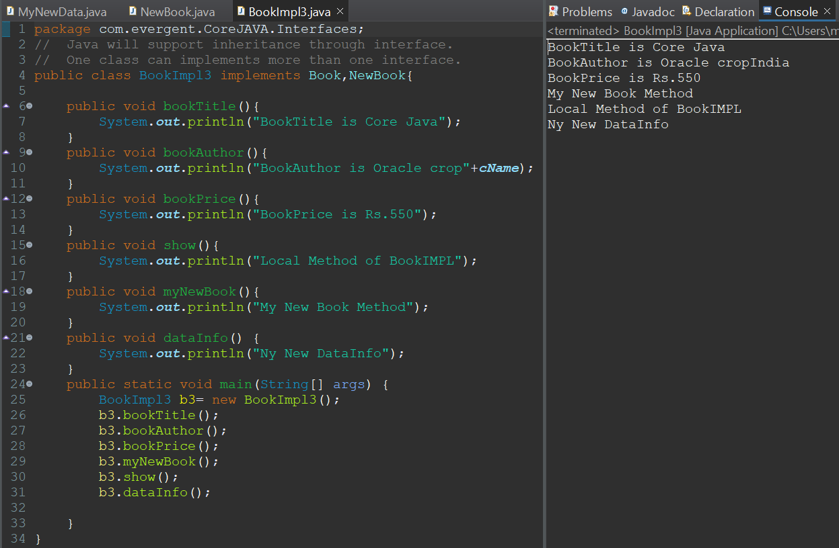

**Day-8 ABSTRACT CLASS 14/8/2024**

**KEY-POINTS:**

1. Abstract is keyword
2. Abstract class having abstract and concrete methods.
3. If any class having abstract method that class should be declared as abstract class, otherwise that class will be showing compile-time error.
4. If any class extends abstract class that class should be override all abstract methods, otherwise that class will be showing compile-time error.
5. We cannot create object to abstract class but we can create reference to abstract class.

**Program-1: Program-2:**

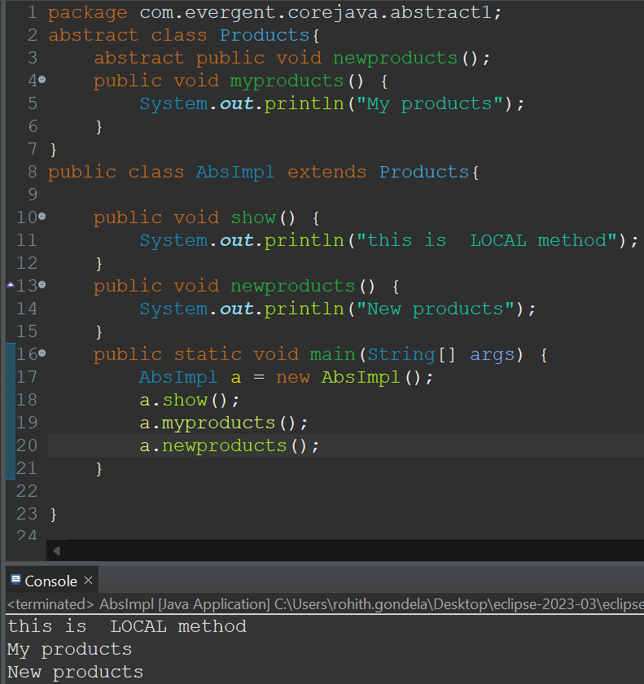 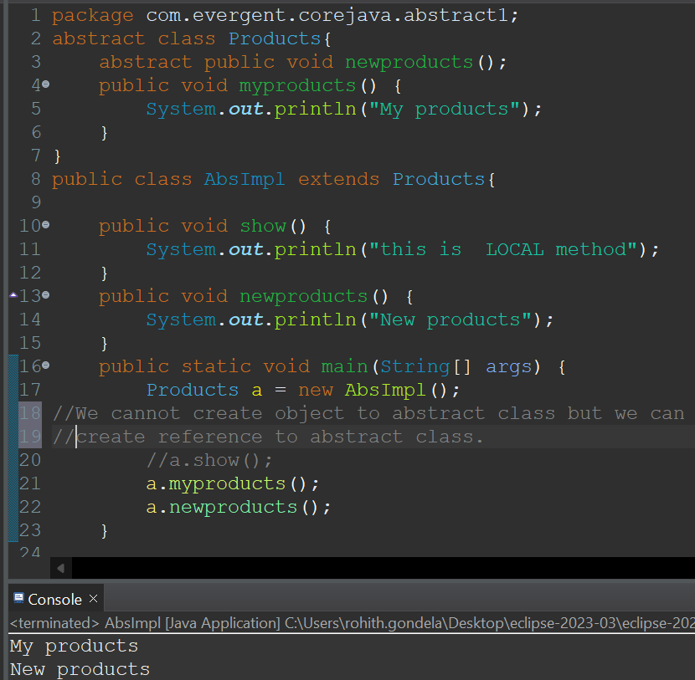

**Program-3: using constructors**

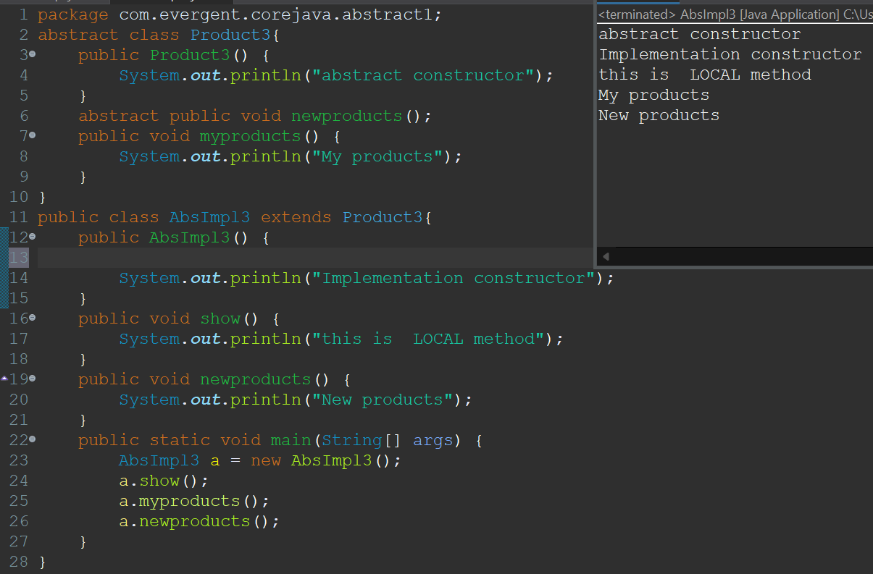

**Day-10 EXCEPTION-HANDLING 19/8/2024**

**KEY-POINTS:**

1. Exception handling is a mechanism.
2. Exceptions are inbuilt mechanism in java.
3. All exceptions are executed while abnormal conditions only.
4. Normal flow it won’t execute any exception.
5. Once any exceptions are occurring in java code then remain lines of code is unreachable.
6. Java.lang.Throwable is a super class for Exception and Error.
7. There are 2 types of Exceptions:
   1. Checked Exception
   2. Unchecked Exception
8. All checked Exceptions are compile-time Exceptions.
9. All unchecked Exceptions are run-time Exceptions.
10. There are 5keywords in Exception handling
    1. Try
    2. Catch
    3. Finally
    4. Throws
    5. Throw
11. Try for business logic.
12. Catch for handling Exceptions.
13. Finally is block if Exception is occur or not finally block will be executed.
14. Throws an exception will be executed method by method.
15. Throw is for runtime exceptions and will call predefined exceptions.
16. Try followed by either catch block or finally block.
17. We should follow exception hierarchy.
18. We can create our own exceptions.
19. Our own exceptions extends exceptions or runtime exceptions.
20. All exception classes are into java.lang package.
21. If there is 2 exceptions in class, Developer should be handle 1st exception then only 2nd exception will be handled.
22. Errors are not in developer control.
23. Exceptions protect business logic.
24. For one try block we can write multiple catch blocks.
25. Handling multiple Exceptions with throws keyword.
26. Handling multiple Exceptions using multi-catch.

**Program-1:**

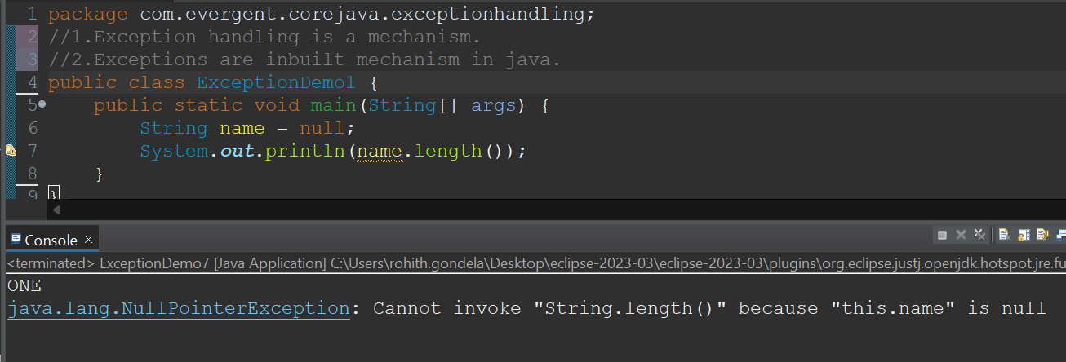

**Program-2:**

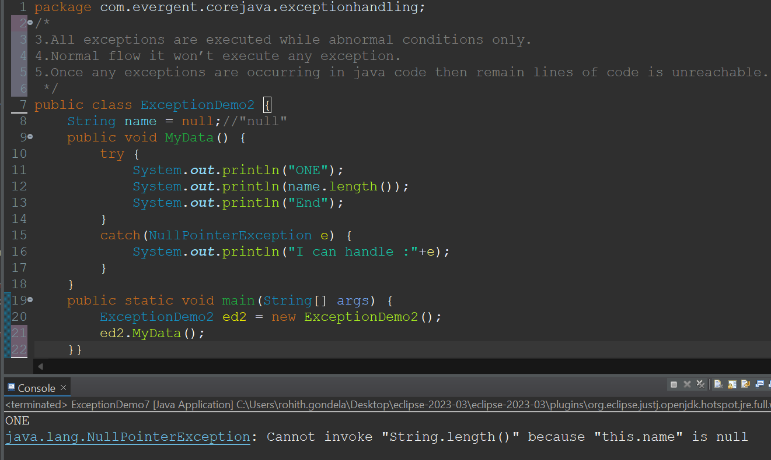

**Program-3:**

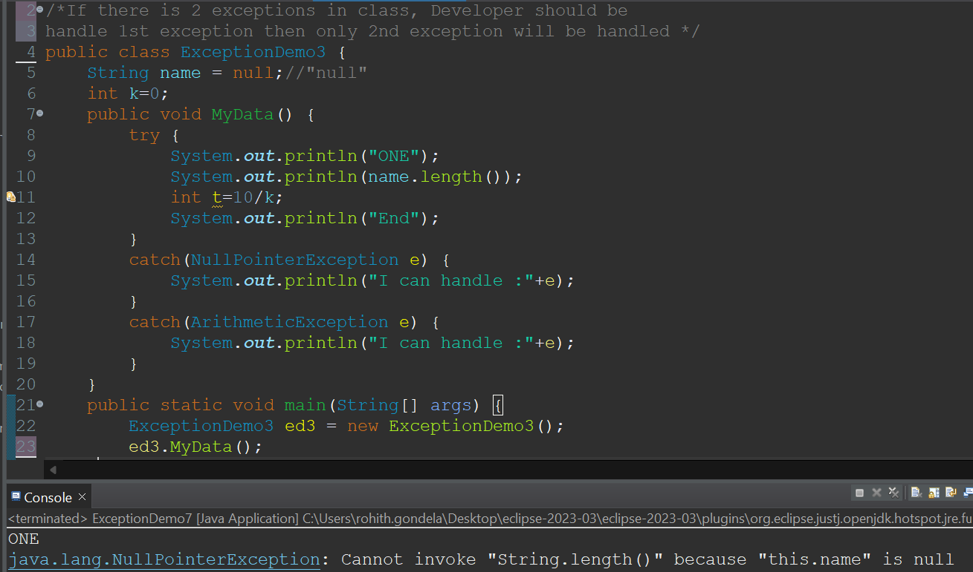

**Program-4:**

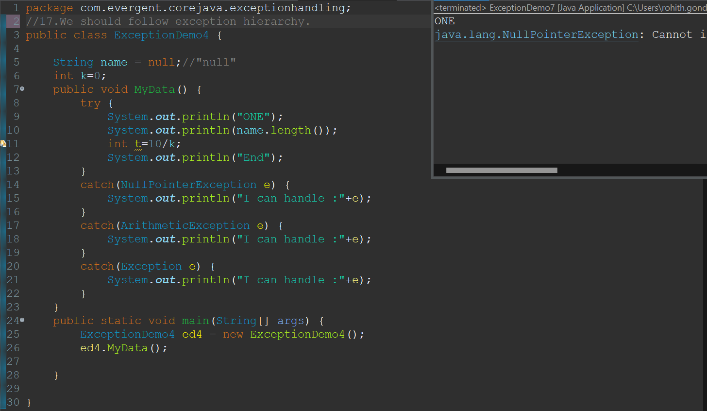

**Program-5:**

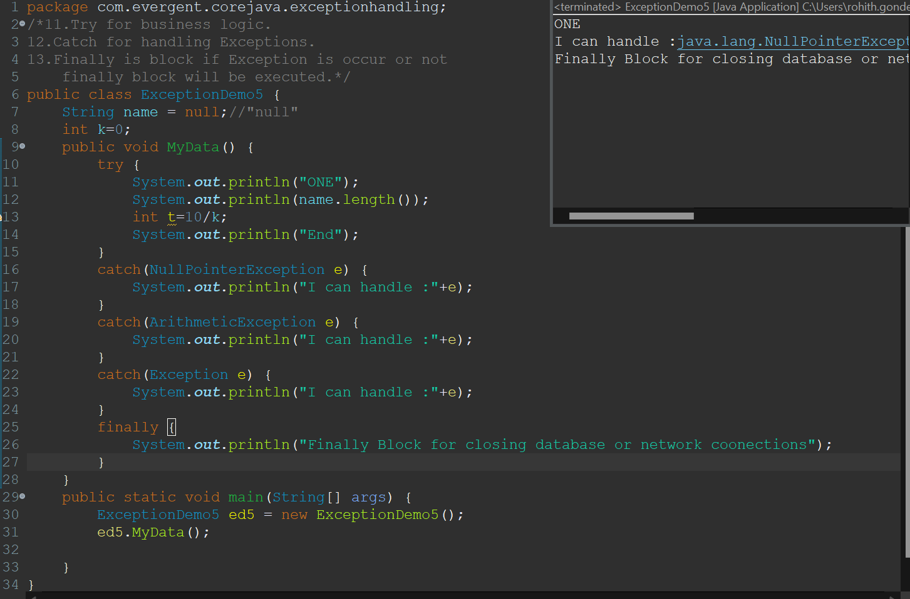

**Program-6:**

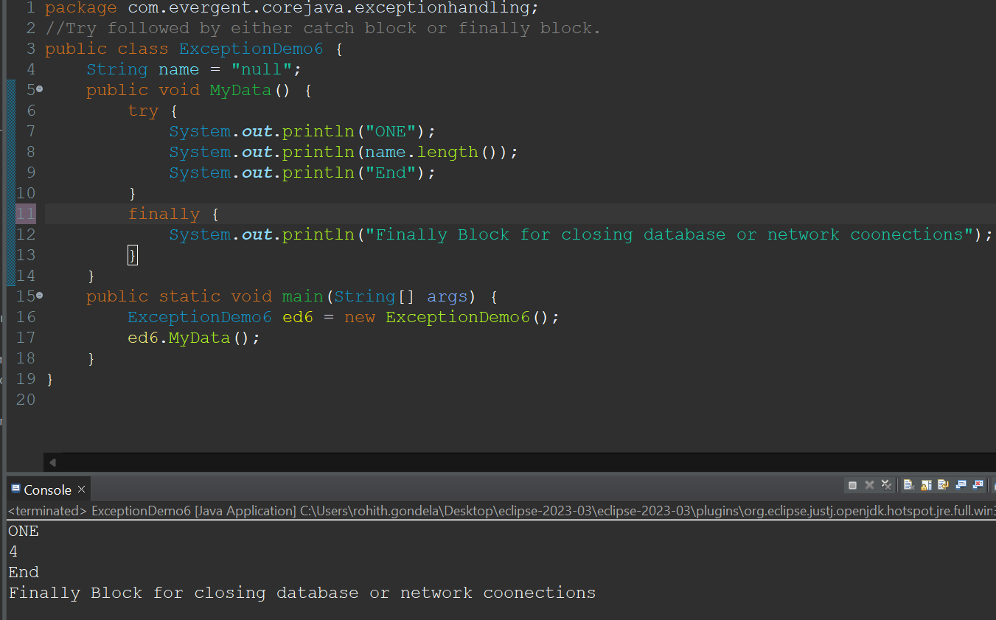

**Program-7:**

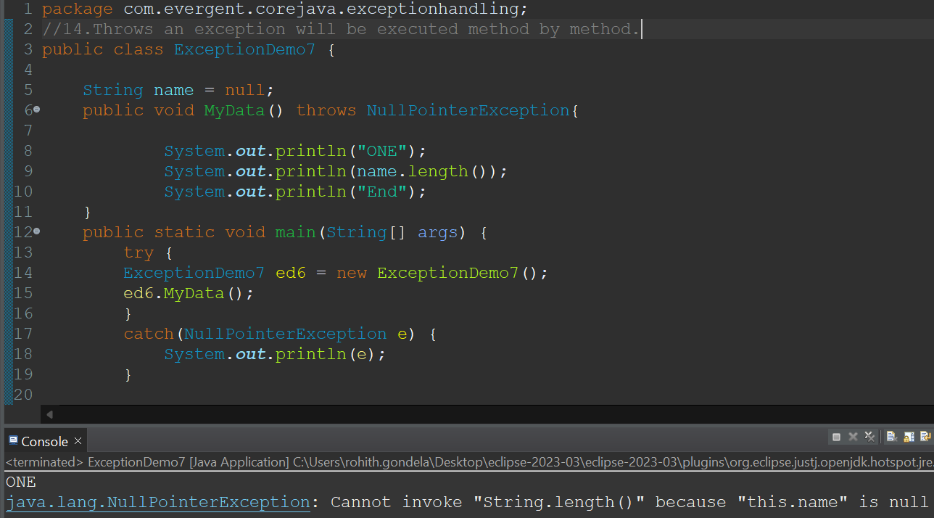

**Program-8:Using throws keyword**

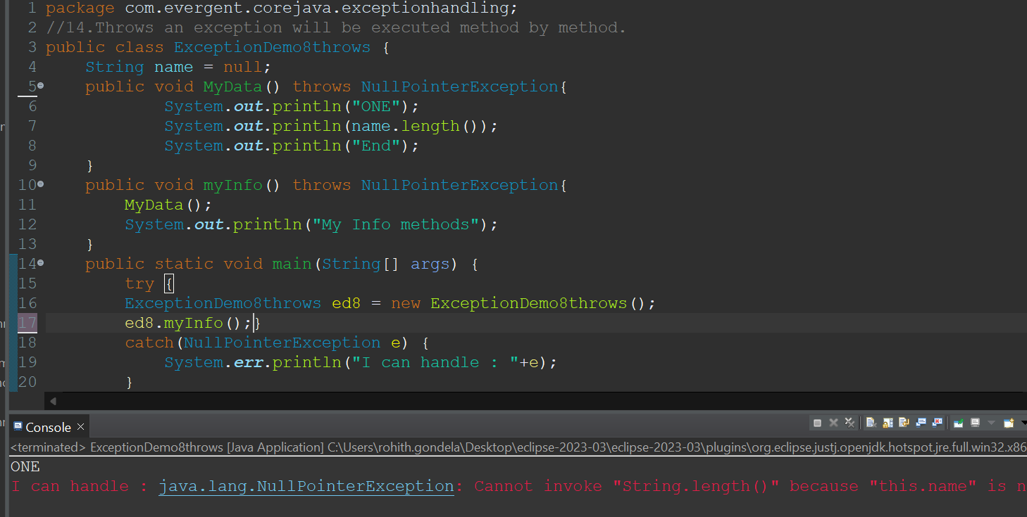

**Program-9:User defined Exception**

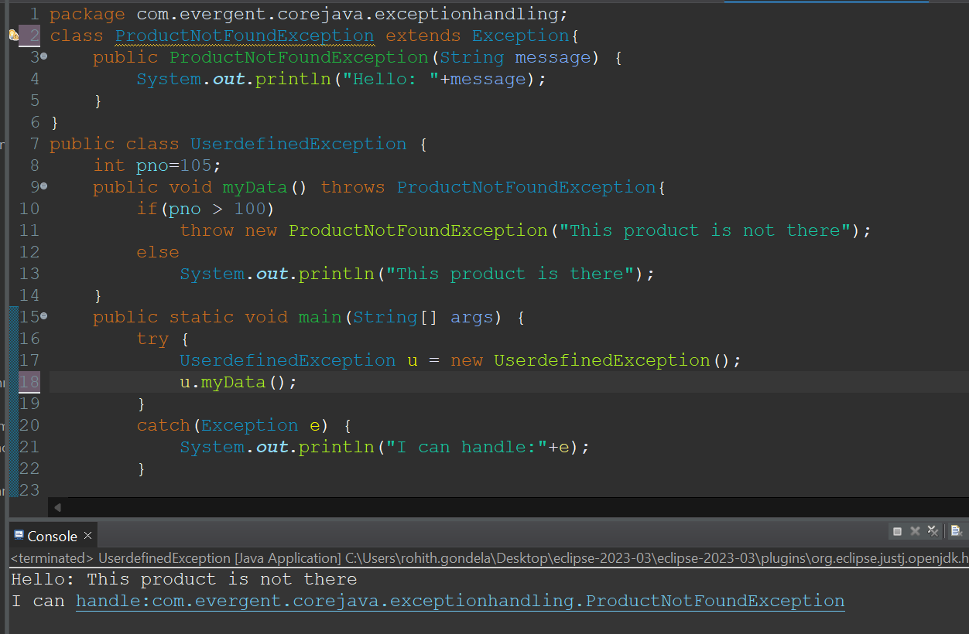

**Program-10:Invalid Age Exception**

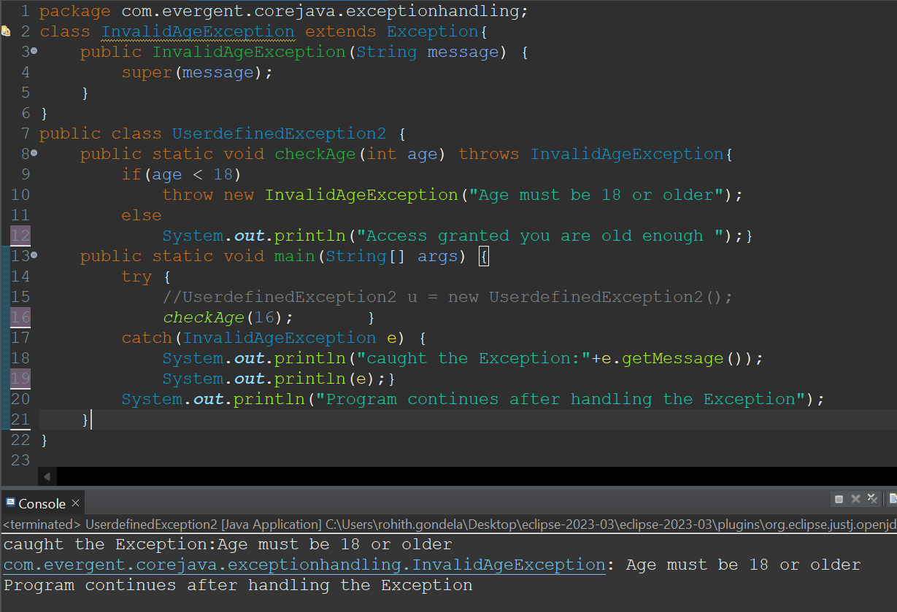

**Program11:Insufficient funds Exception.**

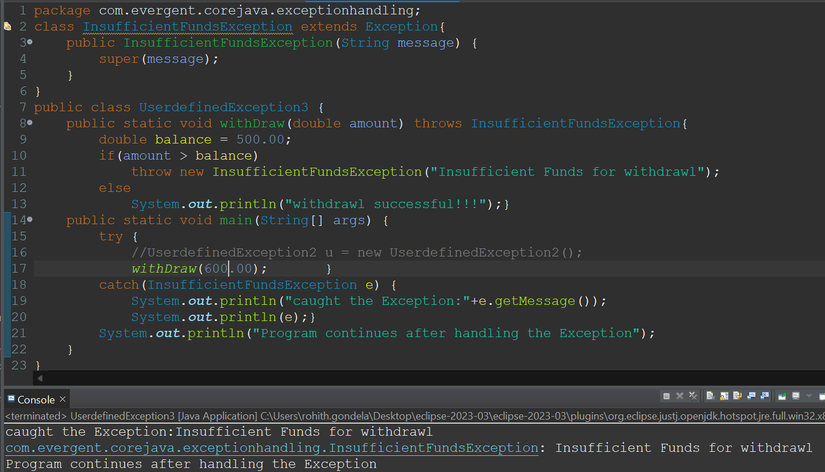

**Program-12:InvalidScore Exception:**

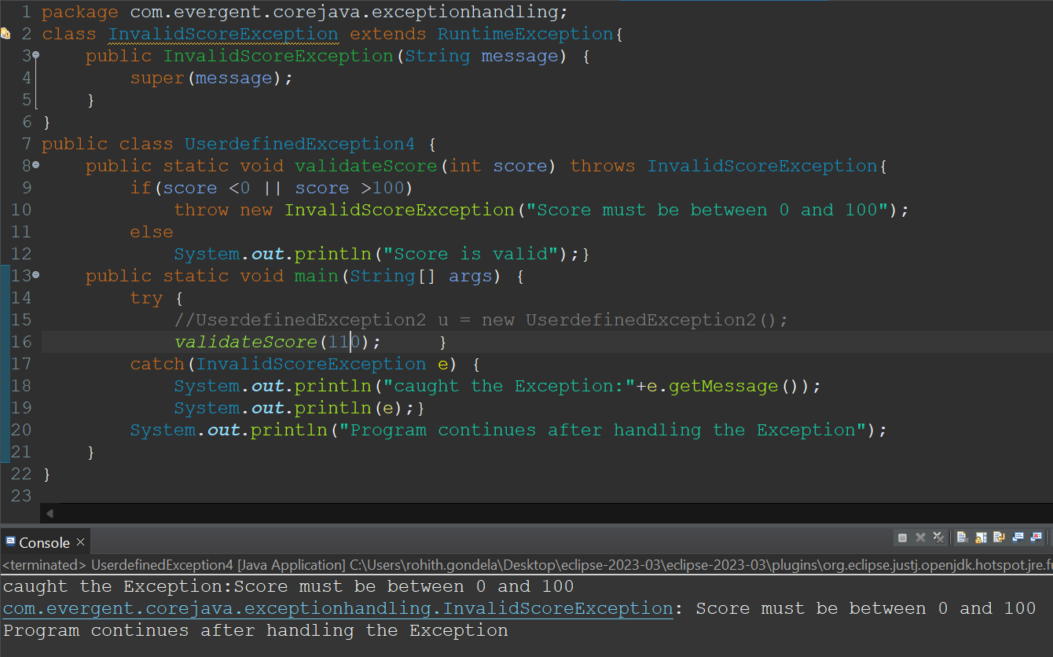

**Program-13: Command Line Arguments**

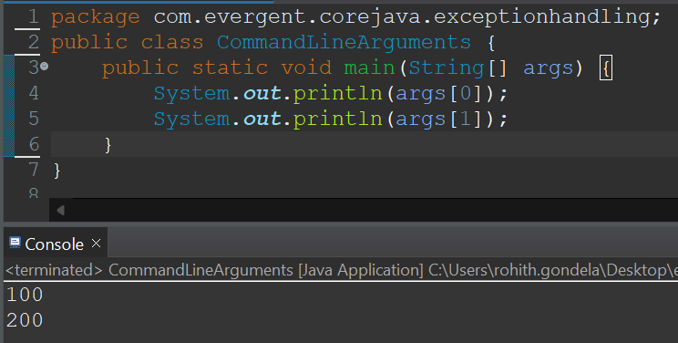

**Program-14:File Not Found Exception**

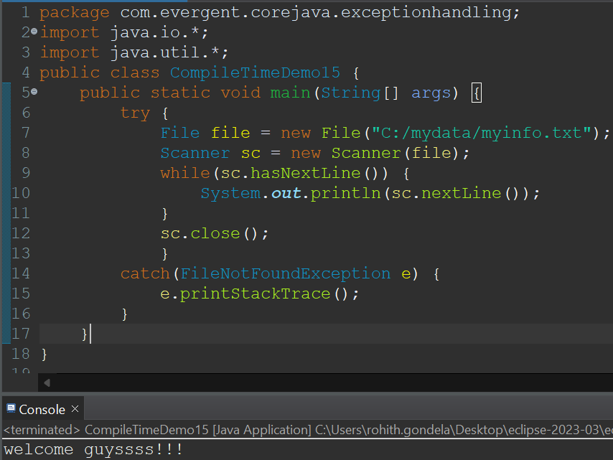

* **Handling Multiple Exceptions using throws keyword**

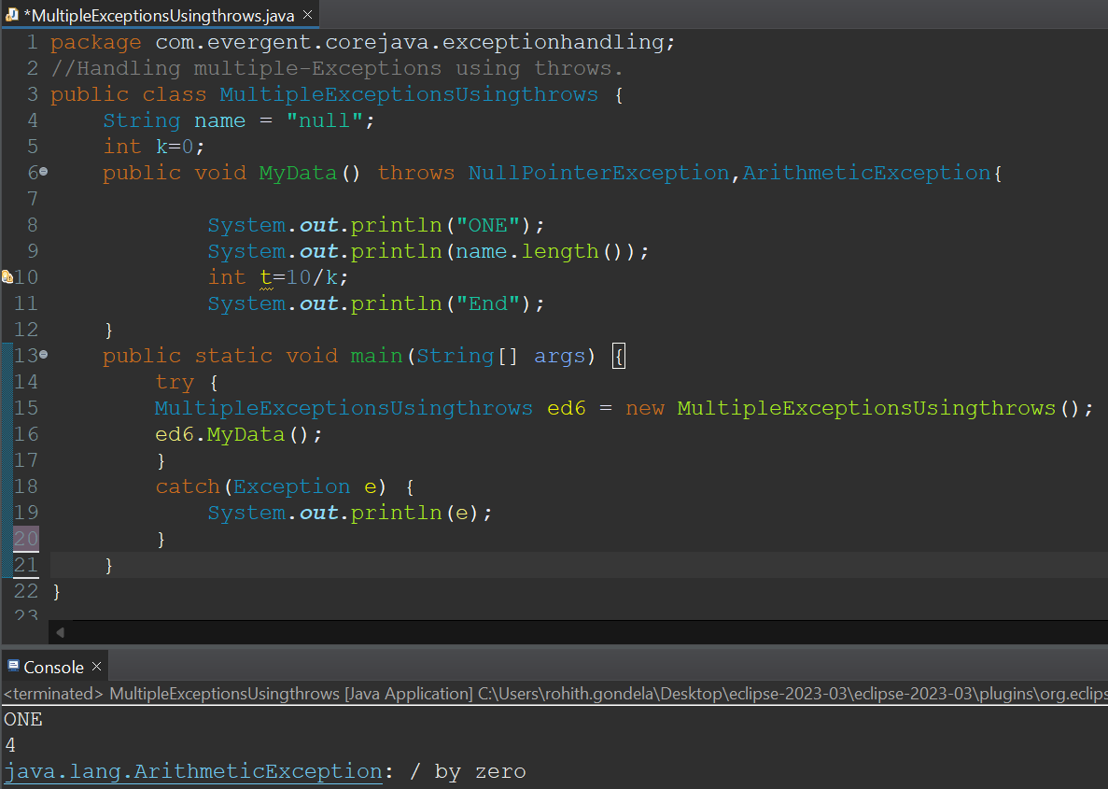

* **Handling Multiple Exceptions using Milti-Catch.**

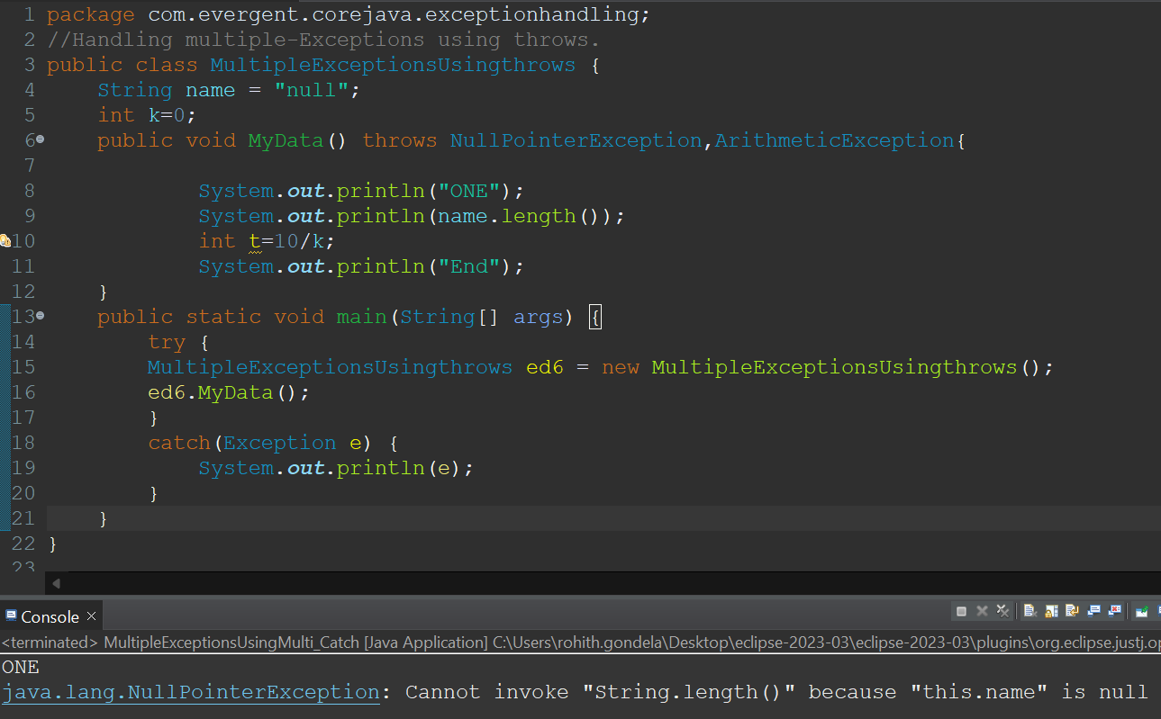

**Day-12 JAVA BEANS 21/8/2024**

* **KEYPOINTS:**
* Java bean is a mechanism.
* Java bean is light weight.
* All attributes are private.
* get/set methods are public.
* Implements java.io.Serializable.
* We can achieve tightly encapsulation through java beans.

**Java beans -Program-1:using getters ans setters.**

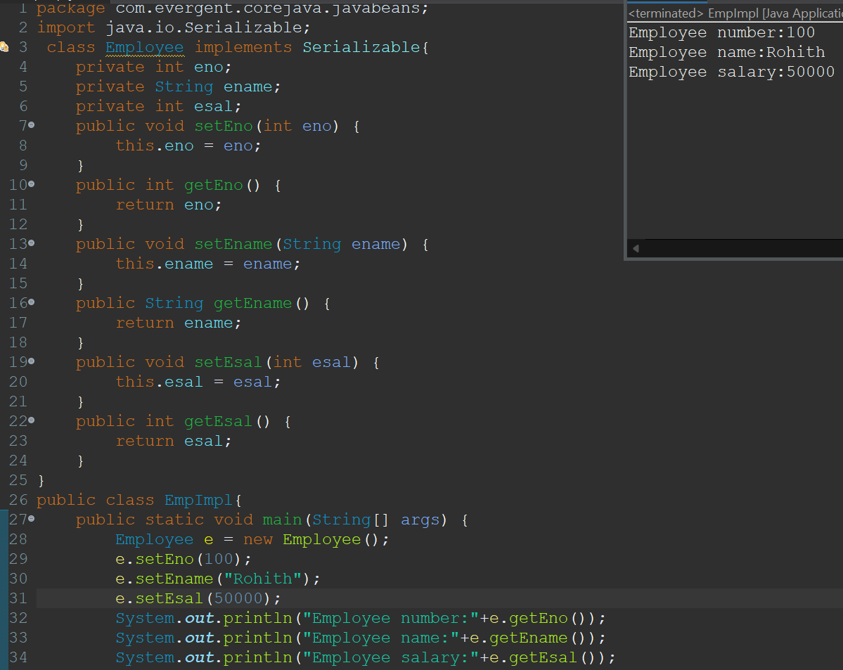

**Java beans -Program-2:using toString().**

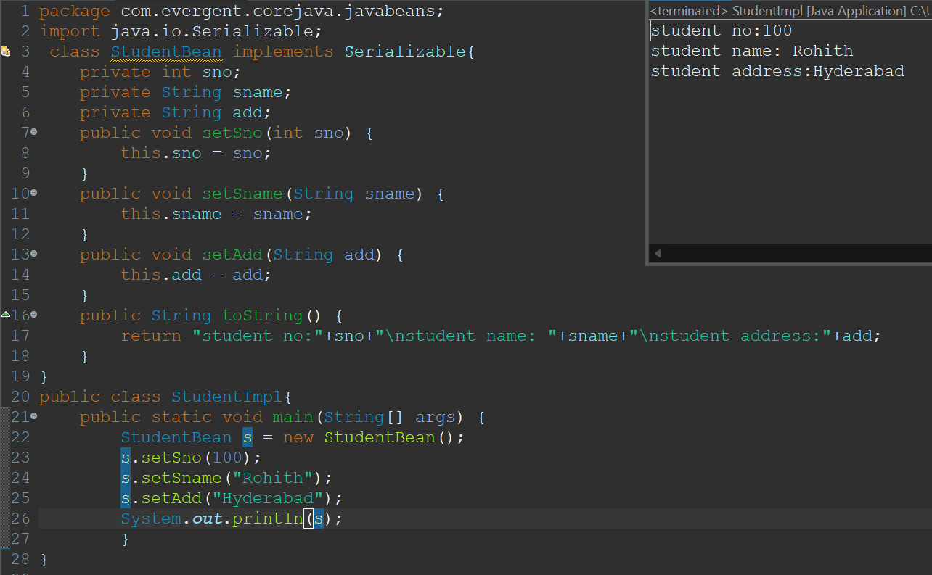

**Java beans -Program-3:using constructor initialization.**

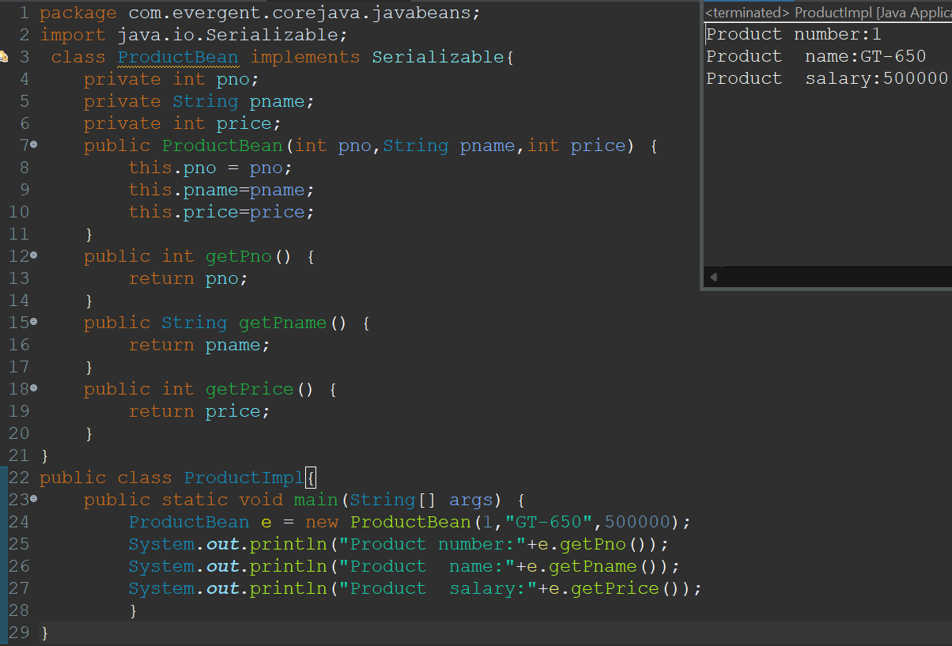

**Stack over flow Error:**

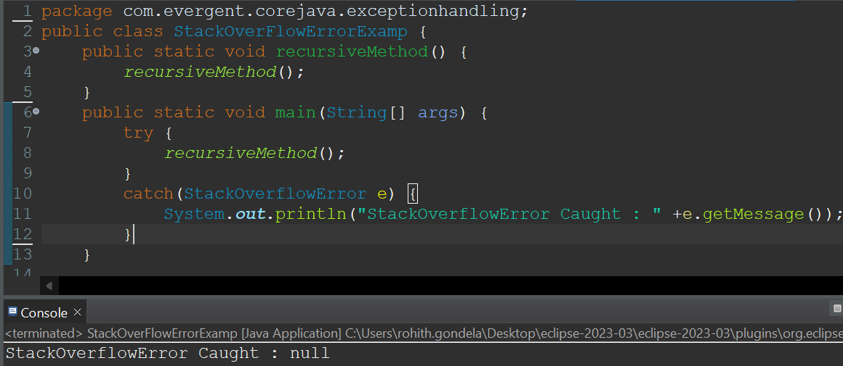

**Out of memory Error:**

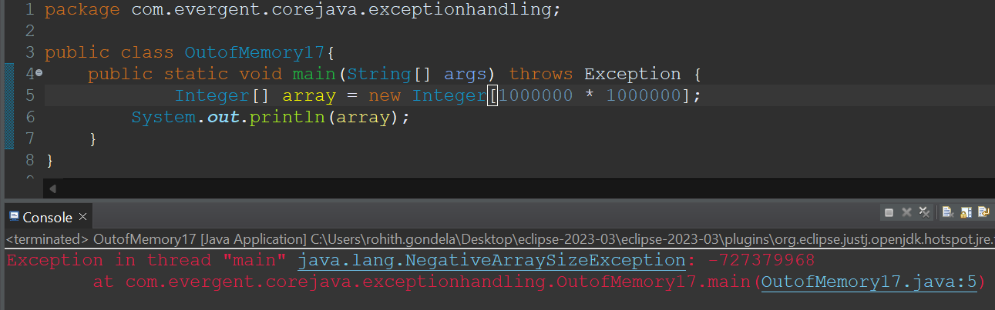

**Day-13 COLLECTION FRAMEWORK 22/8/2024**

Vector(Legacy)

LinkedList

ArrayList

TreeSet

HashSet

<List>

<Set>

**<Collection>**

**KEY POINTS:**

1. Java.util.Collection is the root interface.
2. Advantages:
   1. Size growing
   2. Different data types are storing
   3. Multiple methods

**Program-1: ArrayList**

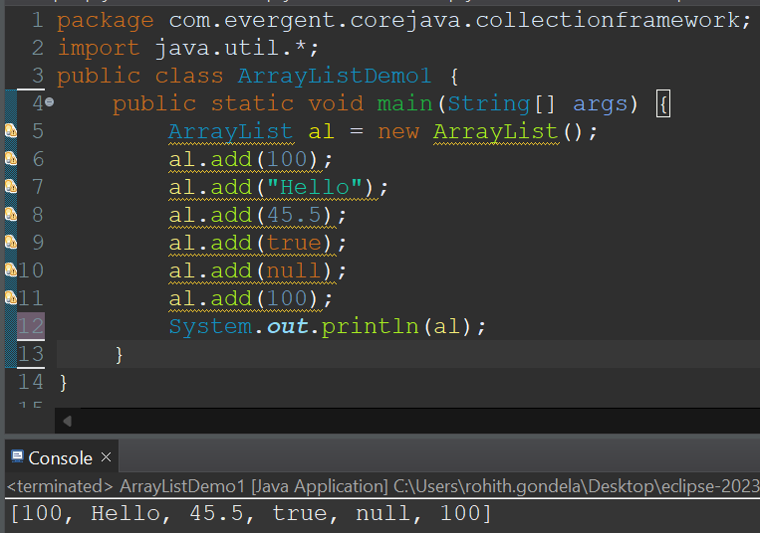

**Program-2: HashSet**

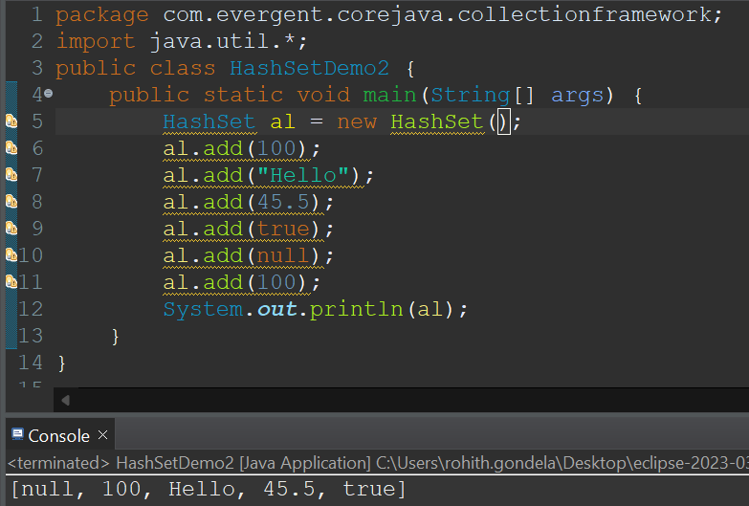

**Retriving the elements from ArrayList Retriving the elements from HashSet**

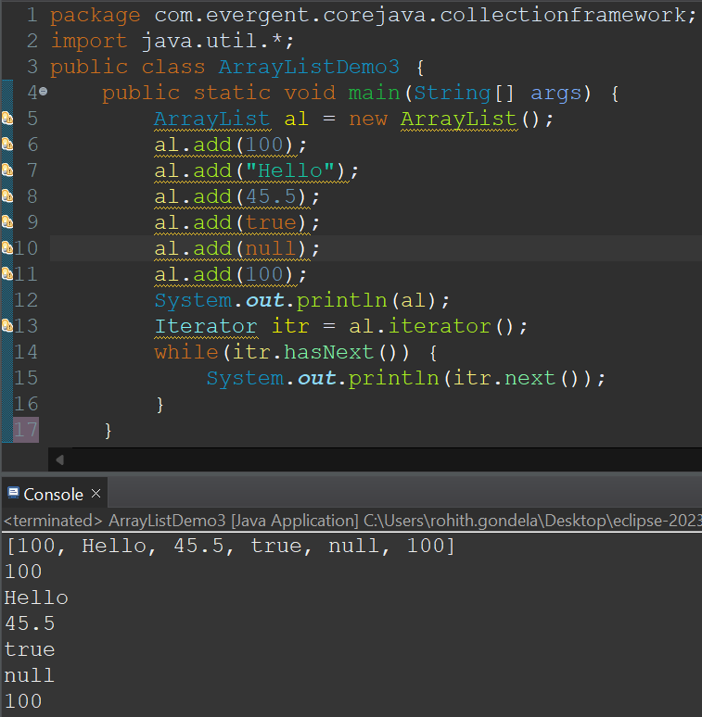 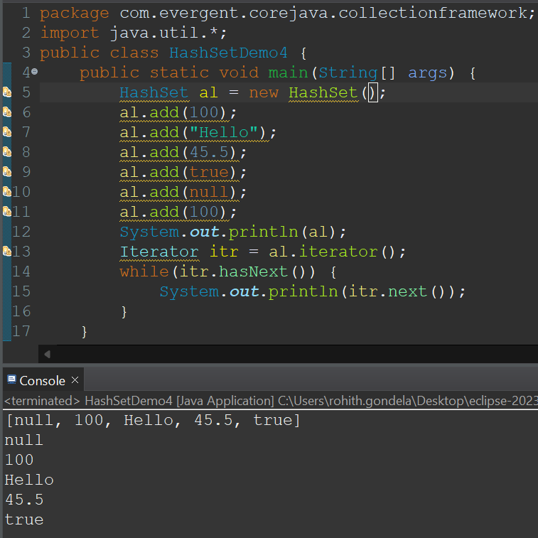

**Program-4:TreeSet**

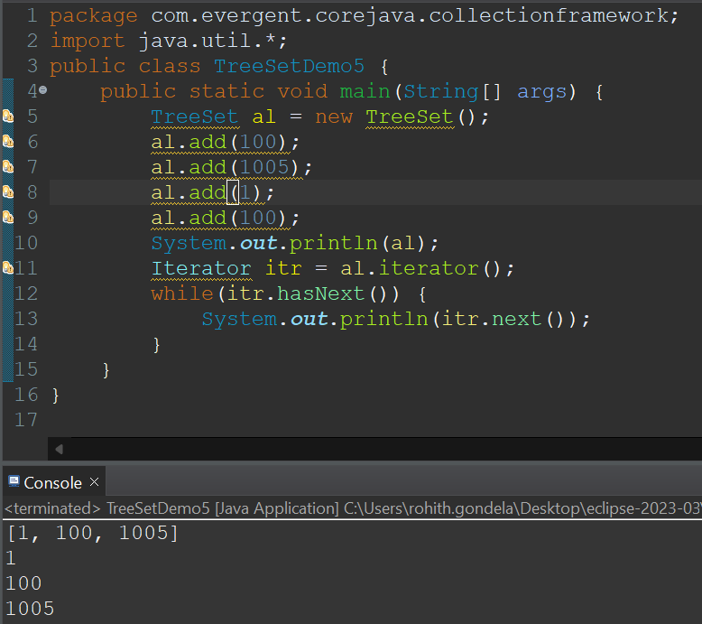

**Day-14 WRAPPER CLASSES 23/8/2024**

**KEY POINTS:**

1. A Wrapper class in Java is a class whose object wraps or contains primitive data types.
2. They convert primitive data types into objects. Objects are needed if we wish to modify the arguments passed into a method (because primitive types are passed by value).
3. The classes in java.util package handles only objects and hence wrapper classes help in this case also.
4. Data structures in the Collection framework, such as [ArrayList](https://www.geeksforgeeks.org/arraylist-in-java/) and [Vector](https://www.geeksforgeeks.org/vector-vs-arraylist-java/), store only objects (reference types) and not primitive types.
5. An object is needed to support synchronization in multi-threading.

**PROGRAM-1: PROGRAM-2:**

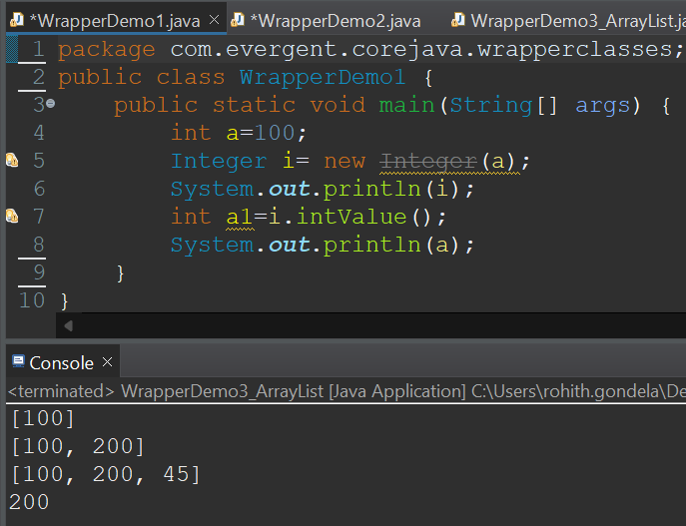 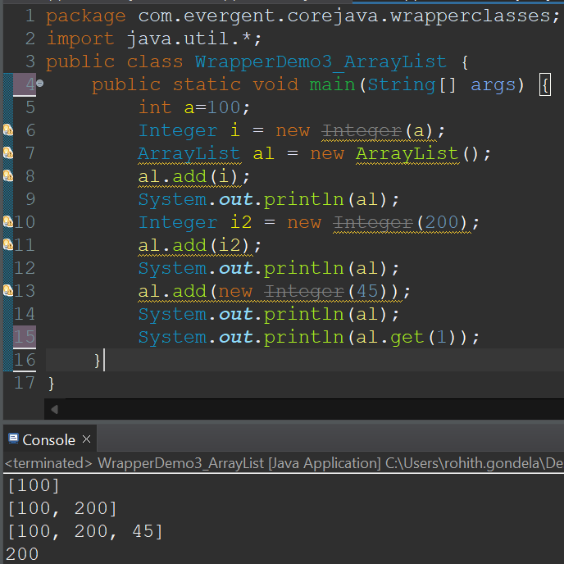

**PROGRAM-3:**

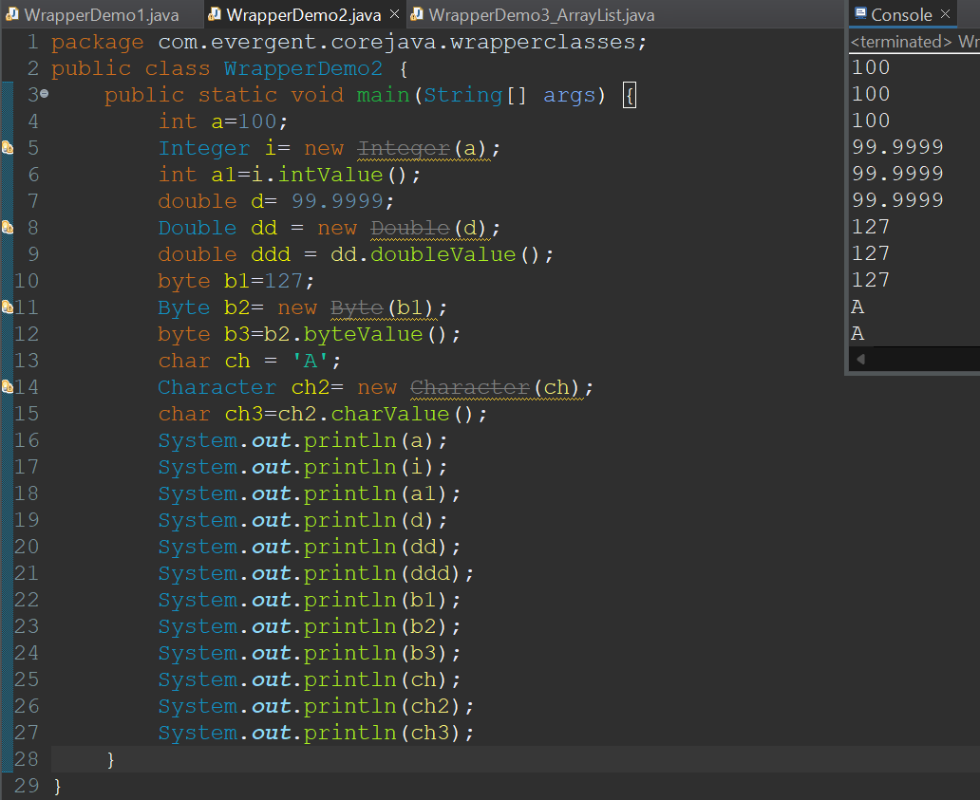

**LIST ITERATOR:**

* It is cursor in Java.
* It can do both transversal(Forward and Backward)
* It has more methods than iterator
* It is better to use compared to iterator and enumeration

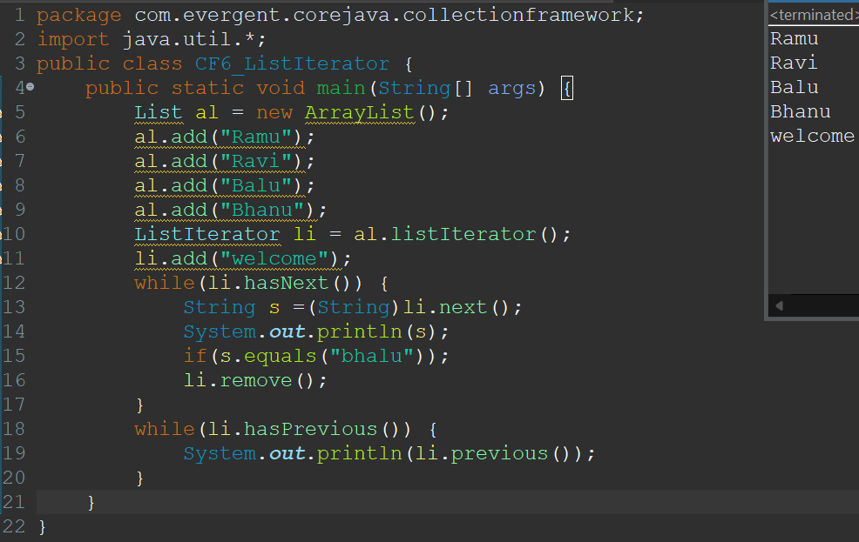

**VECTOR:**

* It is a implementation class for List Interface.
* It is legacy API (jdk-1.0) but not recommended to use.
* Vector is not used because one it is legacy and another reason the size of the vector increase doubly not dynamically like Arraylist.
* The main advantage of vector is Synchronization.Hence it is used in databases and banking security.
* But now instead of vector we have similar alternate way is Synchronized Arraylist.

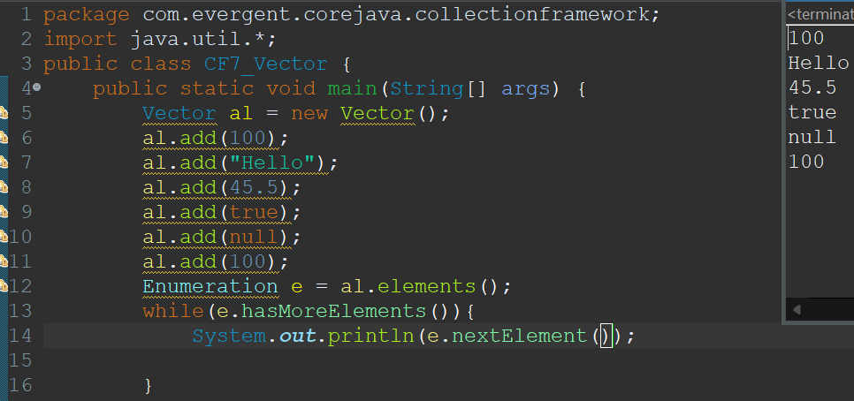

**LINKED LIST:**

A linked list contains a group of elements in a form of nodes.Each node will have three fields,the data field contains data and the link fields contains addresses to previous and next nodes.

LINK DATA LINK LINK DATA LINK LINK DATA LINK

NODE-1 NODE-2 NODE-3

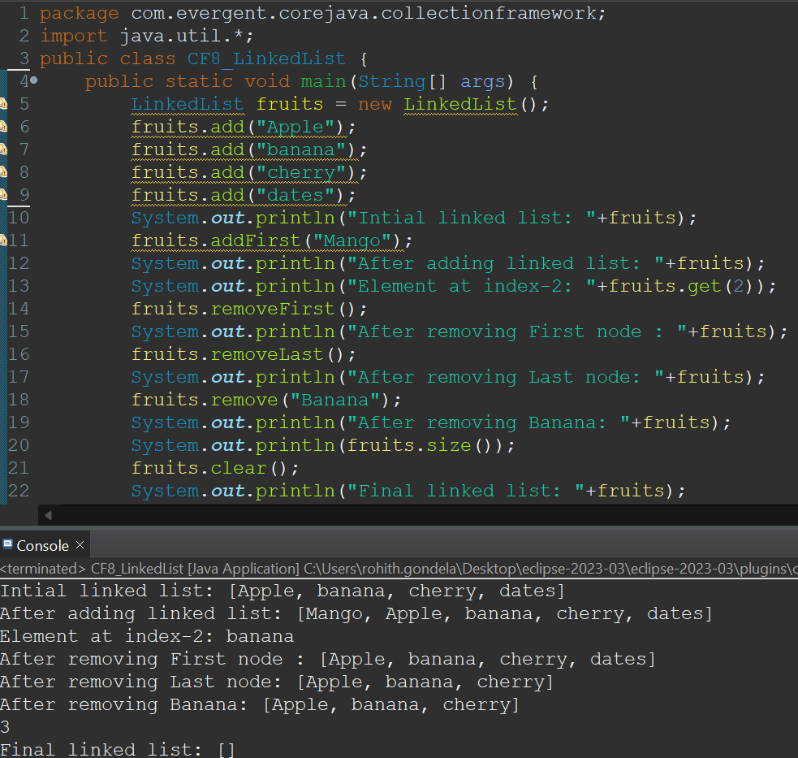

**GENERICS:**

* It was introduced in jdk-1.5.
* If we want to store only one type of data then we can choose Generics.
* Generics only takes wrapper classes.
* It allows only similar data.
* It can be denoted as <>.

Program-1:Using Integer class Program-1:Using String class

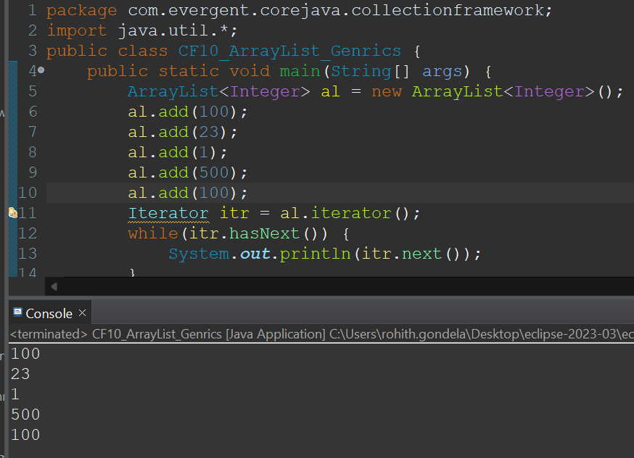 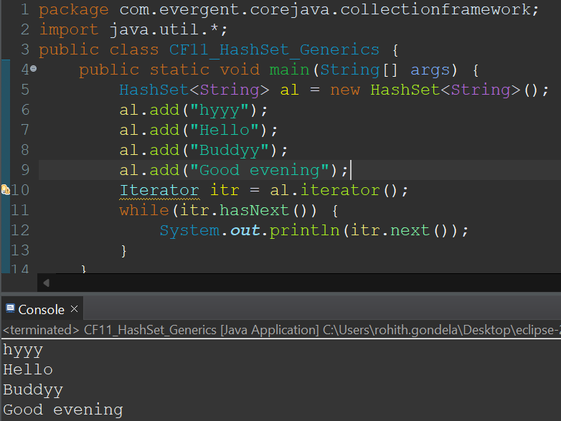

**Another CF-Program with different type**

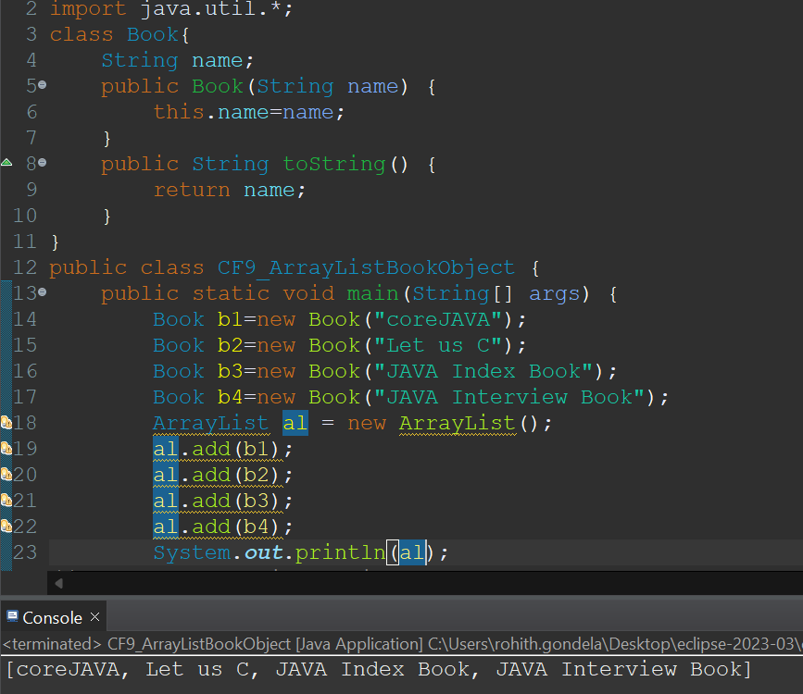

**Day-15 COLLECTION-FRAMEWORK 26/8/2024**

**LINKEDHASHSET:**

* **It is a implementation class for Set interface.**

1.LinkedHashSet Implementation:

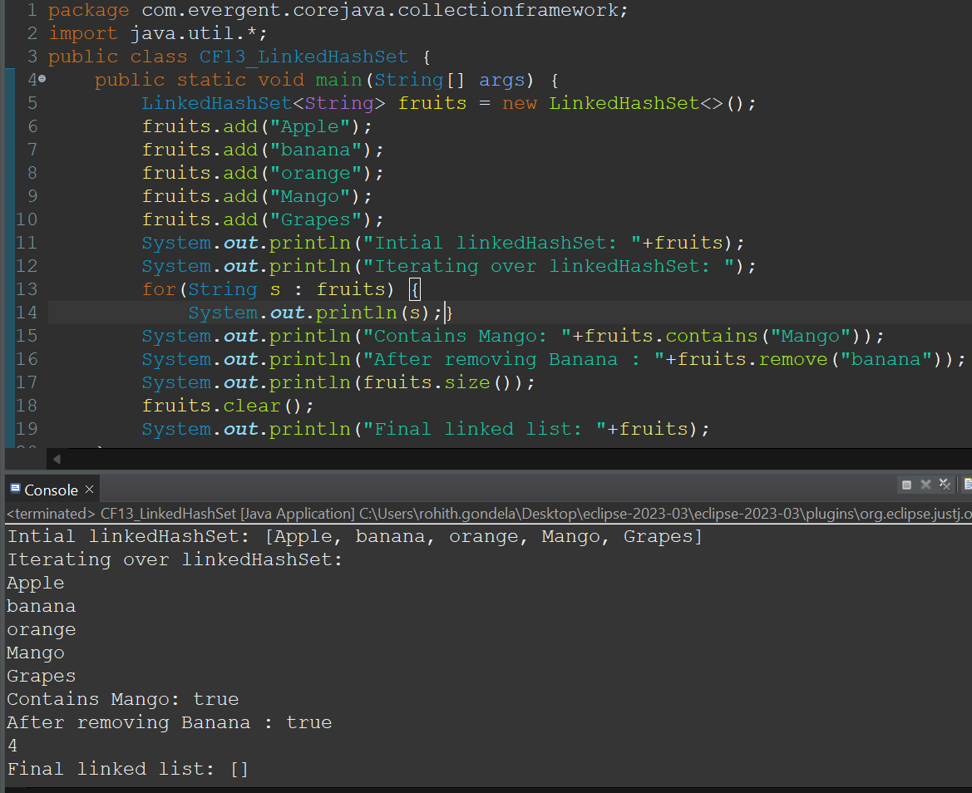

2.ArrayList-HashSet Implementation:

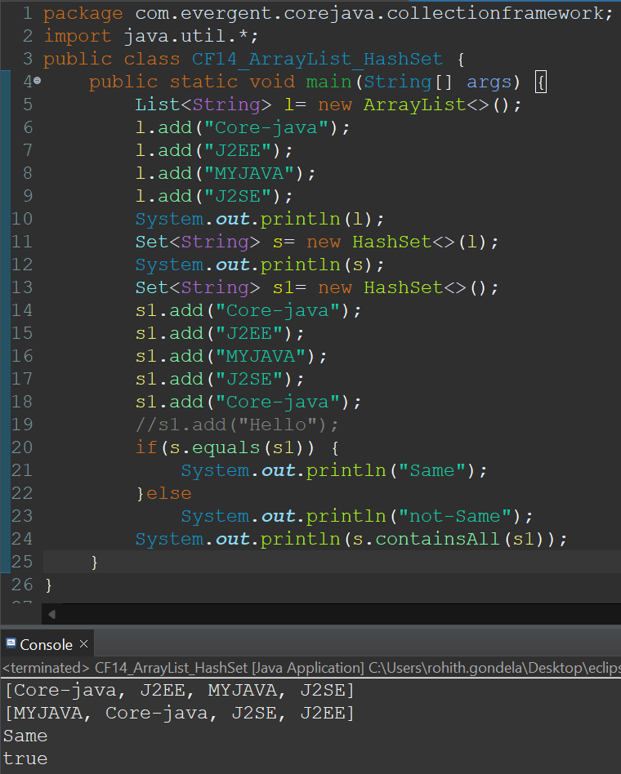

**STACK:**

1. The class is based on the basic principle of last-in-first-out.
2. In addition to the basic push and pop operations, the class provides three more functions of empty, search, and peek.
3. The Stack class extends Vector and provides additional functionality specifically for stack operations, such as **push, pop, peek, empty,**and **search**.
4. The Stack class can indeed be referred to as a subclass of Vector, inheriting its methods and properties.

**Program-1: Program-2:**

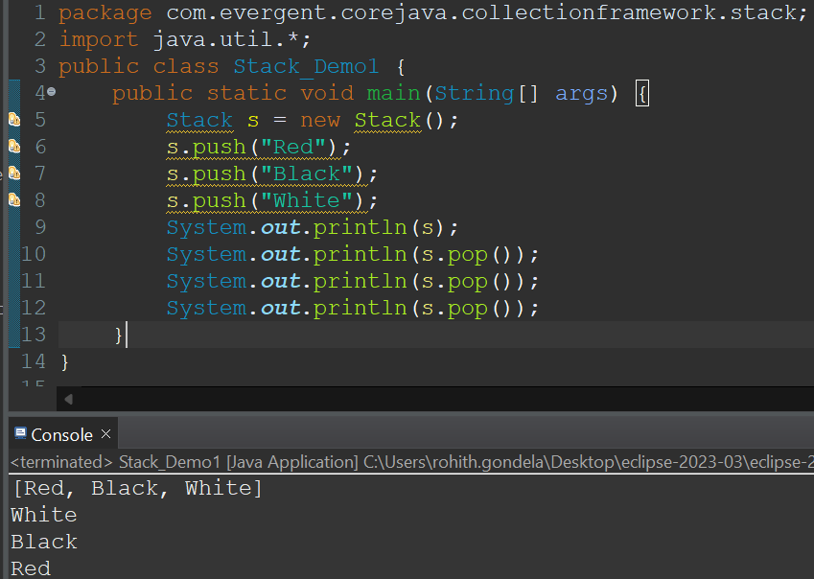 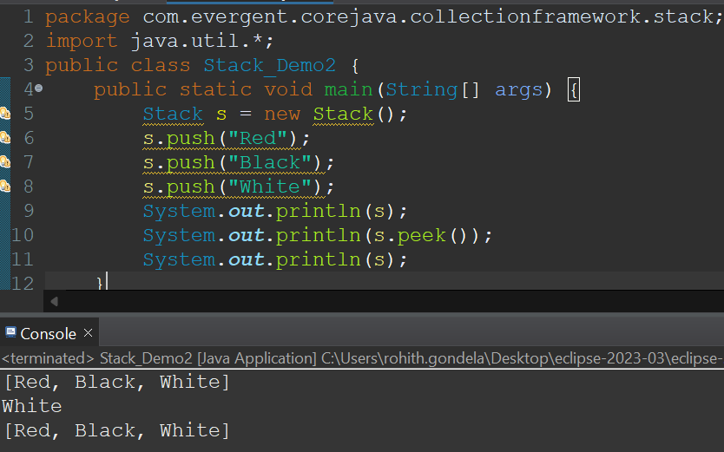

**Program-3: Program-4:**

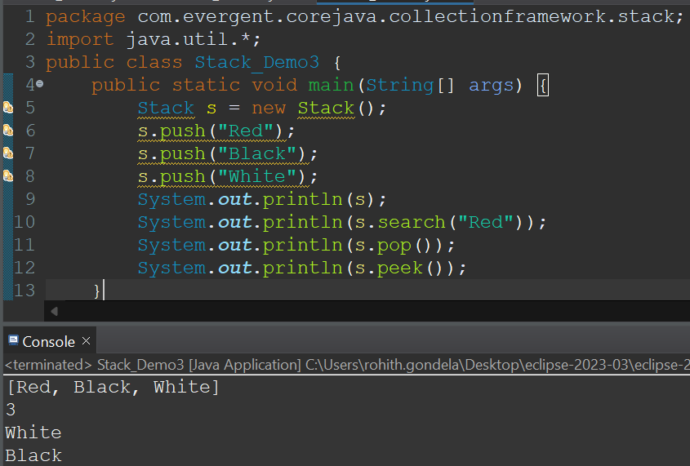 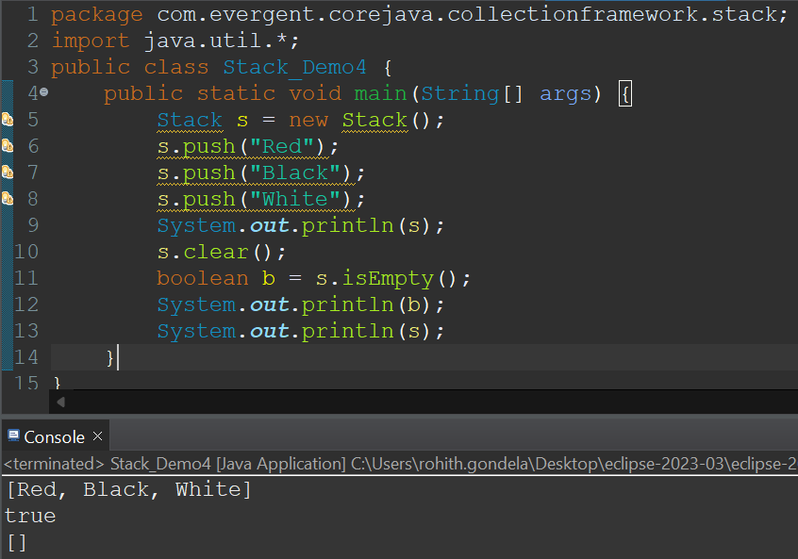

**Program-5:**

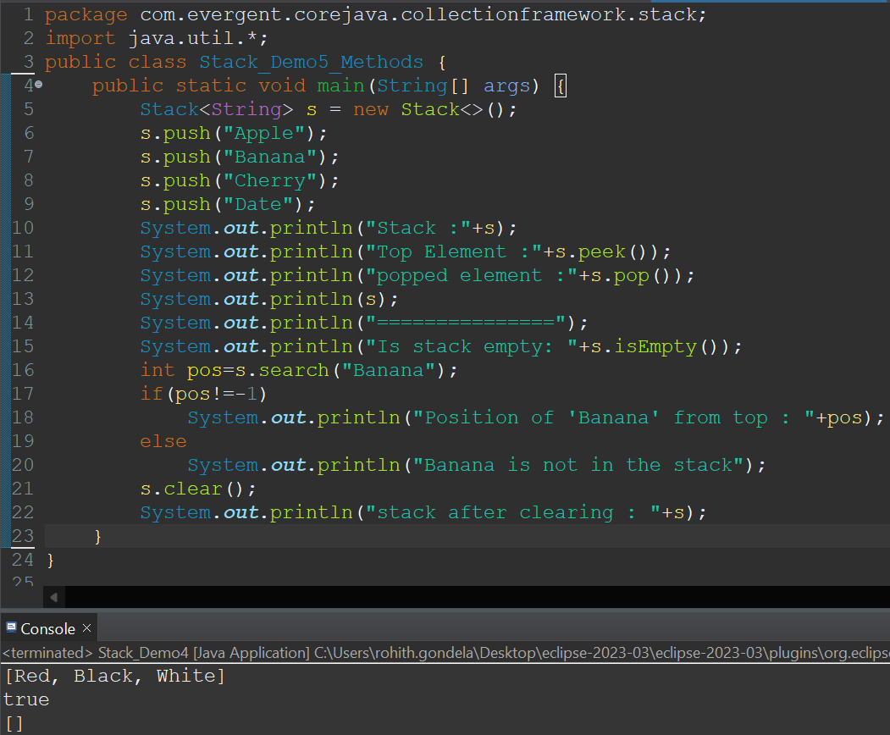

**QUEUE:**

* The **Queue Interface** is present in [java.util](https://www.geeksforgeeks.org/java-util-package-java/) package and extends the [Collection interface](https://www.geeksforgeeks.org/collections-in-java-2/) is used to hold the elements about to be processed in FIFO(First In First Out) order.
* Queue has 2 implementation classes.
  + Priority Queue-(size-11)
  + LinkedList
* neither of these implementations is thread-safe.
* [PriorityBlockingQueue](https://www.geeksforgeeks.org/priorityblockingqueue-class-in-java/) is one alternative implementation if the thread-safe implementation is needed.

**Program-1:**

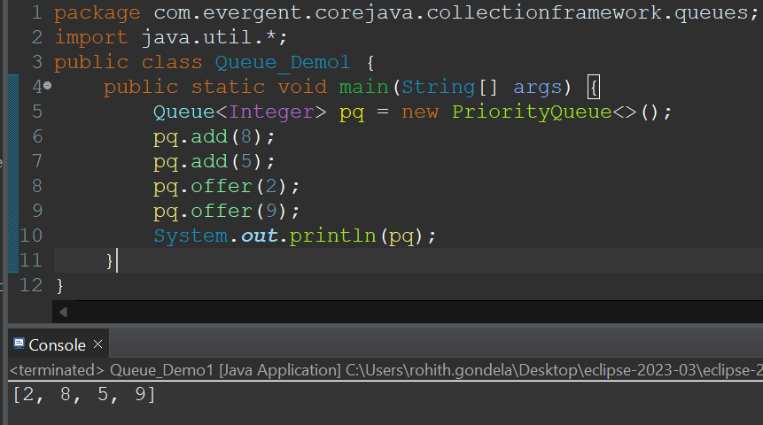

**Program-2: Program-3:**

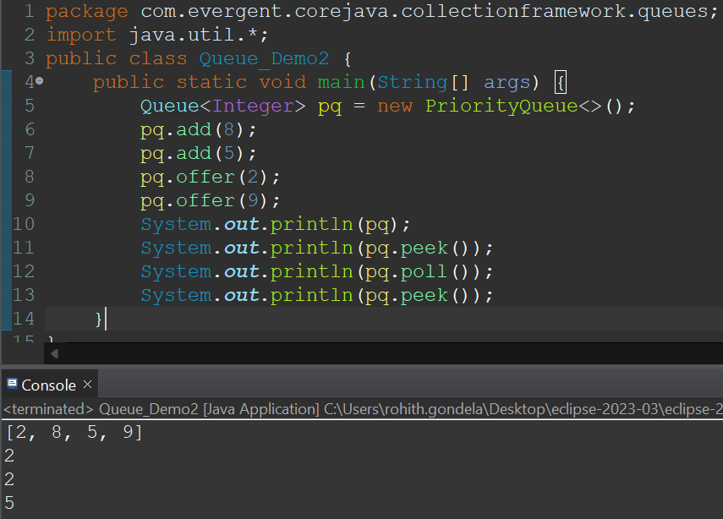 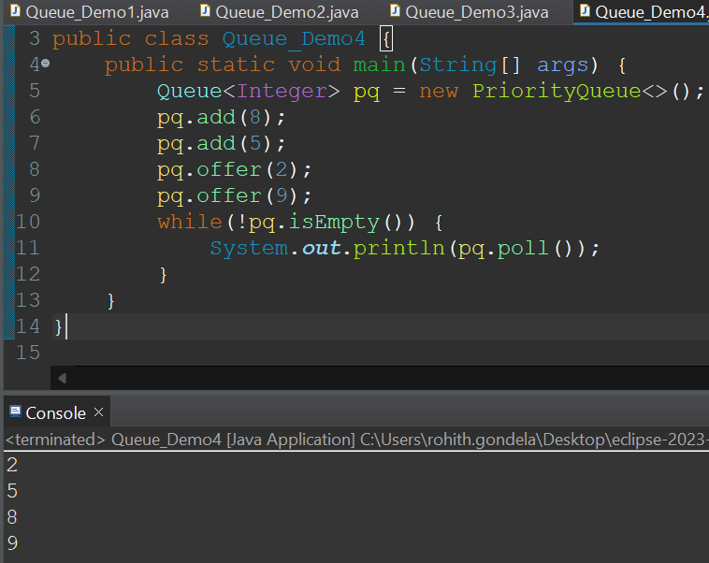

**Program-4:**

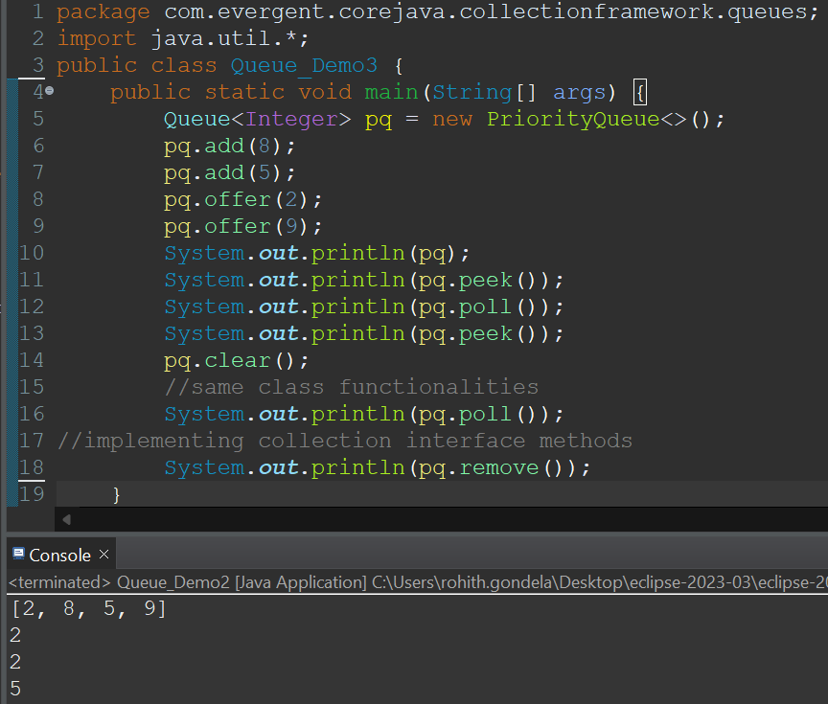

**Program-6:using multiple iterations**

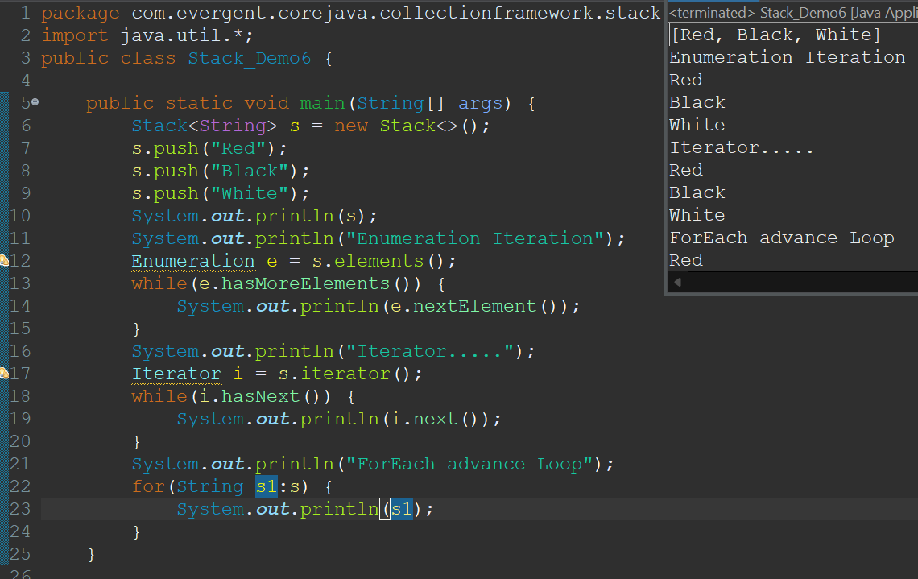

**Day-16 COLLECTION-FRAMEWORK 27/8/2024**

**<SET>**

**<COLLECTION>**

**<QUEUE> <LIST>**

**PRIORITY QUEUE <DEQUE>**

(size-11)

**ARRAYDEQUE LINKEDLIST**

**DEQUE:**

1. DEQUE stands for double ended queue.
2. We can add and delete at both ends.
3. Here we can achieve FIFO compare to Priority queue.
4. The default size of Double Ended Queue is 17.

**ARRAYDEQUE:**

**Program-1:**

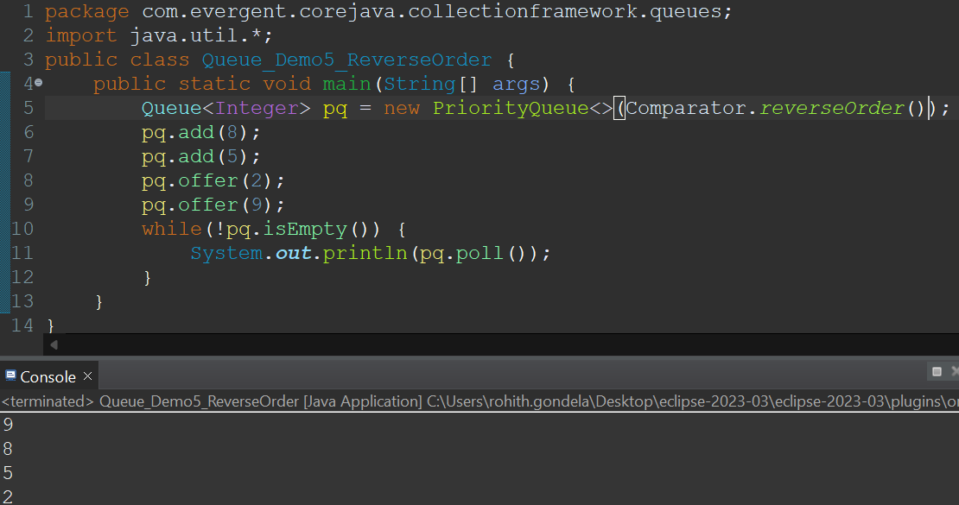

**Program-2:**

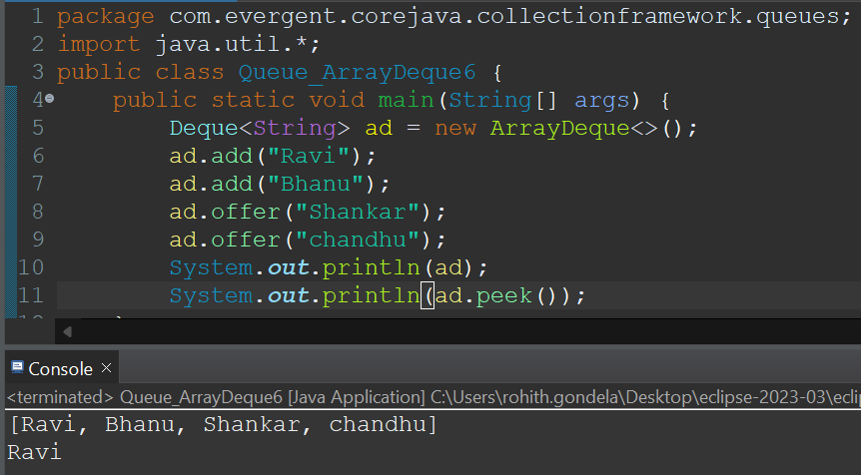

**Program-3: Program-4:**

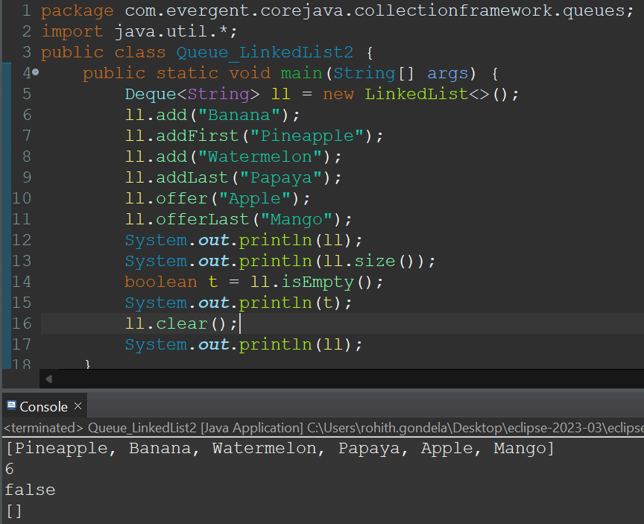 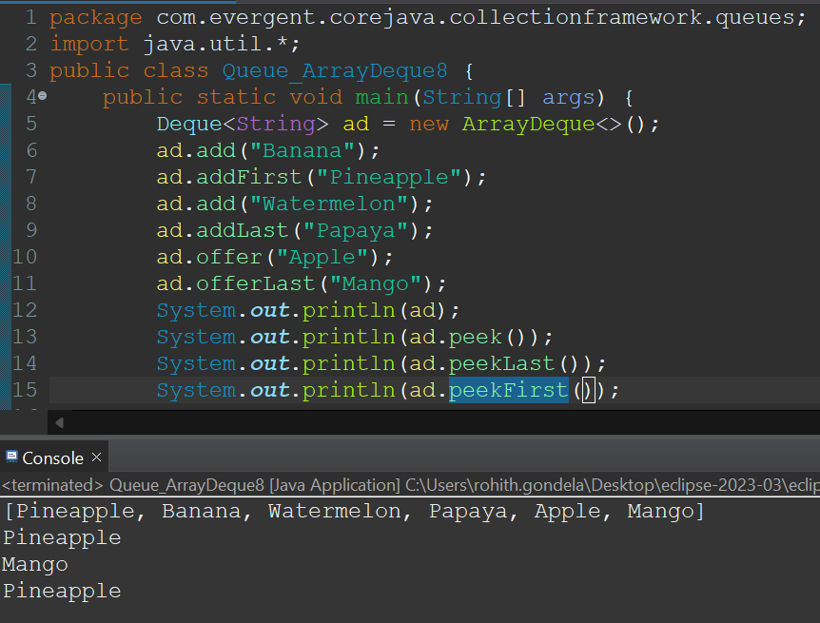

**Program-5:**

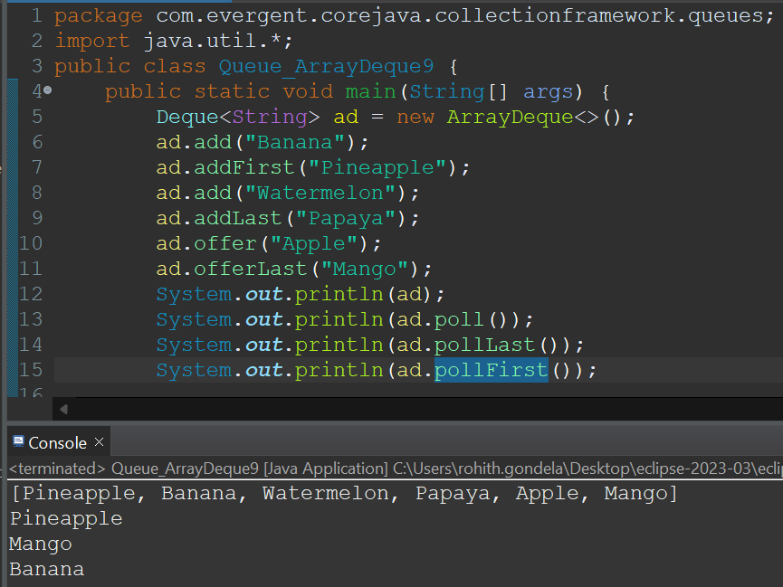

**LINKEDLIST:**

**Program-1:**

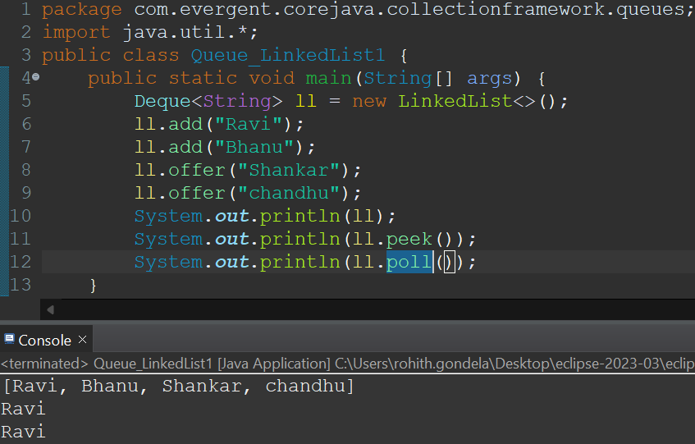

**Program-2:**

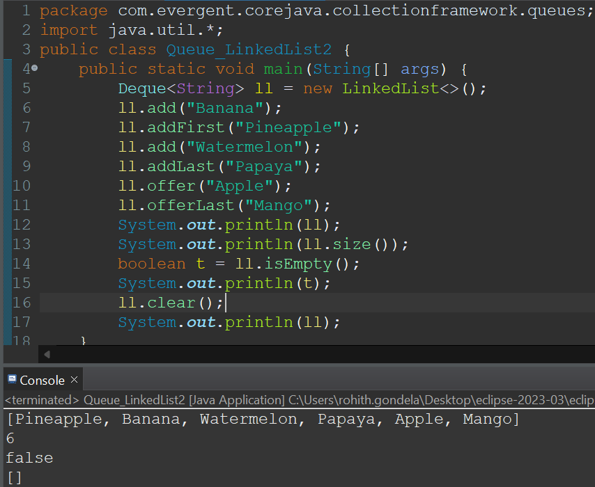

**Program-3:**

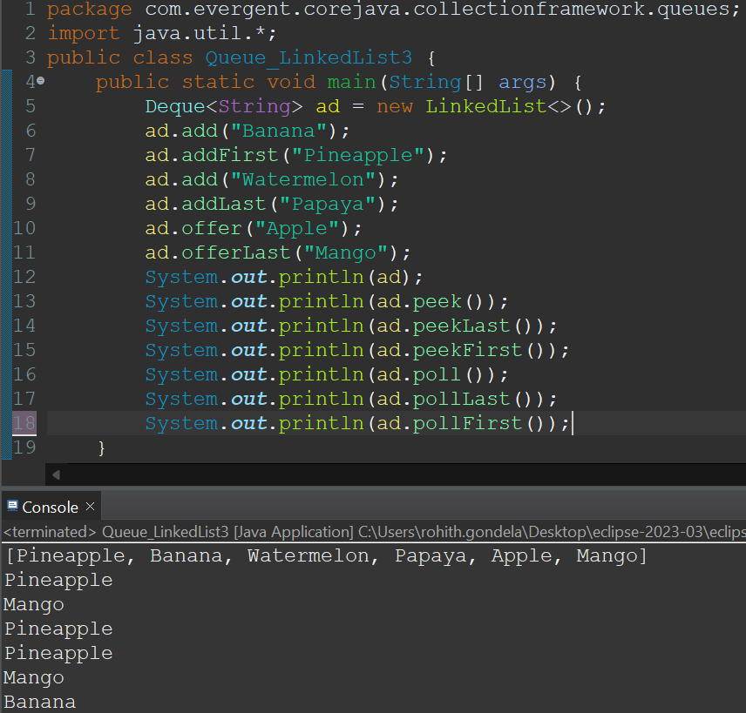

**Day-17 COLLECTION-FRAMEWORK 28/8/2024**

* **Variable Life time:**

Life time refers to the duration which a variable exists in memory.

**Local variables:** scope of the local variables is method or block. It is stored in stack segment.

**Instance variables:** Instance variables exists as long as the object belong to exists.It is stored in stack segment.

**Static variables :** As long as class is loaded in memory.It is stored in method Area.

* **Type Casting:**

There are 2 types of casting

1. Primitive
2. Object

These 2 types has another 2 types casting

1. Widening(Implicit)----> Small to large(Automatic)
2. Narrowing (Explicit)--->Large to Small(Here we can loss the data.)

**Program-1:**

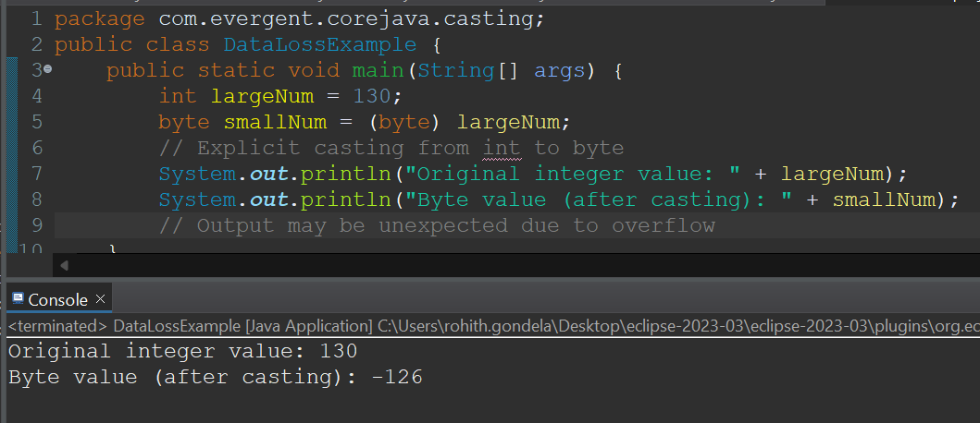

**Program-2:**

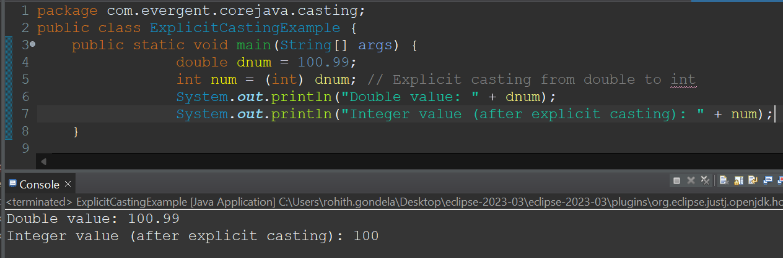

**Program-3:**

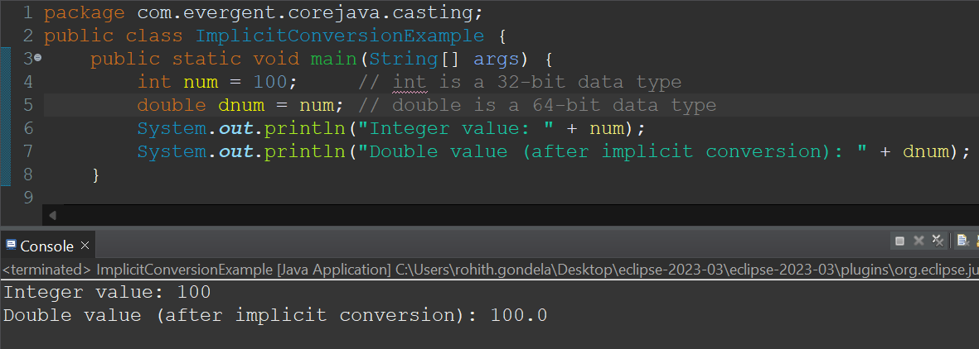

* **MAP-INTERFACE:**

**<Collection>**

**<Map>**

**Hashtable HashMap TreeMap**

**[**No null keys **[**Allowed null **[**For sorted values**]**

And values**]** keys and values**]**

**[**Unordered list**]**

**[** Keys can’t duplicate **]**

**HashMap-program-1: Hashtable-program-2:**

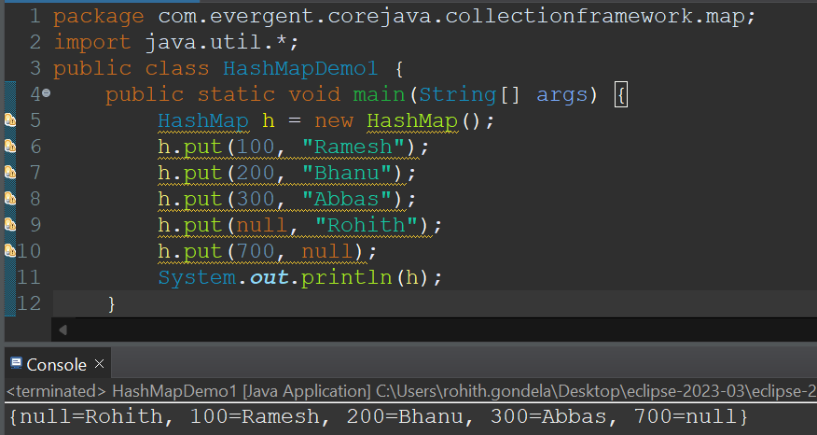 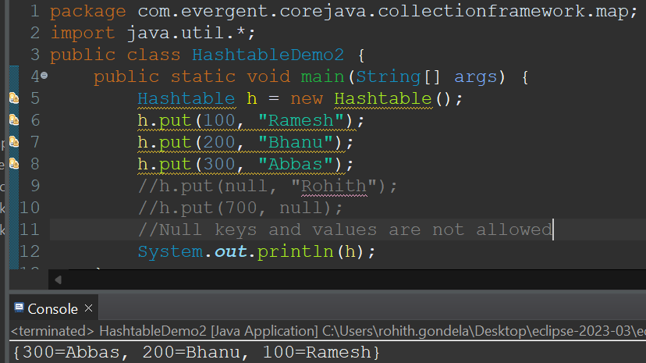

**HahMap program-3: TreeMap program-4:**

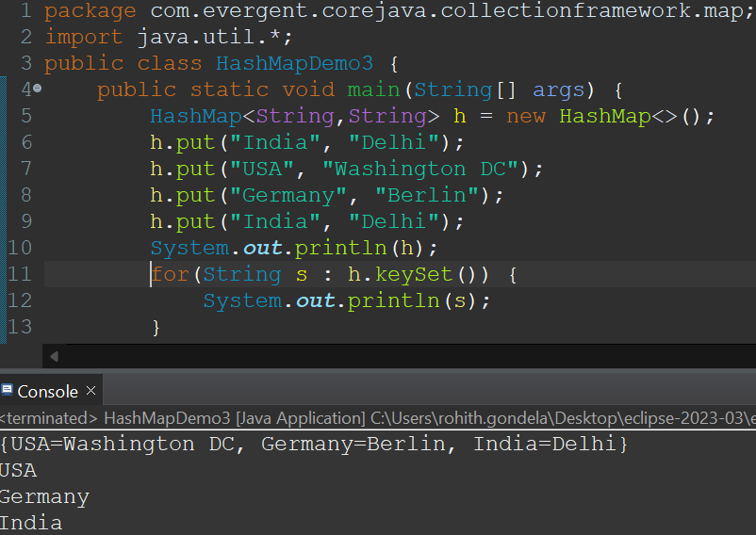 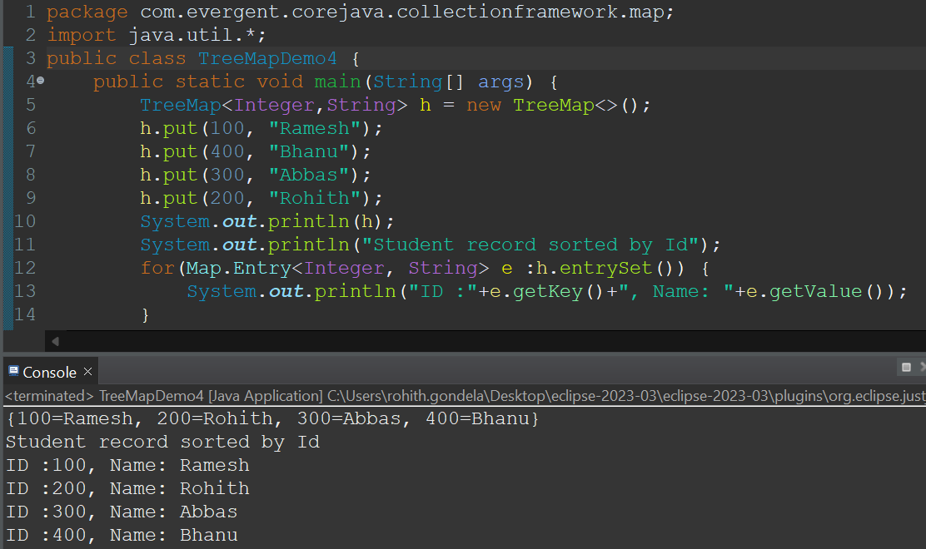

* **MULTI-THREADING:**

**Life cycle of a Thread**

**New born stage**

**Start() stop()**

**Dead Stage**

**isAlive() run()**

**Yeild()**

**Join()**

**Stop()**

**Runnable**

**Running**

**Suspend() resume()**

**Sleep() notify()**

**Wait() notifyAll()**

**Stop()**

**Block stage**

**Start():** start() method is used in it to invoke the run method in the running state.

**Runnable:** Thread scheduler picks the thread and assigns the time duration of the task.  
**Running:**Thread is on running start .Thread is executing the tasks.  
 **Blocked:**if the thread is under suspend(),wait(),sleep() states it comes under blocked state.  
**Dead:**if the execution is stopped or completed it comes under dead state.

**Methods in Multi-Threading:**  
**yield():**If a thread completes the task within the allocated time duration the remaining time is given to the next priority thread.  
 **sleep()-**sleep methods stops the exceution for particular given duration period.  
 **resume()-**resume method to resume the execution of thread from blocked state to running state.

**Synchronization:**  
 Executes thread one by one simultaneously.  
 Synchronization is possible in only method blocks.

**Program-1: Program-2:**

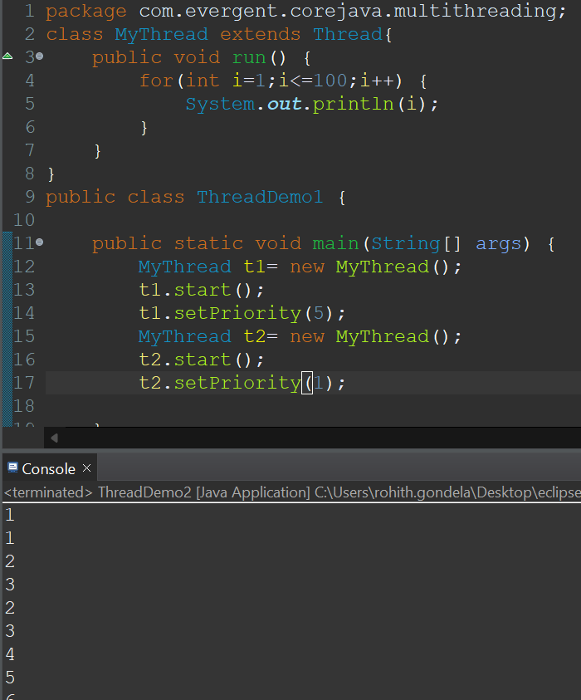 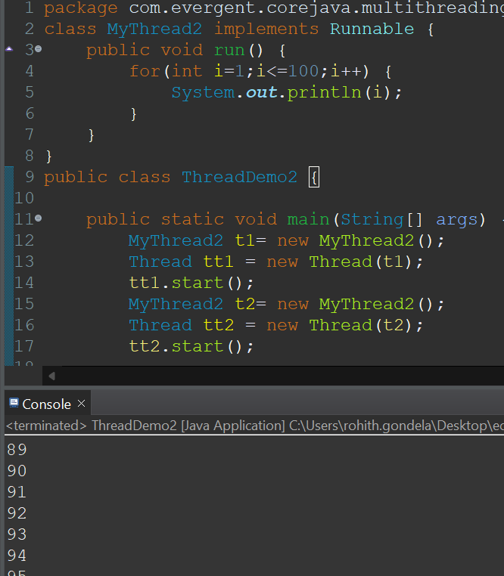

**Program on Synchronization:**

//implementation of a producer and consumer.

class Q {

int n;

boolean valueSet = false;

synchronized int get() {

if(!valueSet)

try {

wait();

} catch(InterruptedException e) {

System.out.println("InterruptedException caught");

}

System.out.println("Got: " + n);

valueSet = false;

notify();

return n;

}

synchronized void put(int n) {

if(valueSet)

try {

wait();

} catch(InterruptedException e) {

System.out.println("InterruptedException caught");

}

this.n = n;

valueSet = true;

System.out.println("Put: " + n);

notify();

}

}

class Producer implements Runnable {

Q q;

Producer(Q q) {

this.q = q;

new Thread(this, "Producer").start();

}

public void run() {

int i = 0;

while(true) {

q.put(i++);

}

}

}

class Consumer implements Runnable {

Q q;

Consumer(Q q) {

this.q = q;

new Thread(this, "Consumer").start();

}

public void run() {

while(true) {

q.get();

}

}

}

public class SynchronizedDemo {

public static void main(String[] args) {

Q q = new Q();

new Producer(q);

new Consumer(q);

System.out.println("Press Control-C to stop.");

}

}

**OUTPUT:**

Put: 207066

Got: 207066

Put: 207067

Got: 207067

Put: 207068

Got: 207068

Put: 207069

Got: 207069

Put: 207070

Got: 207070

Put: 207071

Got: 207071

Put: 207072

Got: 207072

Put: 207073

Got: 207073

Put: 207074

Got: 207074

Put: 207075

Got: 207075

Put: 207076

**Day-18 ARRAYS CLASS AND COLLECTIONS CLASS 29/8/2024**

**Collection class:**

Collections class in Java is one of the utility classes in Java Collections Framework. The **java.util package** contains the Collections class in Java. Java Collections class is used with the static methods that operate on the collections or return the collection. All the methods of this class throw the **NullPointerException** if the collection or object passed to the methods is null.

**Methods in Collections Class:**

* **Sort():** Sort the elements in the given List**.**
* **Reverse() :** reverse the elements in the given List.
* **Shuffle():**shuffle the elements in the given List.
* **Max():** Finds the maximum element.
* **Min():** finds the minimum element.
* **Fill():** Fills the all elements with the given element.
* **Copy():** copying the elements from one list to another list.
* **replaceAll():** replace the element with the given element.
* **synchronizedList()**(Vector replacemet)**:** returns a synchronized (thread-safe) list backed by the

specified list.

* **synchronizedMap()**(Hashtable replacemet)**:**returns a synchronized (thread-safe) map backed by the specified map.

**Program-1:**

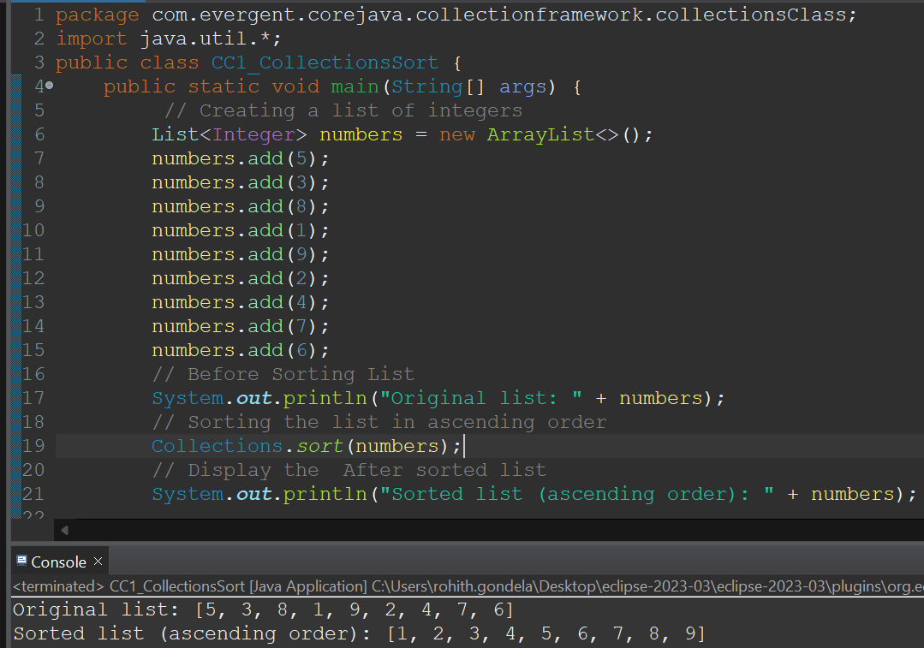

**Program-2:**

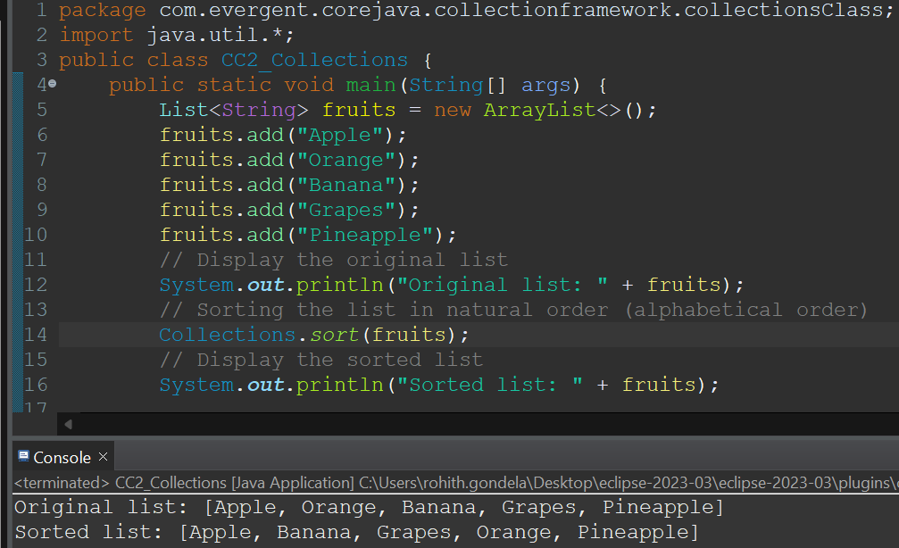

**Program-3:**

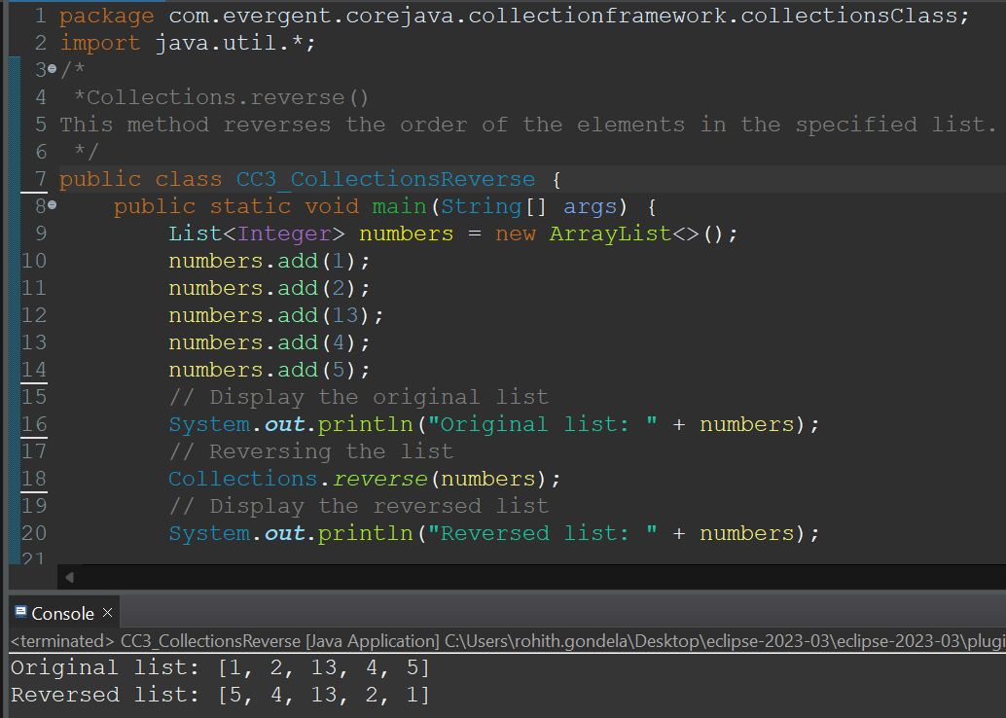

**Program-4:**

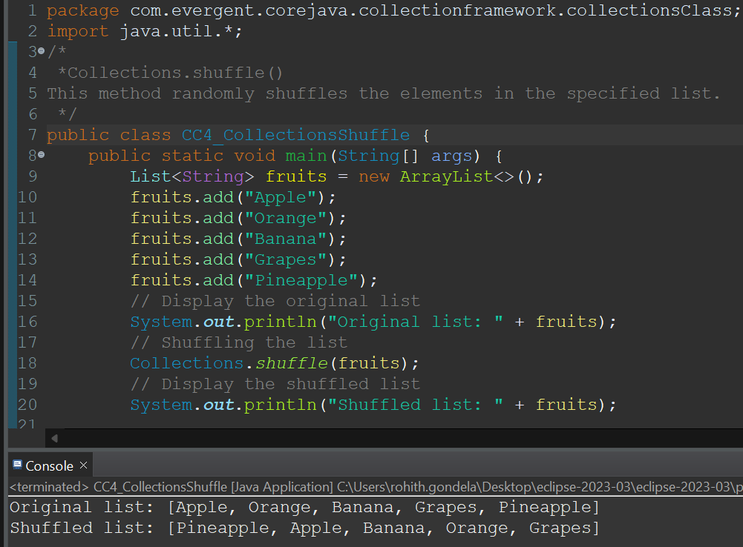

**Program-5:**

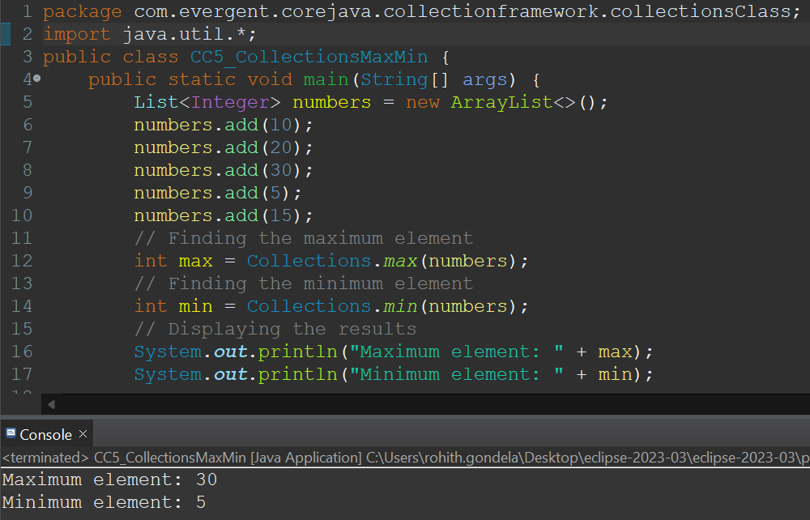

**Program-6:**

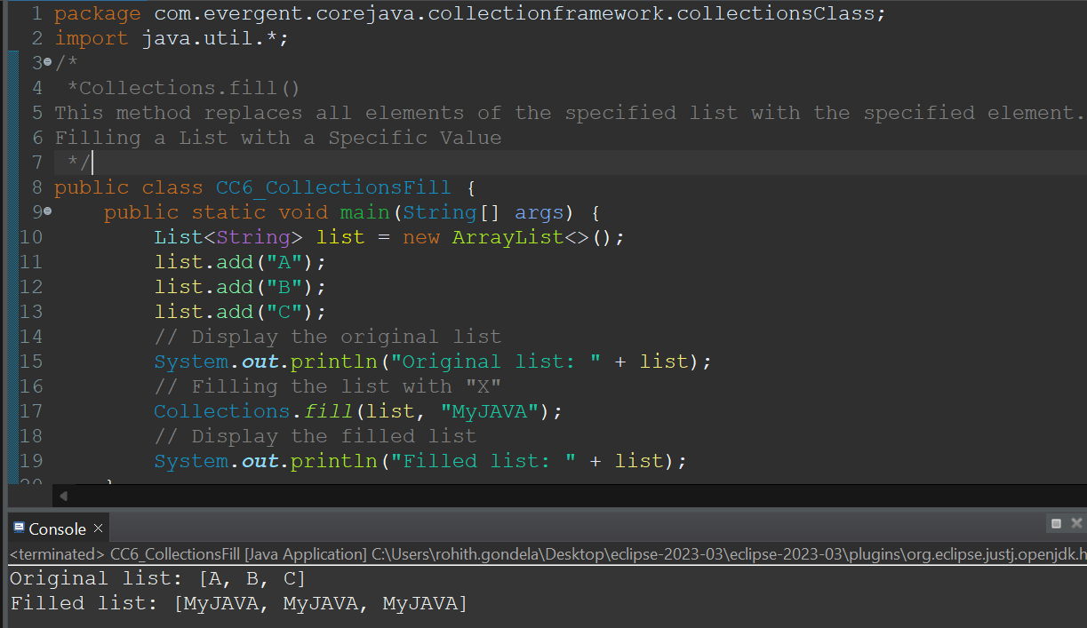

**Program-7:**

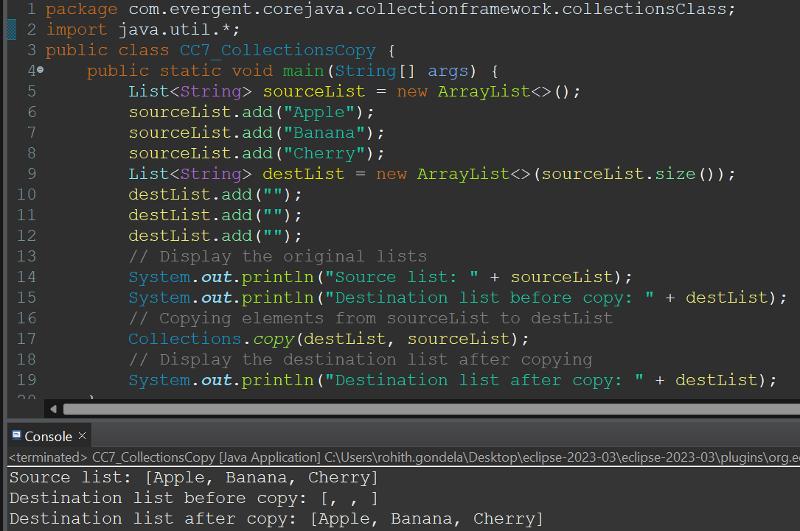

**Program-8:**

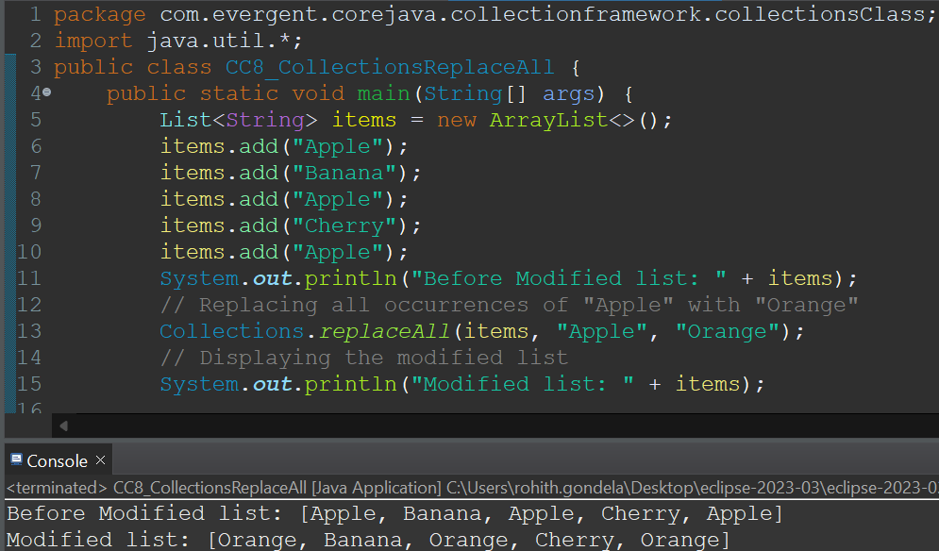

**Program-9:**

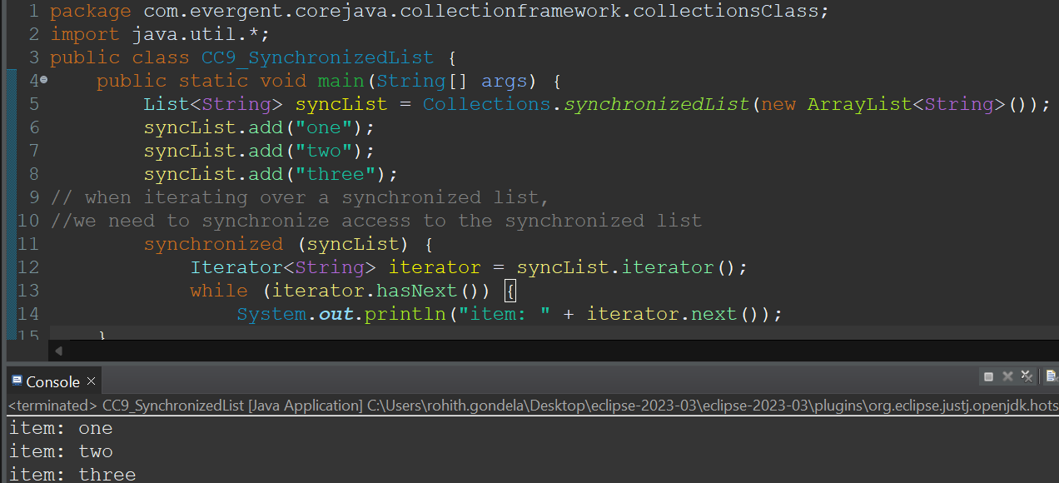

**Program-10:**

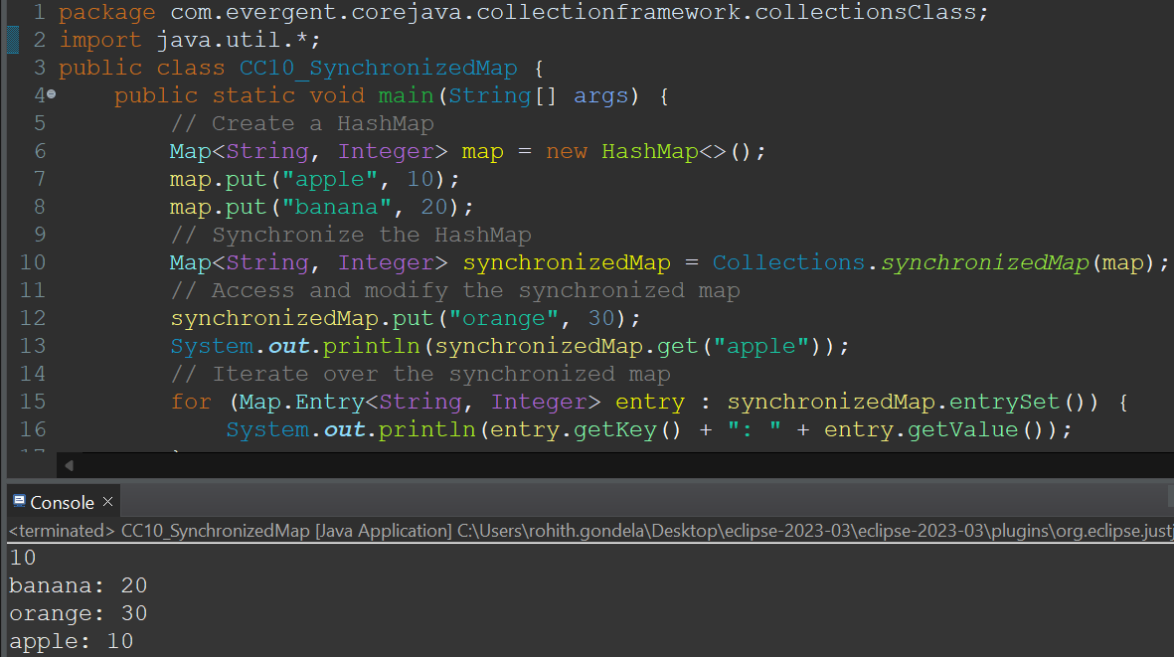

* **ARRAYS CLASS:**

The Arrays class in **java.util package** is a part of the Java Collection Framework. This class provides

**static methods** to dynamically create and access Java arrays. It consists of only static methods and the methods of Object class. The methods of this class can be used by the class name itself.

**Methods in ArraysClass:**

* **Sort():** Sort the elements in the given List**.**
* **Fill():** Fills the all elements with the given element.
* **Copy():** copying the elements from one list to another list.
* **asList():** Returns a fixed-size list backed by the specified Arrays.
* **toString()**: It returns a string representation of the contents of this array. The string representation consists of a list of the array’s elements, enclosed in square brackets (“[]”). Adjacent elements are separated by the characters a comma followed by a space. Elements are converted to strings as by String.valueOf() function.

**Program-1:**

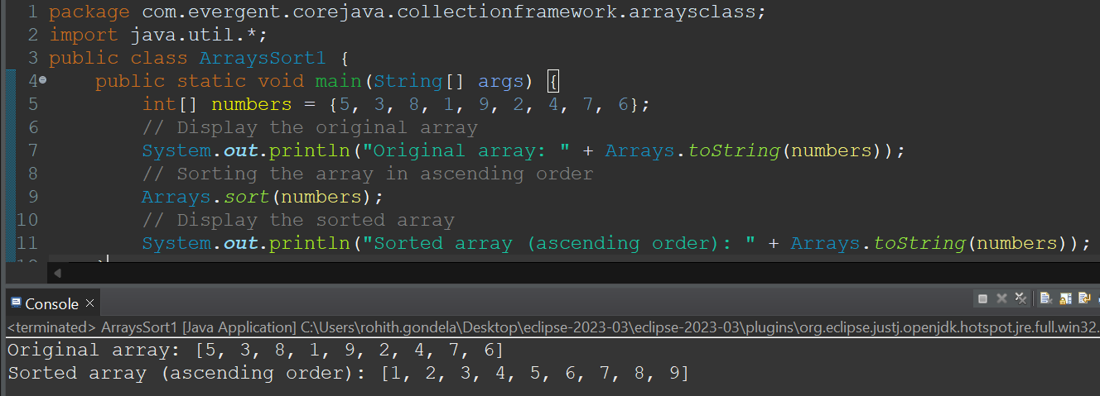

**Program-2:**

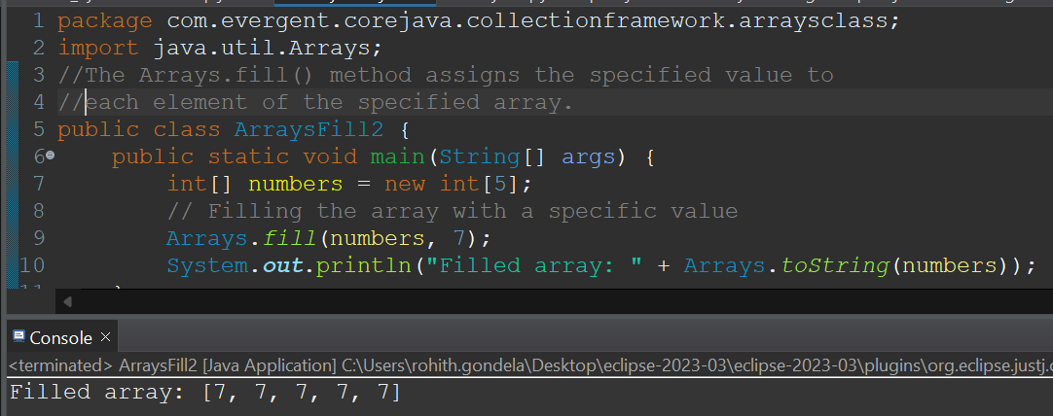

**Program-3:**

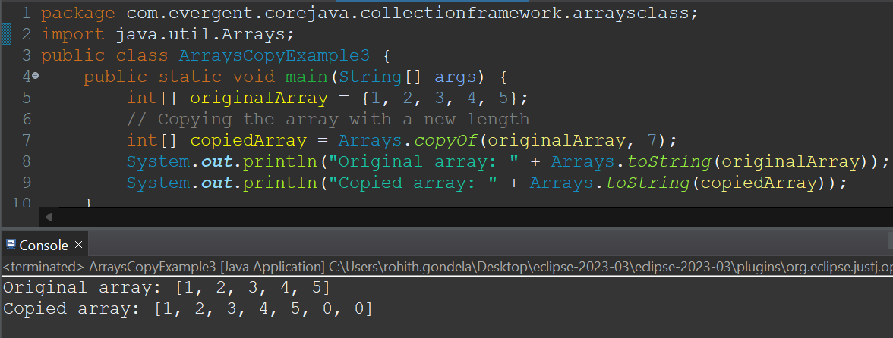

**Program-4:**

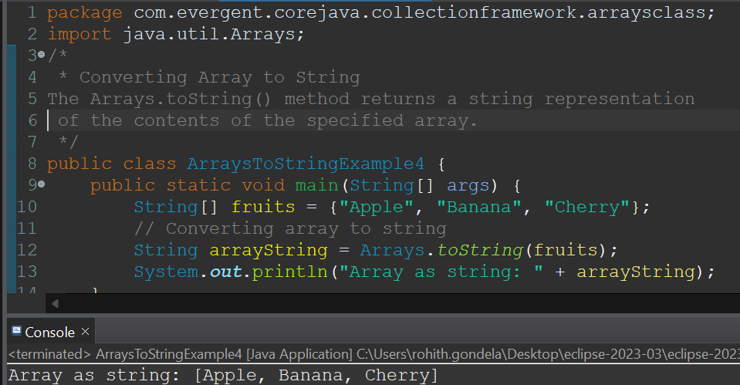

**Program-5:**

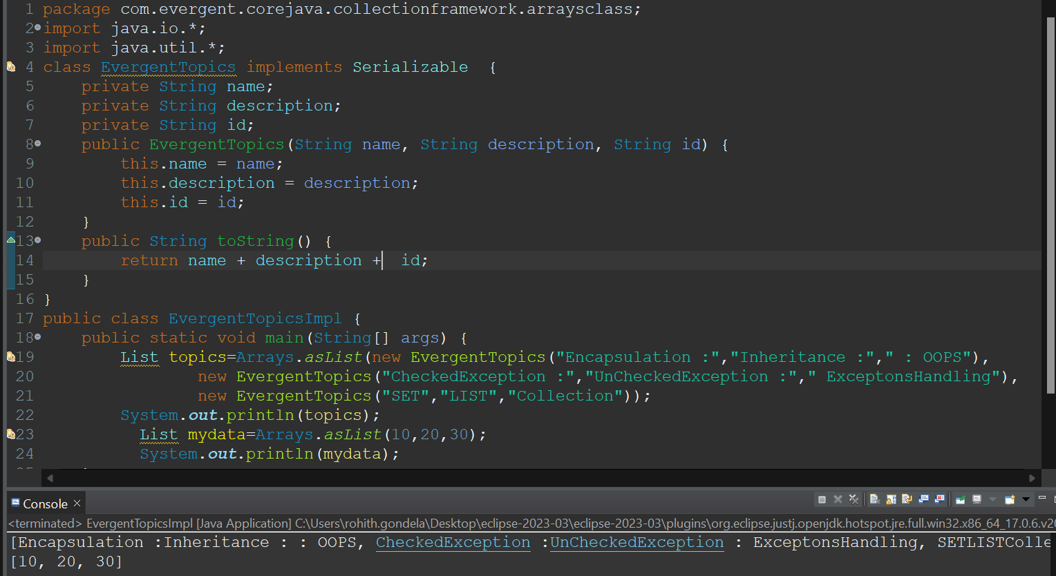

**Day-19 IO STREAMS 30/8/2024**

**Stream :** Flow of data is called Stream.

Depending on the type of operations, **streams can be divided into two primary classes:**

Input Stream: These streams are used to read data that must be taken as an input from a source array or file or any peripheral device. **For eg., FileInputStream, BufferedInputStream, ByteArrayInputStream** etc.

**Output Stream:** These streams are used to write data as outputs into an array or file or any output peripheral device. **For eg., FileOutputStream, BufferedOutputStream, ByteArrayOutputStream** etc.

Depending on the types of file, **Streams can be divided into two primary classes**

**ByteStream:** This is used to process data byte by byte (8 bits). Though it has many classes, the FileInputStream and the FileOutputStream are the most popular ones. **The FileInputStream is used to read from the source and FileOutputStream is used to write to the destination.**

**BufferedInputStream :** It is used for Buffered Input Stream.

**DataInputStream:** It contains method for reading java standard datatypes.

**FileInputStream:**This is used to reads from a file

**InputStream:**This is an abstract class that describes stream input.

**PrintStream:**This contains the most used print() and println() method

**BufferedOutputStream:**This is used for Buffered Output Stream.

**DataOutputStream:**This contains method for writing java standard data types.

**FileOutputStream:**This is used to write to a file.

**OutputStream :**This is an abstract class that describe stream output.

**CharacterStream:** In Java, characters are stored using Unicode conventions (Refer this for details). **Character stream automatically allows us to read/write data character by character.** Though it has many classes, the FileReader and the FileWriter are the most popular ones. FileReader and FileWriter are character streams used to read from the source and write to the destination respectively.

**BufferedReader:**It is used to handle buffered input stream.

**FileReader:**This is an input stream that reads from file.

**InputStreamReader:**This input stream is used to translate byte to character.

**OutputStreamReader:**This output stream is used to translate character to byte.

**Reader :** This is an abstract class that define character stream input.

**PrintWriter:** This contains the most used print() and println() method

**Writer:** This is an abstract class that define character stream output.

**BufferedWriter:** This is used to handle buffered output stream.

**FileWriter:** This is used to output stream that writes to file.

**Program-1:**

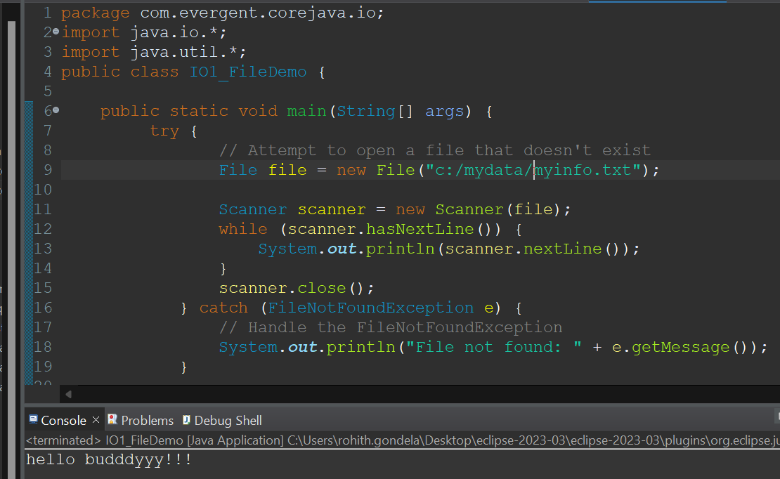

**Program-2:**

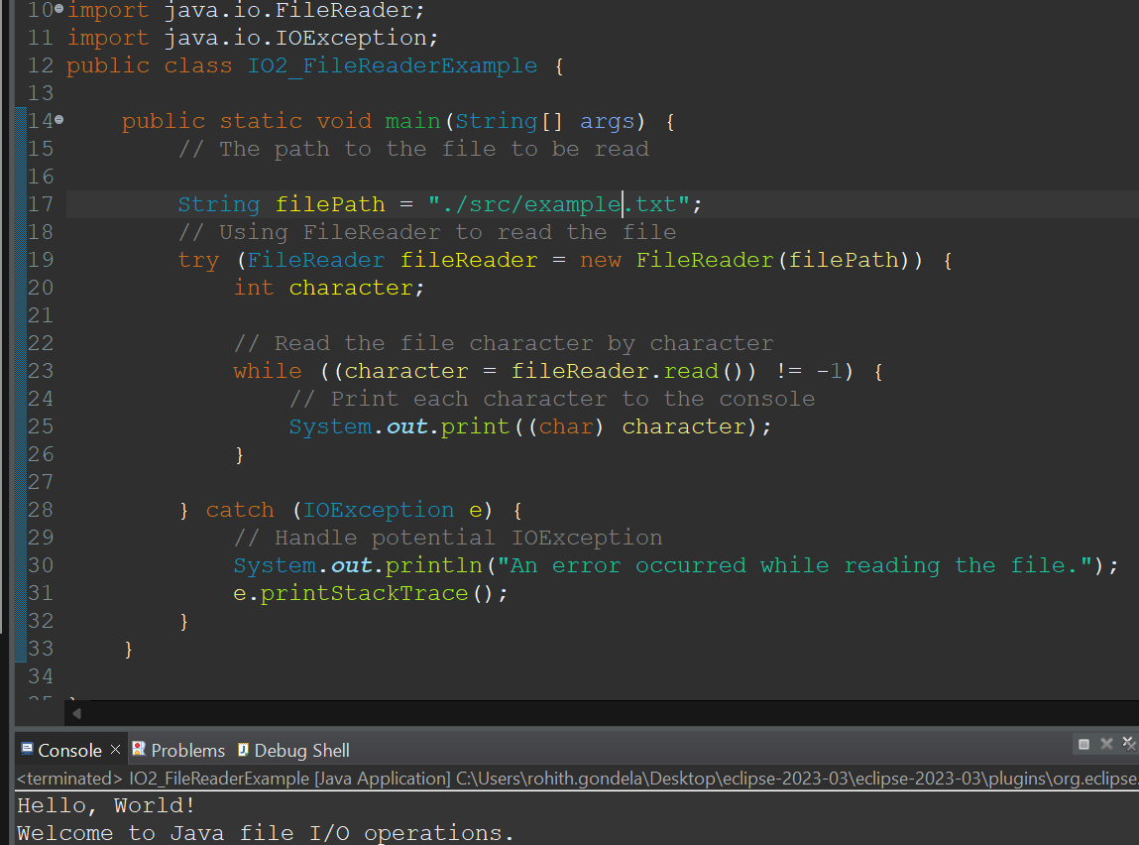

**Program-3:**

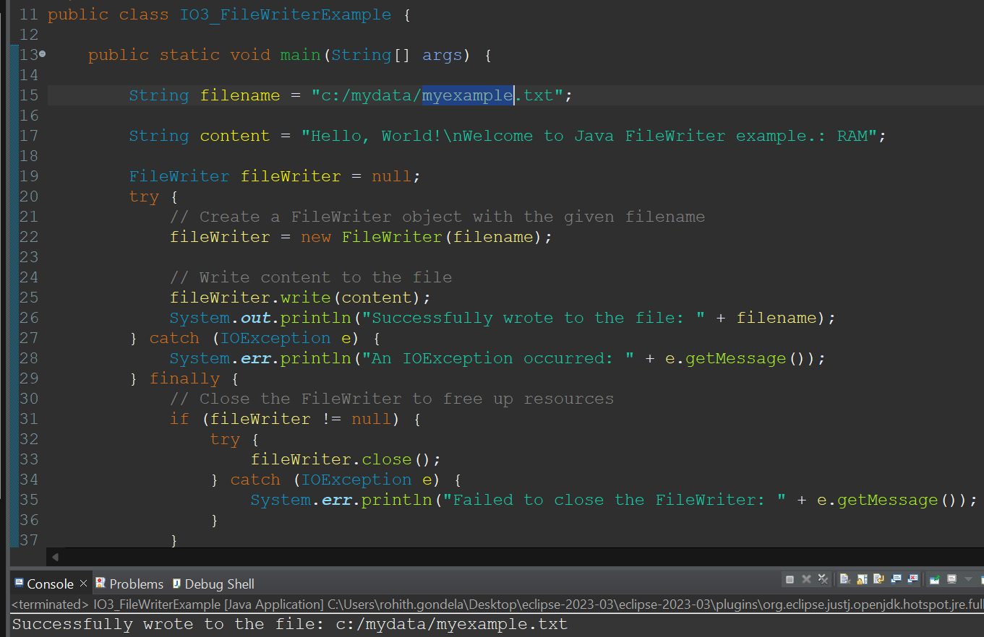

**Program-4:**

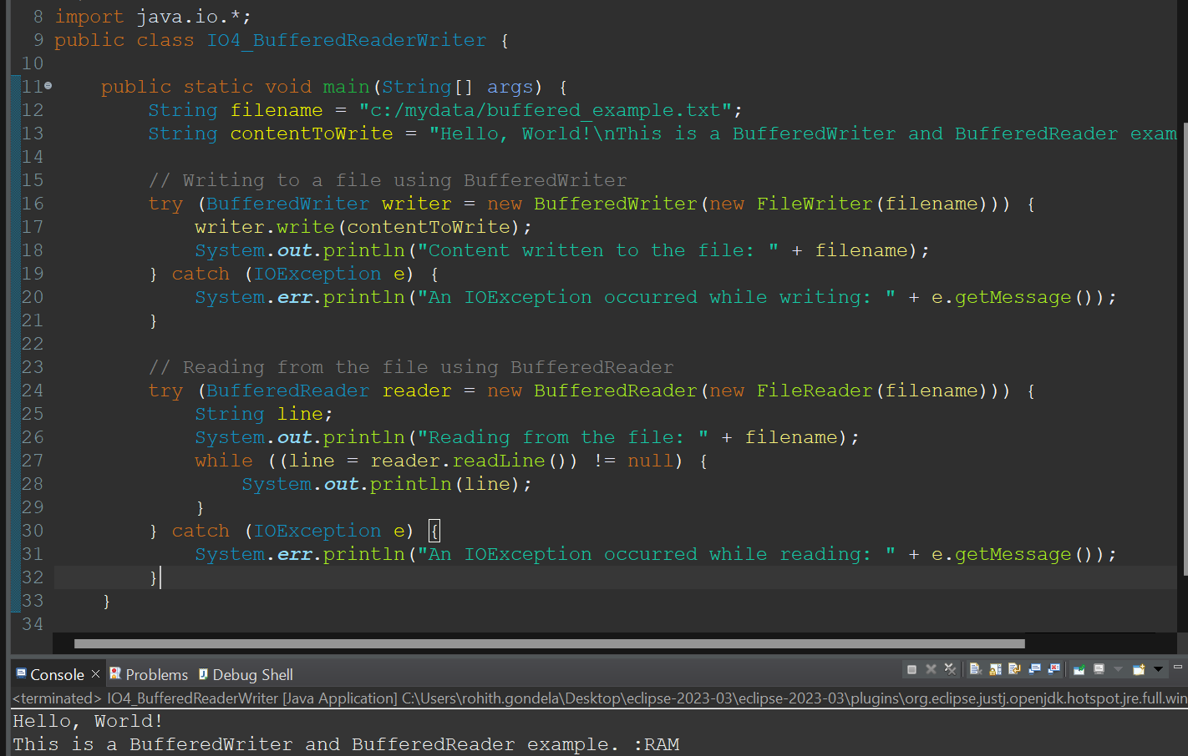

**Program-5:**

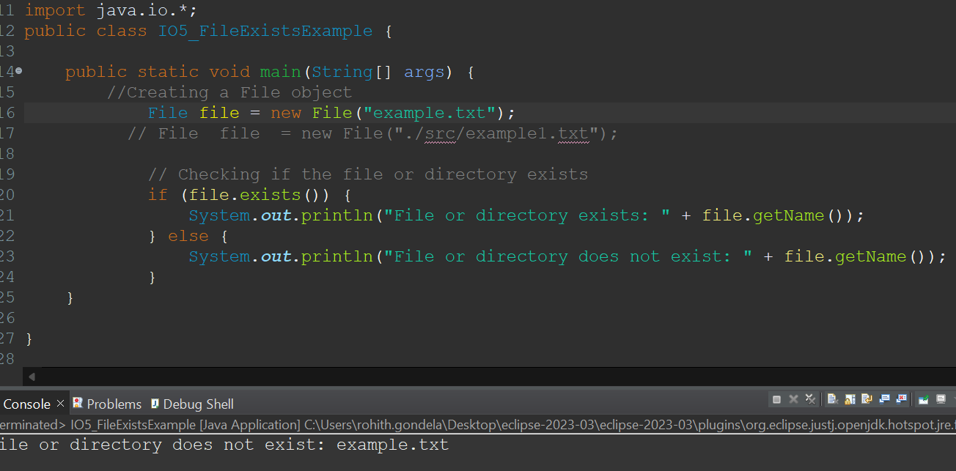

**Day-20 JAVA DATABASE CONNECTIVITY 30/8/2024**

**JDBC** Stands for Java Data Base Connectivity.

**It is the bridge between two different technologies.**

Steps for jdbc:

1. Loading Driver
   1. Class.forName(com.mysql.jdbc.Driver)
2. URL -
   1. Local host
   2. Port number
   3. Database name
   4. Username
   5. Password
3. Com = DriverManager.getConnection(URL);
4. Statements:
   1. Statement
   2. Prepared Statement
   3. Callable statement
5. These all statements have 3 methods:
   1. excute()------Return type is boolean(T/F)
   2. excuteUpdate()-----Return type is int
   3. excuteQuery()-------Return type is Result set
6. Statement stmt = conn.createStatement();
7. ResultSet rs=stmt.executeQuery();
8. while(rs.next()){

System.out.println(rs.getInt(1));

System.out.println(rs.getString("ename"));

System.out.println(rs.getInt(3));

}

1. Close Connection.
2. Close Class.

**Program on JDBC:**

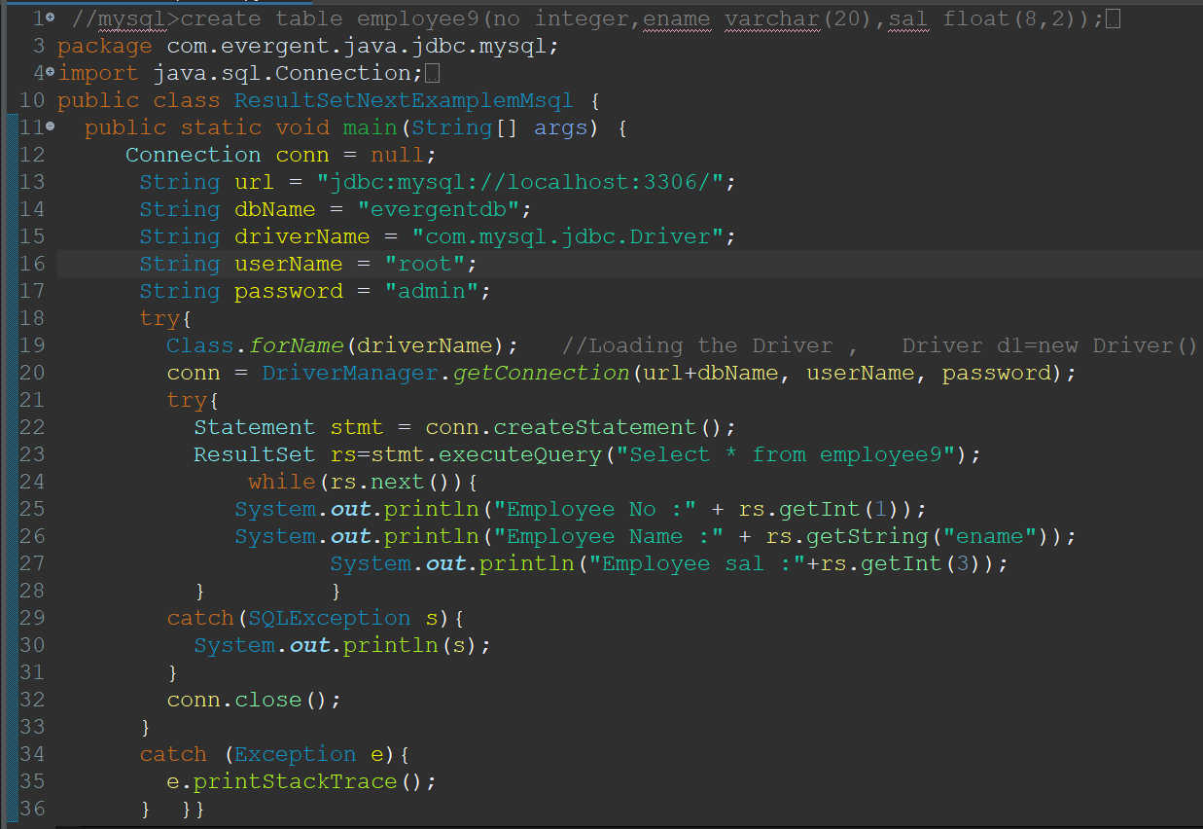

**OUTPUT:**

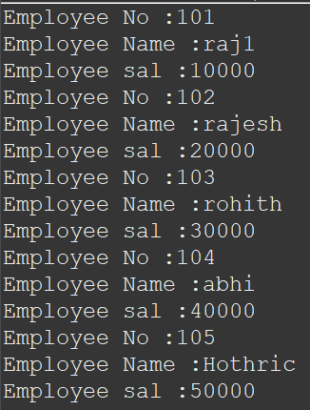

**Remaining programs:**

















**Day-21 JAVA -8 4/9/2024**

**Anonymous inner class:**

Anonymous inner class is an inner class without a name and for which only a single object is created. In simple words, a class that has no name is known as an anonymous inner class in Java. It should be used if you have to override a method of class or interface.

**Progarm-1: Progarm-2:**

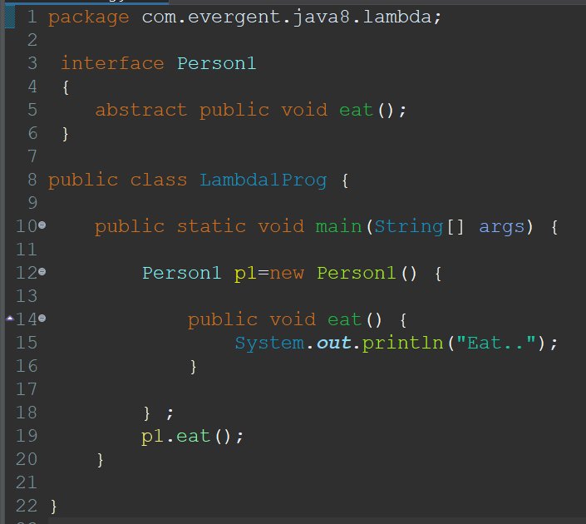 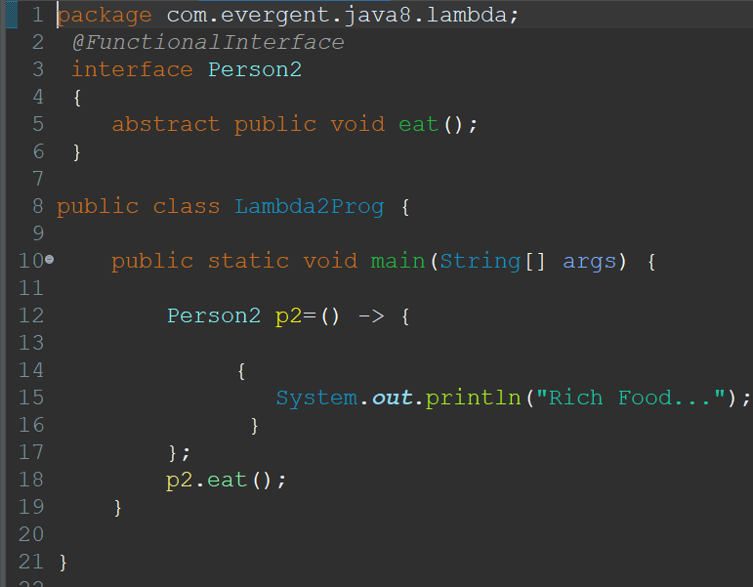

**Progarm-3: Progarm-4:**

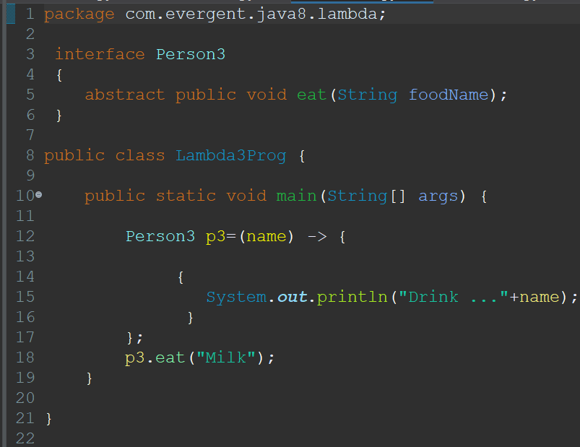 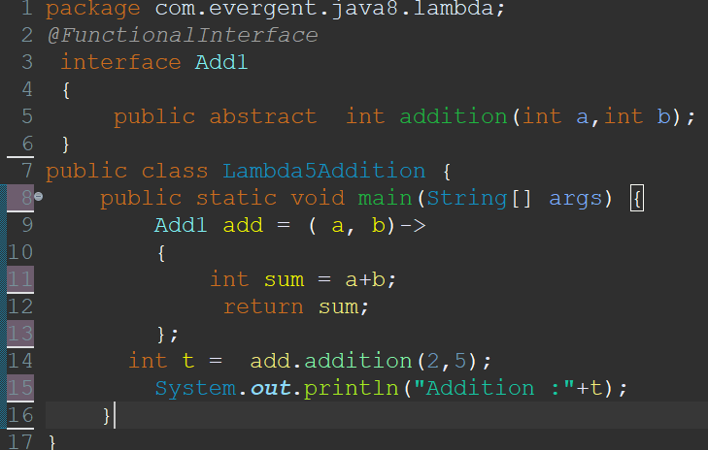

**Progarm-5:**

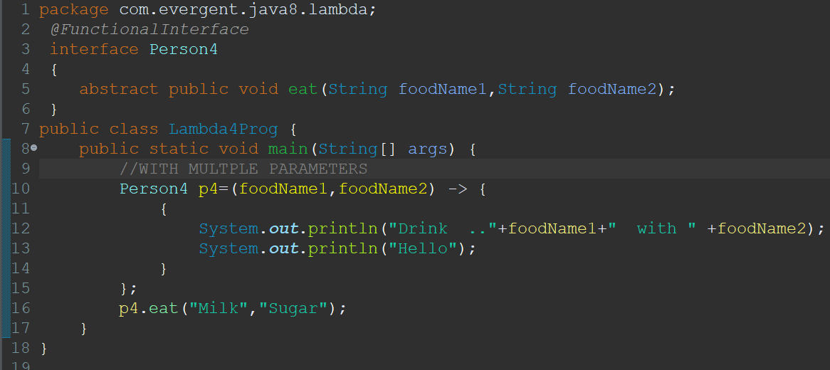

**Progarm-6:**

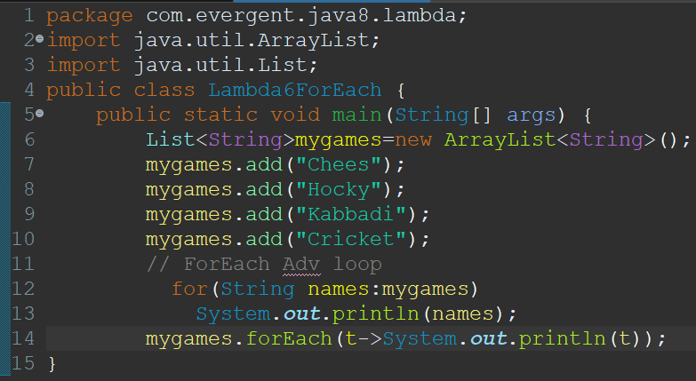

**Progarm-7:**

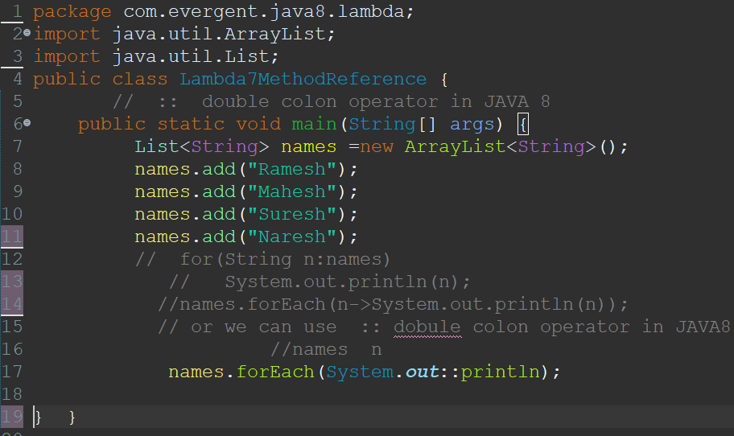

**Progarm-8:**

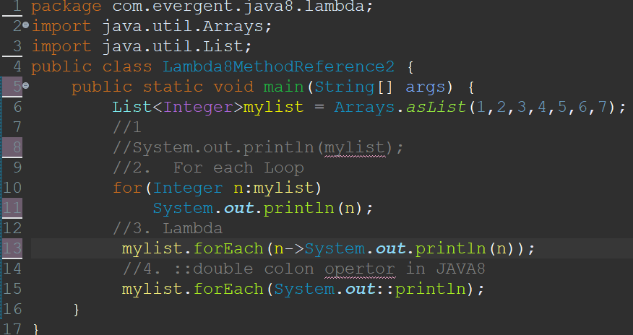

**Progarm-9:**

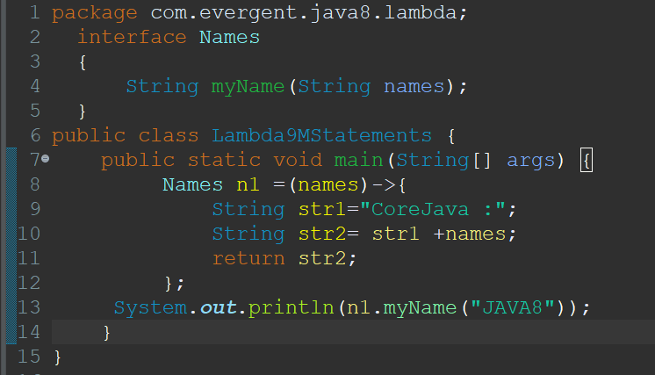

**Progarm-10:**

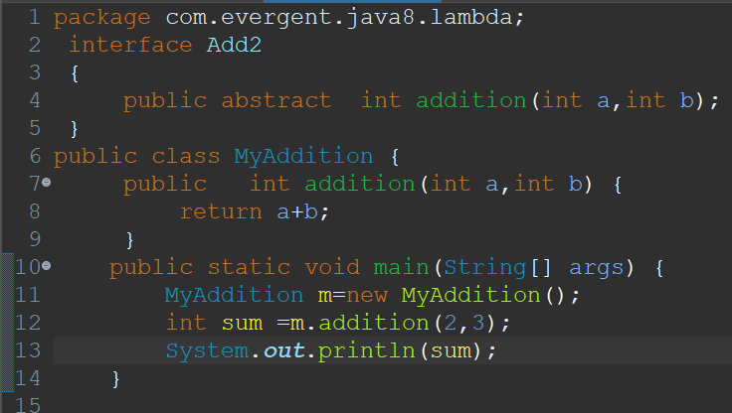

**Day-22 STREAM API &DATE AND TIME 5/9/2024**

**Stream:** Flow of data.

**Methods:**

1. distinct()
2. Limit()
3. Skip()
4. Map()
5. Filter()

**Program-1:**

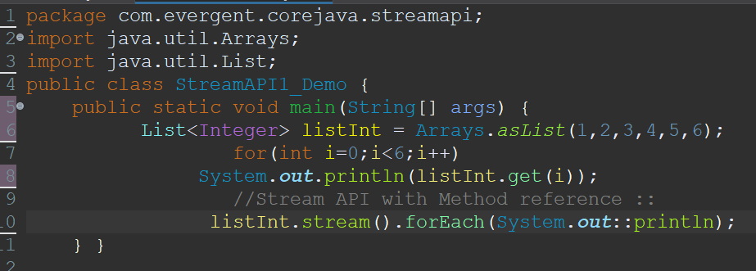

**Program-2:**

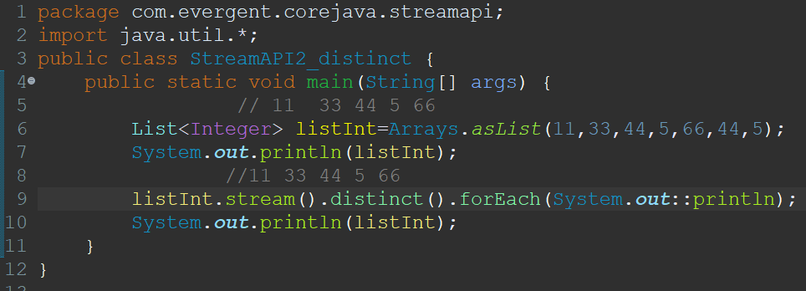

**Program-3:**

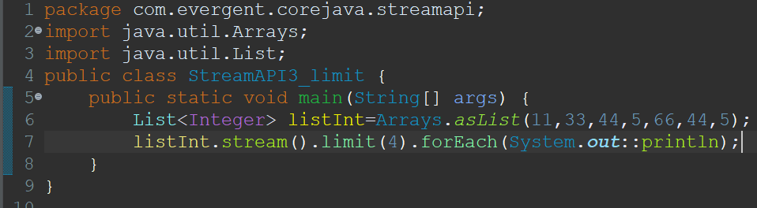

**Program-4:**

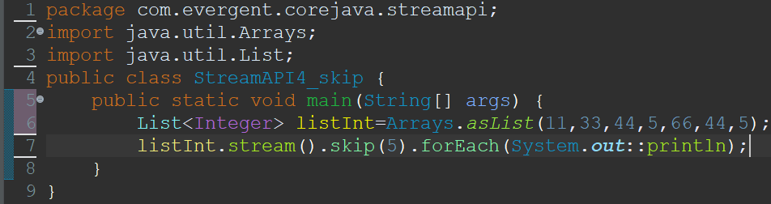

**Program-5:**

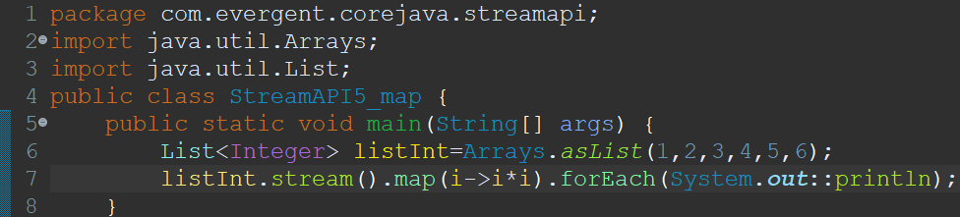

**Program-6:**

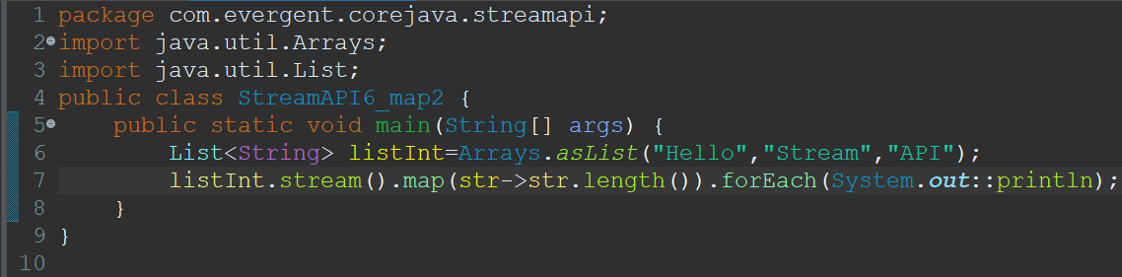

**Date and Time: Program-1:**

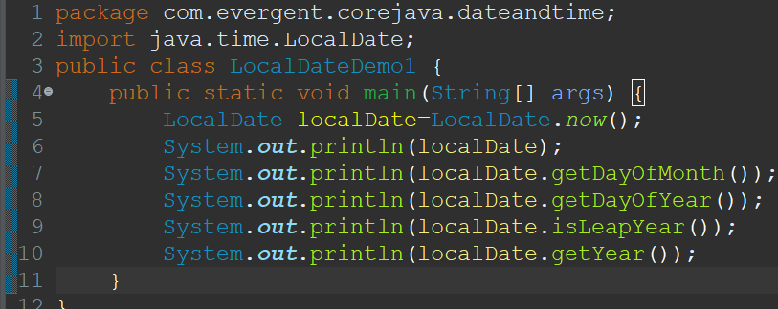

**Program-2:**

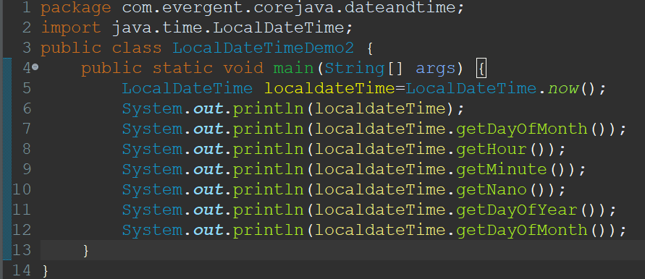

**Day-25 EXECUTOR FRAMEWORK 10/9/2024**

Java provides its own multi-threading framework called the Java Executor Framework.

Java executor framework (java.util.concurrent.Executor), released with the JDK 5 is used to run the Runnable objects without creating new threads every time and mostly re-using the already created threads.

**Thread Pools in Java:**

A thread pool reuses previously created threads to execute current tasks and offers a solution to the problem of thread cycle overhead and resource thrashing.

The java.util.concurrent.Executors provide factory methods that are being used to create ThreadPools of worker threads. Thread pools overcome this issue by keeping the threads alive and reusing the threads.

**Some types of Java Executors are listed below:**

* SingleThreadExecutor
* FixedThreadPool
* CachedThreadPool
* ScheduledExecutor

**Executor 1: SingleThreadExecutor**

A thread pool of single thread can be obtained by calling the static newSingleThreadExecutor() method of the Executors class. It is used to execute tasks sequentially.

**Syntax:**

**ExecutorService executor = Executors.newSingleThreadExecutor();**

**Executor 2: FixedThreadPool(n)**

As the name indicates, it is a thread pool of a fixed number of threads. The tasks submitted to the executor are executed by the n threads and if there is more task they are stored on a LinkedBlockingQueue. It uses Blocking Queue.

**Syntax:**

**ExecutorService fixedPool = Executors.newFixedThreadPool(2);**

**Executor 3: CachedThreadPool**

Creates a thread pool that creates new threads as needed, but will reuse previously constructed threads when they are available. Calls to execute will reuse previously constructed threads if available. If no existing thread is available, a new thread will be created and added to the pool. It uses a SynchronousQueue queue.

**Syntax:**

**ExecutorService executorService = Executors.newCachedThreadPool();**

**Executor 4: ScheduledExecutor**

Scheduled executors are based on the interface ScheduledExecutorService which extends the ExecutorService interface. This executor is used when we have a task that needs to be run at regular intervals or if we wish to delay a certain task.

**Syntax:**

**ScheduledExecutorService scheduledExecService = Executors.newScheduledThreadPool(1);**

The tasks can be scheduled using either of the two methods:

scheduleAtFixedRate: Executes the task with a fixed interval, irrespective of when the previous task ended.

scheduleWithFixedDelay: This will start the delay countdown only after the current task completes.

**Syntax:**

scheduledExecService.scheduleAtFixedRate

(Runnable command, long initialDelay, long period, TimeUnit unit)

Implentation class

One Method-execute()

**<Executor>**

**Executors**

Extends

**<ExecuteService>**

**Callable vs Runnable:**

If wereturn in Runnable we get null,but in callable returns object/data.

**Future:**

Future is interface represents the result of an interface of an asynchronous computation.

It provides methods to check if the task is complete to wait for the result and to cancel the task.

**Executor Framework:**

The executor frame work in java is a popular tool for managing concurrent execution.

It provides a flexible and efficient way to submit task for asynchronous execution control the

life-cycle of these tasks and handle the result.

**ExecutorService :**

* It was introduced in jdk-1.5.
* ExecutorService is a interface in package of java.util.concurrent.
* That provides a framework for managing and controlling threads,allowing you to execute tasks asynchronously without manually handling the creation and management of individual threads.

**Methods:**

1. execute()
2. Shutdown()
3. awaitTermination()

**We can use submit method in 2 ways:**

1. Runnable
2. Callable

**The return type of submit method is future interface.**

**Program-1:**

